Australian Institute of Marine Science

ANNUAL REPORT 2013-14

AIMS: Australia's tropical marine research agency
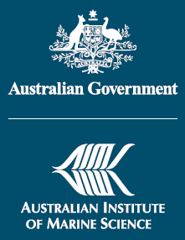

The research reported herein is based on early analyses of complex datasets and should not be considered definitive in all cases. Institutions or individuals interested in all consequences or applications of Australian Institute of Marine Science's research are invited to contact the Chief Executive Officer at the Townsville address below.
For additional copies of this report, please phone AIMS on (07) 4753 4444, write to us at the Townsville address or email media@aims.gov.au.
This report, along with a range of other information about AIMS, is available online at www.aims.gov.au.
© Australian Institute of Marine Science
Townsville, Queensland
PMB No 3, Townsville MC Qld 4810
Telephone: (07) 4753 4444
Facsimile: (07) 4772 5852
Darwin, Northern Territory
PO Box 41775, Casuarina NT 0811
Telephone: (08) 8920 9240
Facsimile: (07) 8920 9222
Perth, Western Australia
The University of Western Australia Oceans Institute (M096)
35 Stirling Highway, Crawley WA 6009
Telephone: (08) 6369 4000
Facsimile: (08) 6488 4585
ABN 789 61616230
ISSN 1037-3314

Contents
PART ONE: OUR PERFORMANCE 1
About AIMS 3
The year in review: Report from Chair and CEO 4
Key outcomes 11
Delivery against stated goals 19
Research 28
Data management and dissemination 51
Stakeholder engagement 53
Revenue 58
Facilities and resource management 60
PART TWO: OUR ORGANISATION 64
MANAGEMENT AND ACCOUNTABILITY 66
CORPORATE GOVERNANCE 68
ENVIRONMENTAL PERFORMANCE 82
STAFF 84
PART THREE: FINANCIAL STATEMENTS 92
Independent Auditor's Report 93
Statement by the Directors, Chief Executive Officer and Chief Financial Officer 95
Statement of Comprehensive Income for the period ended 30 June 2014 96
Statement of Financial Position as at 30 June 2014 97
Statement of Changes in Equity for the period ended 30 June 2014 98
Cash Flow Statement for the period ended 30 June 2014 99
Schedule of Commitments as at 30 June 2014 100
Schedule of Contingencies as at 30 June 2014 102
Notes to and forming part of the Financial Statements 103
Supplementary Financial Information (Unaudited) 138
PART FOUR: APPENDICES 141
Appendix 1. SCIENCE PUBLICATIONS 142
Appendix 2. EXTERNAL COMMITTEES AND NON-GOVERNMENT ORGANISATIONS AND POSITIONS 163
International Forum 163
Appendix 3. LEGISLATIVE FOUNDATION AND MINISTERIAL POWERS 167
PART FIVE: INDEXES 170
ABBREVIATION LIST 171
INDEX OF ANNUAL REPORT REQUIREMENTS 174


10 September 2014
The Hon Ian Macfarlane MP
Minister for Industry
Parliament House
CANBERRA ACT 2600
Dear Minister,
On behalf of the Council Directors of the Australian Institute of Marine Science (AIMS), we have pleasure in presenting our 42nd annual report, for the year ended 30 June 2014. The report is forwarded in accordance with Section 9 of the Commonwealth Authorities and Companies Act 1997.
This report provides information so that you, the Commonwealth Parliament and users of AIMS’ research output can make an informed judgement about the Institute’s performance during the 2013–14 financial year.
The report has been prepared in accordance with the Commonwealth Authorities (Annual Reporting) Orders 2011 and the Finance Minister’s Orders for Financial Reporting (incorporating policy and guidance)—for reporting periods ending on or after 1 July 2012. The Council endorsed the content of the AIMS Annual Report 2013–14 by a resolution on 03 September 2014.
Yours sincerely,

Mr Wayne Osborn
Chairman
Australian Institute of Marine Science

Mr John Gunn
Chief Executive Officer
Australian Institute of Marine Science
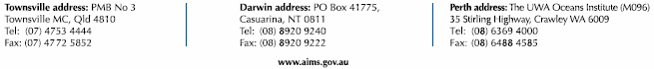
Certification of Report of Operations
The Council Directors of the Australian Institute of Marine Science (AIMS) are responsible under Section 9 of the Commonwealth Authorities and Companies Act 1997 for the preparation and content of AIMS' Report of Operations, in accordance with the Finance Minister’s Orders.
Council endorsed the content of the Report of Operations by a resolution on 03 September 2014.
Mr Wayne Osborn
Chair
Australian Institute of Marine Science
Mr John Gunn
Chief Executive Officer
Australian Institute of Marine Science

PART ONE: OUR PERFORMANCE
About AIMS 3
Location of AIMS' major activities and facilities 4
The year in review: Report from Chair and CEO 4
A healthy and resilient Great Barrier Reef 5
Sustainable coastal ecosystems and industries 6
Ecologically sustainable offshore oil and gas development 7
Our capacity 7
High quality science 7
Comprehensive environmental data 8
Leading capabilities and relationships 8
Our year 9
Key outcomes 11
A healthy and resilient Great Barrier Reef 11
Sustainable coastal ecosystems and industries in tropical Australia 14
Sustainable use of north-west marine ecosystems 18
Delivery against stated goals 19
Portfolio Budget Statement expectations 20
AIMS Research Plan 2011-15 24
Research 28
Publications 28
High impact articles 29
Other significant publications 34
Leadership 35
Contributing to issues of national importance 35
Partnerships 38
Fostering research capability 44
Collaboration 47
Visiting scientist program 49
Science quality assurance 50
Data management and dissemination 51
Stakeholder engagement 53
Communication 55
Revenue 58
External revenue 58
Facilities and resource management 60
Research facilities 60
Marine operations 61

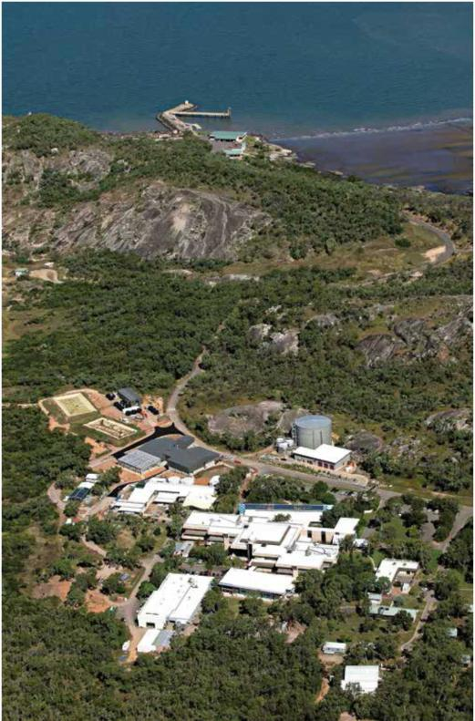
AIMS' Cape Ferguson site, outside Townsville. Image: Aerial Impressions.

About AIMS
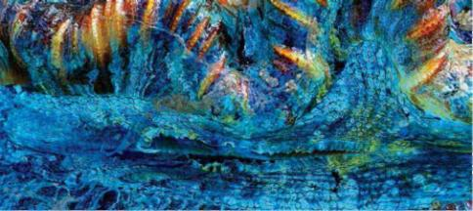
The Australian Institute of Marine Science (AIMS) is a Commonwealth statutory authority established under the Australian Institute of Marine Science Act 1972. As Australia's tropical marine research agency, our mission is to generate and transfer knowledge to support the protection and sustainable use of the marine environment through innovative, world-class scientific and technological research.
To ensure that the outputs of our research are transferred to users and have the required impact, AIMS actively engages with government (ministers, policy makers, resource managers and environmental regulators), private industry sectors (ports, oil and gas, mining, tourism, services), non-government organisations, scientific peers and the Australian public.
AIMS was established in 1972 near Townsville, in recognition of the importance of the Great Barrier Reef to Australia. Today we also operate from bases in Perth and Darwin, which allows us to undertake research across northern Australia, spanning two oceans and three regional seas.
The Institute:
- conducts strategic and applied research into marine life, from microbes to whole-of-ecosystem studies, and the processes that sustain them
- monitors the condition of, and trends in, the marine environment
- builds models and decision-support tools to help users interpret the data we collect
- develops a broad spectrum of enabling technologies, from molecular sciences to ocean technologies.
AIMS' research is targeted towards priorities of the Commonwealth and state governments and industry. Over the last year the Institute's research has continued to:
- underpin Australia's environmental management of the Great Barrier Reef to ensure that this World Heritage Area remains healthy and resilient
- support the sustainable development of coastal industries and ports across northern Australia from Gladstone to the Pilbara
- provide the environmental baselines and condition and risk assessments required for development of the offshore oil and gas industry in north-western Australia.

Location of AIMS' major activities and facilities
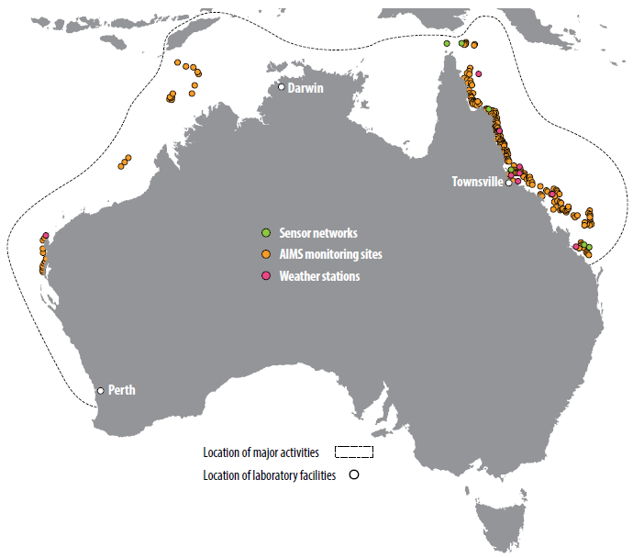

The year in review: Report from Chair and CEO
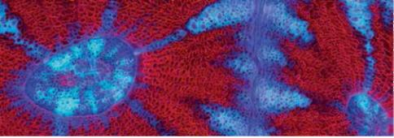
In 2011-12, just over $47 billion of Australia's economic activity depended on our marine environment AIMS Index of Marine Industry, a figure equal to the gross value of Australia's agricultural production. And the marine economic activity is likely to grow to $100 billion by 2025. Most of that wealth is generated from oil, gas and tourism, and it comes increasingly from northern ports and waters.
The importance of, and growth in, Australia's 'blue economy' brings with it the imperative to balance economic development with the protection of productive, and in many places unique, ecological assets such as the Great Barrier Reef and the Ningaloo Reef.
As a national agency, AIMS is dedicated to providing the information and research needed by governments, industry and the wider community to make informed decisions about the sustainable management of our marine estate.
This role is recognised as a priority by the Commonwealth Government, which provided AIMS with an extra budget allocation of $30.9 million from 2014 to 2017. The extra funding will support additional research and, importantly, the operation of AIMS' new National Sea Simulator (SeaSim), which is available for the use of Australian and international marine researchers.
The Minister for Industry, the Hon Ian Macfarlane MP, has given us a clear sense of his expectations of AIMS. He wants a strong and visible focus on the needs of our stakeholders and in particular the growing marine industries that operate across Australia's tropical regions. That has led us to establish three key outcomes that will guide us for the next 10 years:
- A healthy and resilient Great Barrier Reef;
- Sustainable coastal ecosystems and industries; and
- Ecologically sustainable offshore oil and gas development.
These three outcomes are the focus of the strategic plan that AIMS has developed for 2014-24, and of our research and business plans for the coming year.

A healthy and resilient Great Barrier Reef
AIMS' monitoring programs and the broad spectrum of our research over the past 40 years provide an invaluable record of the trends in health of the Great Barrier Reef, and contribute to our deep understanding of the factors that contribute to loss and rebuilding of reef communities. Last year we reported that over 50 per cent of the Reef's coral cover had been lost from 1985 to 2012. Over the last two years our reef surveys have documented significant growth of coral cover in some reefs that had been badly affected by cyclones over the last decade. This recovery is an indication of the Reef's resilience, which in the absence of stress allows reef communities to bounce back when conditions are favourable. However, we have also seen worrying expansion of a major crown-of-thorns starfish outbreak in the reefs between Cooktown and Cairns.
In response to a United Nations Educational, Scientific and Cultural Organisation (UNESCO) review of the status of the Great Barrier Reef World Heritage Area, the federal and Queensland governments have conducted major strategic assessments of the property over the last 12 months. AIMS staff were heavily involved in this process, leading a number of projects, facilitating and contributing to expert advisory groups and formally reviewing the documents. A measure of the contribution of AIMS' research to these assessments can be seen in the reference to more than 200 AIMS publications as critical evidence supporting the conclusions reached.
Following the assessment process, AIMS has been invited by the Australian and Queensland environment ministers to join a high level partnership group to advise on the development of the Great Barrier Reef 2050 Long-term Sustainability Plan. AIMS has also been invited to assist with an investment plan for the Reef Trust (see Key Outcomes: Developing the Reef Plan p 11).
Our 2012 study revealing the loss of half the Reef's coral cover concluded that coral cover would recover at a rate of 0.9 per cent per year if we could stop the periodic epidemics of crown-of-thorns starfish. In response, we have developed a research strategy to focus the work of AIMS and its partners on the crown-of-thorns starfish. The research investigates the genome, microbial biology and chemical signalling of the starfish, and how it responds to water quality. Australia's last major research effort on crown-of-thorns starfish in the 1990s failed to adequately explain or prevent outbreaks. However, we are confident that the suite of new tools available to science, from genomics to advanced numerical modelling, and the experimental capability provided by the National Sea Simulator, provide a quantum step in our capacity to research strategies to prevent future outbreaks.

Sustainable coastal ecosystems and industries
Australia's tropical coastline is a focus of national economic development, with major port construction planned in the Pilbara, Darwin and north Queensland. With our partners, we have developed research programs that are contributing to planning and the regulatory frameworks for these huge infrastructure projects.
Over the last year AIMS has worked with the Western Australian Marine Science Institution on Australia's largest dredging research program. This work has already informed approval processes for projects such as the Port Hedland Outer Harbour and the large port developments in Darwin. The National Sea Simulator will play a vital role in our ongoing efforts to understand the vulnerability of marine organisms, such as corals, sponges and sea grasses, to dredging operations. These experimental studies allow us to advise on the most effective ways to mitigate environmental risk when developing or expanding ports across northern Australia, and in tropical ecosystems around the world.
Darwin's East Arm Wharf is a major port expansion for oil, gas and bulk materials, and it will also host a supply base for offshore industry and a naval facility. AIMS provided an observing system, built hydrodynamic models, and provided advice on sediment transport, toxicology and the impact of dredging. This input allowed the Darwin Ports Corporation to improve the design and take an ecologically sustainable approach to construction and future operation of the East Arm Wharf area (see Key Outcomes: Contributing to ecologically sustainable port development p 16).
Improving water quality is essential for the coastal and inshore regions of the Great Barrier Reef, and many other areas where coastal development is taking place close to sensitive environments. This year we helped revise the Australian and Queensland governments' Reef Water Quality Protection Plan (ReefPlan), which now has the goal of ensuring that by 2020 the Reef is no longer adversely affected by run-off water from broad-scale land use. Our monitoring programs will help evaluate the effectiveness of the steps taken towards this goal. Analysis of 10 years of satellite imagery, for instance, has shown that large river flood events have a significant impact on water quality, reaching far off the coast and lasting several months (see Key outcomes: Contributing to the Reef Report Card p 14).

Ecologically sustainable offshore oil and gas development
Oil and gas producers such as Woodside Petroleum, recognising the environmental sensitivities of their operating environment, have long partnered with AIMS to build an understanding of these environments. Woodside, in particular, has invested in baseline environmental monitoring, most recently in supporting the five-year baseline environmental study of Scott Reef off north-western Australia. The reports of that project were key source documents for the environmental impact statement and subsequent environmental approvals for the Browse [Basin] Joint Venture.
Earlier this year AIMS, Shell Australia (Shell) and INPEX Operations Australia (INPEX) announced a business partnership to conduct baseline surveys and provide operational and scientific monitoring in the event of a Tier 3 oil spill. The companies approached AIMS to lead a collaborative project in partnership with the Commonwealth Scientific and Industrial Research Organisation (CSIRO), the University of Western Australia, Curtin University, Monash University and ChemCentre, the West Australian Government's chemical analysis laboratory. It is a powerful research partnership of trusted research organisations (see Key outcomes: Working with the oil and gas industry p 18).

Our capacity
AIMS is well placed to deliver on the three strategic outcomes because of our unique combination of:
- ability to undertake high quality science
- access to, and expertise in analysing, comprehensive environmental data; and
- staff, infrastructure and collaborative relationships that ensure our capabilities remain at the forefront of tropical marine science.

High quality science
In addition to the research mentioned above, science highlights in 2013-14 include:
- our research showing that healthy shark populations may aid coral reef recovery, published in PLoS ONE;
- a new understanding of how corals may influence cloud formation and protect themselves from heat stress, published in Nature;
- the finding that ocean acidification will tend to favour boulder-like corals over branched corals, and also reduce habitat for crabs, shrimps, sea stars and other invertebrates, published in Proceedings of the Royal Society B: Biological Sciences;
- the discovery of hidden coral diversity by using genomics, skeleton analysis and ecological observations to distinguish new species, published in the Zoological Journal of the Linnaean Society;
- using Coral Sea surface temperature records to reconstruct variation in climate and currents since 1795, published in Nature Communications;
- the discovery that fish become bolder in acidic waters leading to predation, published in Nature Climate Change
- a rethinking of the 'neutral theory of biodiversity'and of the role of common species in reef ecosystems, published in Proceedings of the National Academy of Sciences;
- showing that large river floods affect Reef water quality for many months over a wide area according to analysis of a decade of satellite images, published in Marine Pollution Bulletin; and
- an international award to Madeleine van Oppen and her colleague Ruth Gates from the Hawaii Institute of Marine Biology. The Paul G. Allen Ocean Challenge award for 2013 will allow them to select genetic traits in corals that will enable the corals to cope better with the stresses imposed by acidifying and warming oceans.
The research findings mentioned above are described in more detail in High impact articles (see p 29).

Comprehensive environmental data
The world of science increasingly uses models to describe, predict and explore our environment and the impacts of human activities. Advances in computing, modelling methods and sensor technologies provide both the demand and capability to collect both high quality and high density data.
AIMS continues to be a primary source of marine biological, chemical and physical data across Australia's tropical shelf waters, and to make these data available through our world-class data centre.
This year we continued to support Australia's Integrated Marine Observing System (IMOS), a national system of observing technologies documenting variability across Australia's marine jurisdiction. AIMS is a major operator of IMOS infrastructure across northern Australia from the Ningaloo Marine Park in Western Australia to the bottom of the Great Barrier Reef in Queensland, including Darwin Harbour (see Partnerships: IMOS p37)
The AIMS Long-term Monitoring Program database includes 32 years of observations and measurements from 164 reefs surveyed by divers, and holds over six million data records across 289 sites via our responsibility for the Reef Rescue Marine Monitoring Program.
We continued to monitor seagrass beds damaged by cyclone Yasi. So far we have seen some early signs of recovery 18 months after the cyclone caused massive seagrass loss. The most recent surveys are still being analysed to determine if this recovery is being sustained. As noted earlier we have large scale collaborations to measure and monitor Scott Reef, Rowley Shoals, Ningaloo Reef and other Western Australian sites. We now have the most comprehensive sets of baseline data on Australia's continental shelf ecosystems. New data sets made available include the Great Barrier Reef e-Atlas; a major synthesis of information on run-off impact on the Great Barrier Reef; and a decade of data collected from the North-West Shelf.

Leading capabilities and relationships
AIMS had 203 full time equivalent staff as at 30 June 2014, including 11 casual staff. In addition to this, a variety of AIMS services such as vessel crewing, catering and maintenance are carried out by 42 contractors. Across the same period AIMS had 26 postdoctoral researchers and 77 postgraduate students. AIMS maintains its commitment to training and early-career researcher development in partnership with universities across Australia and around the world.
AIMS research vessels were highly utilised and our researchers very active in the field during the reporting period. Our research vessels collectively facilitated 3911 researcher days in the field via 91 voyages, travelling more than 42,000 nautical miles and spending a total of 611 days at sea. Added to this is AIMS research field work undertaken on charter vessels or based from research stations and other non-boating related sites.
Our National Sea Simulator tanks are now operational and experiments under way include spawning crown-of-thorns starfish; coral successfully spawning and now being challenged with temperature gradients; and establishment of experiments looking at the impact of dredging sediment on sponges and seagrass. In 2014-2015 we will invite scientists from around the world to join our researchers in SeaSim-based collaborative projects.
In addition to the cooperative projects mentioned above, we continue to develop strong international linkages, undertaking projects with 67 international organisations. We signed memorandums of understanding with three international research organisations, the Chinese Academy of Sciences Institute of Oceanology at Qingdao, the Okinawa Institute of Science and Technology in Japan and the King Abdullah University of Science and Technology in Saudi Arabia.

Our year
2013-14 has been a productive and exciting year for AIMS:
We have continued to produce and disseminate our high quality science: publishing articles in respected international journals; producing environmental reports for industry and government agencies; and contributing to national and international reviews and enquiries.
We have increased our efforts to work with the end users of our scientific activities, focusing our research on their priority needs and ensuring that our output is relevant and useful to them.
We have forged new partnerships, nationally and internationally, with research providers and industry.
And we have also developed comprehensive strategic plans for our research, our business and our capability. These set the course for our next decade, and ensure that the funding providing to us by government has maximum impact in supporting sustainable use and protection of Australia's vast marine estate.
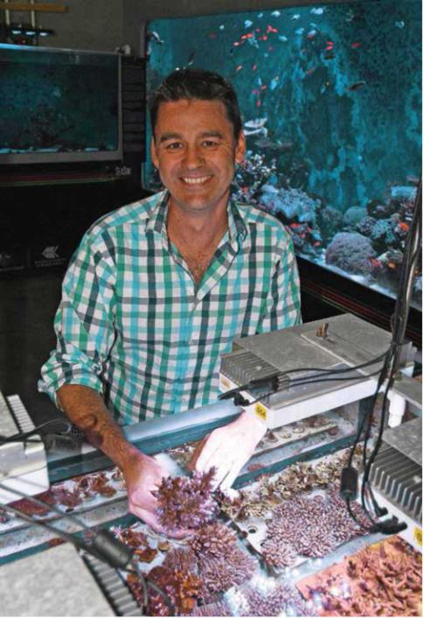
National Sea Simulator Manager Craig Humphrey assesses the health of coral colonies bred in the facility. Image: K. Green, AIMS

Key outcomes
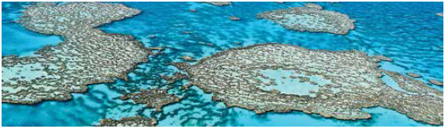
Through its research programs, AIMS is making a significant contribution to Australia.
This section contains six key examples of where the Institute research led to significant outcomes in the last year (i.e. 2013-14), listed against each of AIMS' three research areas of:
A healthy and resilient Great Barrier Reef:
- Developing the Reef 2050 Plan—a long-term sustainability plan for the Great Barrier Reef World Heritage Area
- Aiding decision-making on future scenarios for the Great Barrier Reef
Sustainable coastal ecosystems and industries in tropical Australia:
- Contributing to the Reef Report Card—a key strategic output for water quality management
- Contributing to ecologically sustainable port developments
Sustainable use of north-west marine ecosystems:
- Helping industry determine the impact of the Montara oil spill
- Working with the oil and gas industry to prepare for future incidents
Each of these achievements is described in more detail below.

A healthy and resilient Great Barrier Reef

Developing the Reef 2050 Plan—a long-term sustainability plan for the Great Barrier Reef World Heritage Area
There is currently a strong focus on the health and likely future of the Great Barrier Reef. In response to the World Heritage Committee's concerns about the impact of coastal development on the Great Barrier Reef, the Australian and Queensland governments conducted a comprehensive strategic assessment of the Great Barrier Reef's marine and coastal zones. Program reports - developed in conjunction with the assessment — set out specific management actions to be taken — to address threats to the Great Barrier Reef. The draft strategic assessment was released in November 2013 for three months of community consultation, with feedback from that consultation considered in finalising the reports. Building on the assessments, a Reef 2050 Long-Term Sustainability Plan is being developed to guide the sustainability and management of the Great Barrier Reef and inform its future development and protection from 2015 to 2050.
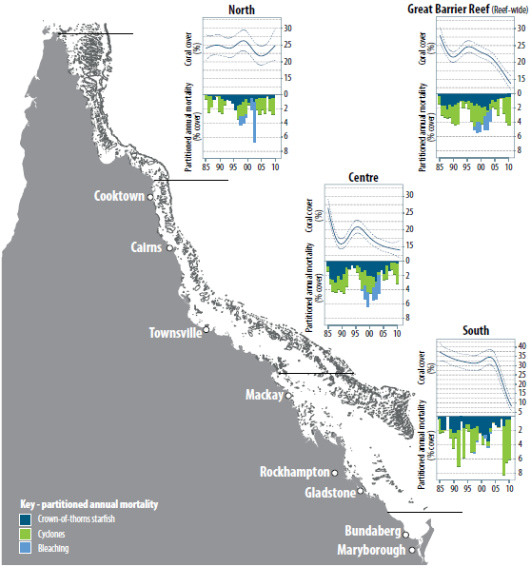
An example of where AIMS data was used to inform the status of coral in the Great Barrier Reef Region Strategic Assessment.
AIMS research provided significant inputs into many areas of the strategic assessment. Our research is referenced over 200 times and covers monitoring, water quality assessments, dredging impacts, oceanography, diseases, climate change impacts and the role of top order predators. The AIMS Long-term Monitoring Program, in particular, was the primary source of information on the 50 per cent decrease in coral cover on the Reef over the last 27 years, and on the status and impacts of crown-of-thorns outbreaks (see figure above).
"We work closely with AIMS on a range of research, including data for the strategic assessment of the Great Barrier Reef World Heritage Area that looked at the Reef's values, threats to those values and what's needed to protect it."
Great Barrier Reef Marine Park Authority (GBRMPA) Chairman Russell Reichelt
AIMS led or was a major contributor to two projects that provided critical inputs into the strategic assessment:
- An integrated monitoring framework for the Great Barrier Reef World Heritage Area; and
- A framework for understanding cumulative impacts, supporting environmental decisions in informing resilience-based management of the World Heritage Area.
The first report formed the basis for a recommendation to develop an integrated monitoring program. The second report formed the basis of discussion on future scenarios for coral reefs and seagrass and dugongs. AIMS also provided expert comment for the draft strategic assessment both as an institutional submission and through the role of the -AIMS CEO as a member of the independent review panel.
AIMS' role as a trusted independent advisor to government — and the importance of our inputs into the strategic assessment — is underlined by our appointment to the Great Barrier Reef 2050 Long Term Sustainability Plan Partnership Group and our advisory role in the development of an investment plan for the Reef Trust.

Aiding decision-making on future scenarios for the Great Barrier Reef
A project led by AIMS' Healthy and Resilient Reef Program team has been a major influence on thinking about management of cumulative impacts on the Reef and has featured prominently in the strategic assessment of the Great Barrier Reef World Heritage Area.
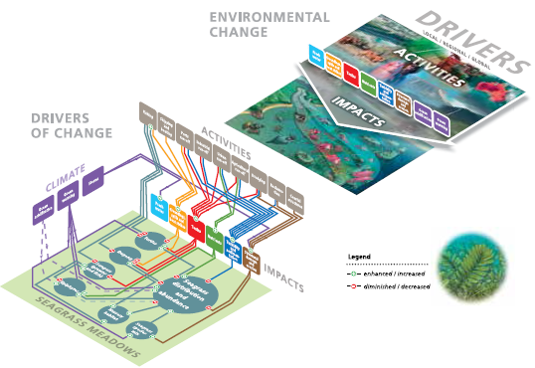
Semi-quantitative model to predict impacts and risks of specific activities and environmental conditions
Through the creation of qualitative information, which draws on the expertise of researchers and reef users, the AIMS team identified the key drivers and activities which could be linked to specific impacts on important attributes such as corals, seagrass and dugong. This allowed the development of semi-quantitative models that could drive specific scenarios of changed activities and environment that demonstrate changes in risk and impacts (see schema model on previous page). These models are critical to the development of informed, evidence-based management and policy options needed to ensure the achievement of long-term goals for the Great Barrier Reef World Heritage Area.

Sustainable coastal ecosystems and industries in tropical Australia

Contributing to the Reef Report Card—a key strategic output for water quality management
Water quality management remains essential to ensure long-term protection of coastal and inshore ecosystems of the Great Barrier Reef. AIMS supports the aim that by 2020 the quality of water entering from broad-scale land use will have no detrimental impact on the health and resilience of the Reef.
This is the aim of the Australian and Queensland governments' Reef Plan; first formulated in 2003, and revised and relaunched in 2013. The Reef Plan's land management initiatives will improve water quality entering the Reef by improving upstream practices. A key action of Reef Plan is the Paddock to Reef monitoring program—designed to evaluate the effectiveness of these land management changes and the progress towards Reef Plan goals and targets.
Through the Marine Monitoring Program, AIMS contributes to Paddock to Reef monitoring and to the annual Reef Report Card—a key mechanism for documenting progress and guiding future management actions. AIMS has been a major contributor to the monitoring program since 2005, providing long-term data series for assessment of inshore coral reef health and local reef water quality. This data, such as on coral health (next page) feeds into the annual Reef Report Card and accompanying synthesis and technical reports.
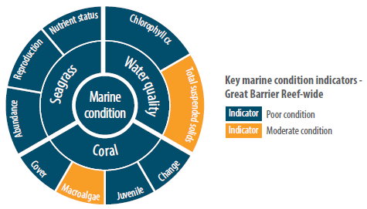
Overall condition of the Great Barrier Reef assessed against key indicators as reported in the Reef Report Card. http://www.reefplan.qld.gov.au/measuring-success/report-cards/2012-2013-report-card.aspx
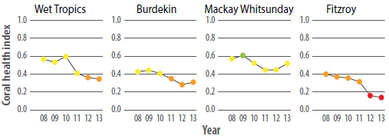
Change in coral reef health indicators since 2008, as reported in the Reef Report Card.
Legend: The coral health index aggregates the community attributes: cover of corals, cover of macroalgae, density ofjuvenile corals and the rate of coral cover increase. Red= very poor, orange= poor, yellow= moderate, light green= good, dark green= very good.
As part of the revision of Reef Plan 2013, a multidisciplinary group of scientists reviewed and analysed recent advances in understanding of water quality issues in the Reef to write the 2013 Scientific Consensus Statement. AIMS scientists were part of the lead authors' group and contributed to the extensive supporting evidence document. Many of the recent advances in the understanding of water quality impacts on coral reefs came from AIMS research and from the ecosystem condition reports delivered by the AIMS Monitoring Program.
The underlying data and detailed information from AIMS' comprehensive monitoring program have also been used for:
- a major risk assessment that informed new investment decisions for catchment management's in the Reef's Natural Resource Management (NRM) regions;
- the Great Barrier Reef Marine Park Authority's Great Barrier Reef Region Strategic Assessment (draft 2013) and Outlook Report (to be published in 2014);
- the Fitzroy Basin Report Card-Australia's first regional waterways assessment; and
- setting water quality objectives by regional natural resource management (NRM) groups, and developing draft water quality guidelines for the Capricorn-Curtis Coast.
AIMS' monitoring data showed that water and sediment quality around inshore reefs changed in response to the magnitude of river flows; these changed environmental conditions had clear impacts on the resilience of inshore coral reef communities. The robust baseline built up by monitoring over a number of dry and wet years lets the impact of improved catchment flow show up against a background of highly variable water quality and coral health.
As summarised in the 2013 Scientific Consensus Statement, evidence indicates that " a reduction in catchment pollutant loads is essential to halt and reverse further decline in the Great Barrier Reef ecosystem condition at a time of rapidly warming climate and ocean acidification". This finding was fundamental to continued government investment in Reef Plan.
AIMS' monitoring data and ecosystem understanding are important foundations for future research on the cumulative impacts of multiple pressures on our coastal ecosystems. The Great Barrier Reef Region Strategic Assessment identified this as a crucial knowledge gap and the management of these impacts as a key strategic challenge.

Contributing to ecologically sustainable port developments
A major infrastructure development in Darwin Port is set to position Darwin as an increasingly important gateway to the Asian region, anticipating northern port requirements for the next 20 years.
The East Arm Wharf development is the centrepiece in the Darwin Port Corporation's 2030 Master Plan. It will provide port facilities to support Australian export growth over the next 20 years and host the Darwin Marine Supply Base, which will, in turn, support Australia's north-western offshore oil and gas industry. It will also host an amphibious-craft landing area for use by Australian Defence Force and commercial operators.
The Plan (see insert this page) outlines development occurring in stages, each of which require an environmental impact statement (EIS). The marine environment adjacent to the infrastructure is of prime concern, particularly the extent to which it may be affected by water quality issues such as turbidity and metal contaminants.
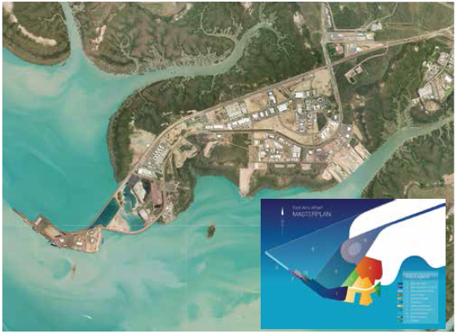
The East Arm Wharf, Darwin Harbour. Insert shows the development stages in the Master Plan for the site.
Image: NT Land Development Corporation.
AIMS has provided expert advice at every stage of development—not only to satisfy EIS requirements, but also to ensure optimal design. For example, Darwin Port Corporation relies on AIMS' hydrodynamic and sediment transport modelling to determine the extent of dredge plumes and likely areas for sediment erosion and deposition, and to design rock walls and vessel landing areas. AIMS continuously improved these models through specialist field observations, with a recent focus on understanding bed-sediment characteristics and distribution. A recent improvement has been the ability to confidently predict dredge intervals and determine sediment infill rates in significant areas of operation. Expert advice from AIMS was instrumental in the decision to discharge dredge spoil from preparation of the Supply Base site to land rather than into harbour waters.
AIMS has also played a key role in assessing environmental impacts of dredging operations. We used in situ probes to assess the potential availability to marine biota of trace metal contaminants draining back into Darwin Harbour from dredge spoil discharge ponds. This study was done in partnership with the dredging contractor for the Northern Territory government and Darwin Ports.
AIMS' scientists have also been called upon by the Technical Advisory Group for the Supply Base development to provide expert guidance in areas of estuarine hydrodynamics, sediment transport and aquatic chemistry. AIMS' probes were used during dredging operations to check that the concentration of biologically available contaminant metals did not exceed water quality regulations.
AIMS' research has led Darwin Ports to improvements in design and an ecologically sustainable approach to construction and future operation of the East Arm Wharf. Improved AIMS models of Darwin Harbour will be available for further development in this growing and increasingly strategic northern port.

Sustainable use of north-west marine ecosystems

Helping industry determine the impact of the Montara oil spill
To evaluate the effect on the marine environment of the late 2009 Montara oil spill off north-western Australia, AIMS conducted extensive surveys in 2010 of the reefs, banks and shoals in the vicinity of the Montara platform and at representative areas away from likely impact. Repeat surveys were conducted at selected sites in 2011 and 2013.
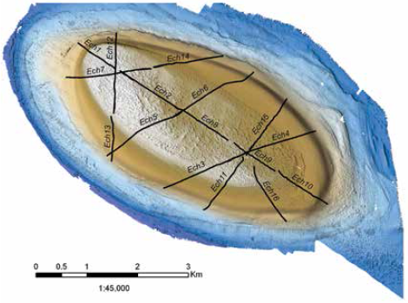
Recent surveys of oceanic shoals the vicinity of the Montara platform highlighted previously underestimated biodiversity of these submerged shoals (image shows data collected for habitat assessment of the shoals including multibeam hydoacoustic survey overlayed with towed video transects and bar plots show proportional cover of major habitats).
These surveys did not detect any major widespread impacts, but the study underlined the importance of having prior baseline information. This point was strongly emphasised by the post-spill Borthwick Inquiry.
The surveys also highlighted the previously underestimated biodiversity of submerged shoals, which host rich communities of coral, sea grass and calcareous algae along with associated reef fish. As a consequence of these studies, baseline shoal surveys were a major component of the agreed Applied Research Program which will support an operational and scientific monitoring program for Shell and INPEX (see below).

Working with the oil and gas industry to prepare for future incidents
AIMS works to maintain the health of Australia's marine environment while safeguarding the significant economic benefits derived from developing offshore oil and gas reserves. Such development carries a small risk that oil or gas condensate will be inadvertently released into the marine environment. Two recent oil spills—the 2009 Montara spill and the 2010 Macondo well blowout in the Gulf of Mexico—highlighted major gaps in our understanding of the environmental impacts of such incidents. In particular, they highlighted the need for data on baseline (pre-development) environmental conditions, to allow scientists to determine the impact of subsequent incidents.
"The Operational and Scientific Monitoring Program willhelp us further understand the marine environment in the Browse Basin and enables a pre-planned spill response and monitoring capability that we can call upon in the unlikely event of a significant spill."
Mike Seymour, Shell Australia's General Manager for Health, Safety, Environment and Social Performance
Since the Montara incident, AIMS has worked closely with the offshore oil and gas industry to improve baseline knowledge of our marine environment and identify key knowledge gaps that prevent detection of impacts and limit the effectiveness of monitoring of any subsequent recovery. In formal submissions and presentations to industry, AIMS has promoted taking a structured, risk-based approach to the prioritisation of new studies.
In early 2014, AIMS, Shell and INPEX announced a business partnership to develop comprehensive environmental baselines to monitor the health of waters in the Browse Basin off north-western Australia.
The Operational and Scientific Monitoring Program (OSMP) incorporates comprehensive plans for monitoring the marine environment in the unlikely event of a spill. AIMS is the lead post-spill contractor in the OSMP, in partnership with CSIRO, the University of Western Australia, Curtin University, ChemCentre and Monash University.
Australia is now in a better position than ever to respond to future incidents. We are identifying and collecting the most relevant baseline information and have a highly qualified team and response plan ready to assess the status and likely impacts of a future oil spill in the unlikely event that one should occur.

Delivery against stated goals
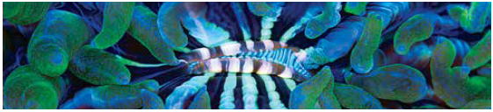
AIMS undertakes high quality research for the protection and sustainable use of Australia's marine territory, focusing on Australia's tropical marine and coastal systems.
Through engagement with stakeholders across government and industry, AIMS' objective is to continue to drive towards scientific excellence while ensuring that its multidisciplinary science capability, infrastructure and research investment remain focused on areas that are relevant and committed to national needs and aspirations.
In meeting its core objective, AIMS has various reporting obligations including:
- the Commonwealth Government Portfolio Budget Statements (PBS) 2013-14;
- corporate goals as outlined in the AIMS Research Plan 2011-15;
- the Australian Institute of Marine Science Act 1972 requirements;
- national and state-based research priority areas; and
- AIMS' commitment to performance review and continuous improvement.
These reporting obligations, and how AIMS has addressed these requirements, are outlined below. Subsequent sections give more detailed information on AIMS' performance in terms of:
- high quality high impact scientific publications;
- scientific leadership;
- research and stakeholder partnerships;
- stakeholder engagement;
- communication profile;
- research capability development; and
- facilities and resources.

Portfolio Budget Statement expectations
Each year the PBS provides Parliament with information on how AIMS will use its allocated resources to achieve government outcomes over the current budget and forward years.
The 2013-14 PBS describes AIMS as contributing to:
- Outcome 1: Growth of knowledge to support protection and sustainable development of Australia's marine resources through innovative marine science and technology.
AIMS' activities contribute to the achievement of Outcome 1 through:
- Program 1.1: Marine Research.
AIMS' focus in Program 1.1 is on the provision of research and services that enhance Australia's capacity to capture the benefits from its marine estate while ensuring protection of marine and coastal ecosystems through effective environmental management.
To deliver on this objective, AIMS' 2013-14 PBS outlined eight deliverables and seven key performance indicators. These are listed below, with a description of our achievements in each of the areas and a rating of how well we are tracking against each deliverable.
Marine program deliverables
Deliverable | Performance | Rating*
Describe patterns of biodiversity from multiple 'voyages of discovery' to some of the most remote and inadequately surveyed areas of the continental shelf off north-west Australia in conjunction with WAMSI and Geoscience Australia | We are currently analysing data from our biodiversity voyages, and developing a predictive spatial model of benthic communities in the Oceanic Shoals bioregion. Additional analysis and spatial modelling are being conducted in collaboration with Geoscience Australia.  AIMS undertook a further voyage to survey additional undocumented areas, including three shoals in the Margret Harries Banks area, Gale Bank, Van Cloon Shoal and adjacent shoals near the Joint Jurisdictional Area in the Timor Sea (see Marine operations p 61). | +++
With support from the oil and gas industry, continue surveys of key reefs and shoal habitats in NW Australia that are potentially vulnerable to industry activities | AIMS completed surveys of several banks and shoals in the vicinity of the Montara oil well as part of industry-funded work to characterise the benthic and fish communities following the 2009 oil spill (see Key Outcomes: Working with the oil and gas industry p 18). | +++
Sustain fundamental observations of tropical Australian marine systems as a partner in Australia's Integrated Marine Observing System (IMOS) | AIMS collected data associated with several IMOS programs, including: a network of oceanographic moorings across northern Australia; wireless sensor networks at several key locations on the Great Barrier Reef; benthic monitoring of corals in Western Australia and seagrass on the Great Barrier Reef; and movement patterns of sharks in both Western Australia and the Great Barrier Reef (see Research Vessel Solander assists ocean researchers p 49). | +++
Analyse long term data sets from the Great Barrier Reef (GBR) and develop predictive models of the cumulative impacts of global change, resource extraction and industrial development on the GBR | AIMS scientists published five journal articles that draw on the AIMS Long-term Monitoring Program (see Key outcomes: Contributing to the Reef Report Card p 14; Developing the Reef 2050 Plan p 11).  Together with other collaborators in the National Environmental Research Program (NERP) Tropical Environment hubs, AIMS published two major reports for the federal Department of the Environment: a framework for integrated monitoring of the Great Barrier Reef region that will enable management of the World Heritage Area to be based on the best available information; and a qualitative framework for understanding cumulative impacts on the outstanding universal values of the Great Barrier Reef World Heritage Area (see Key Outcomes: Aiding decision-making p 13). | +++
Maintain AIMS' monitoring of water quality of the GBR Lagoon and support for the decadal Queensland-Commonwealth Reef Plan, while increasing effort on the development of tools for examining the potential impacts of urban and industrial development along the coast, with particular emphasis on marine dredging activities | Long-term data collected by the AIMS Inshore Monitoring team show that the water and sediment quality around inshore reefs has declined after the major river floods of the past five years. These changed environmental conditions have led to a widespread decline in coral reef condition and demonstrates the sensitivity of inshore coral communities to the elevated loads of sediments, nutrients and pollutants introduced by run-off (see Developing the Reef 2050 Plan p 11).  AIMS has also contributed the refinement of modelling tools to better predict the movement of sediments, including dredge spoil in coastal regions (see Key outcomes: Contributing to ecologically sustainable port developments p 16). | +++
Provide new insight to the possible future states for coral reefs in a high CO₂ world through the study of natural CO₂ vents (cold gas seeps) in Papua New Guinea | AIMS published seven journal articles on this topic in prestigious scientific journals, including two in Nature Climate Change.  Our research shows the detrimental effects of increasing levels of CO₂ (known as ocean acidification) on the diversity and health of fish and invertebrates that inhabit our coral reefs. Our research on cold gas seeps in Papua New Guinea has led to new external collaborations with 26 scientists from 14 organisations across 8 countries (see Collaboration p 47; High impact articles p 29). | +++
Collaborate in the development of implementation plans for operational and scientific monitoring programs to be instigated in the event of any future incidents similar to the Montara oil spill | AIMS completed negotiations to form a consortium of research agencies and universities in Western Australia which will develop and implement a comprehensive Operational and Scientific Monitoring Program (OSMP) with Shell and INPEX. A significant program of baseline monitoring will commence in the next year.  Other companies operating in the area have expressed interest in developing similar implementation and baseline programs. AIMS also provided input into another OSMP being developed in the Ningaloo region (see Working with the oil and gas industry p 18). | +++
Commence operation of new infrastructure capacity provided by the AIMS Tropical Marine Research Facilities Project (funded under the Education Investment Fund) | The National Sea Simulator (SeaSim) was opened by the then federal Minister for Innovation, Industry, Science and Research, Seator the Hon Kim Carr, on 1 August 2013. The facility now actively supports experimental work on: the impacts of dredging on key marine species; the larval ecology of crown-of-thorns starfish; and the impacts of high CO₂ and high temperatures on corals (see Research facilities p 60). | +++
*Rating legend: +++ meeting all expected outcomes, ++ meeting most expected outcomes, + meeting some expected outcomes
Marine program key performance indicators
Key performance indicator | Performance | Rating*
Maintain or increase scientific output and quality as measured by the level of peer reviewed scientific journal papers | AIMS scientists published 186 peer-reviewed scientific journal articles in 2013 compared with 203 in 2012. Although slightly lower than the previous year's output, 2013 is the second most productive year of the last five (see Publications p 28). | ++
Maintain or increase the transfer of new knowledge to users of marine science as measured by the trend in all publication numbers (includes reports etc.) and stakeholder take-up of AIMS' practices, instruments and processes | AIMS produced 260 publications, including journal articles, books, book chapters, conference papers, technical reports, reports for clients, theses and others) in the 2013 calendar year (see Publications p 28).  The AIMS website is a major avenue by which our data is delivered to stakeholders and in 2013-14 data searches increased by 82 per cent, reef weather searches have increased by 11 per cent and demand for coral factsheets has increased by 44 per cent (see Data management and dissemination p 51) | +++
Key performance indicator | Performance | Rating*
Maintain or improve science excellence and impact as assessed through a rolling program of expert peer review | AIMS is currently part-way through its 2011-15 Research Plan. The last review was in 2010 in preparation for the development of the current research plan. AIMS continues to track its research performance against a range of indicators but a formal expert peer review was not scheduled for this financial year. The next scheduled peer review will take place as part of the process in developing the next research plan (see AIMS Research Plan 2011-15 p 24). | +++
Collaborate to increase critical mass and research capabilities as measured by the number of collaborative research papers | AIMS scientists collaborated in 168 research projects. The resulting research articles accounted for 91 per cent of the scientific articles published by AIMS in 2013, a slight increase from 89 per cent in 2012 (see Collaboration p 47). | +++
Partner to increase research capacity and impact as measured by the number of joint ventures and strategic alliances | AIMS maintained, and in some cases expanded, its major joint ventures and strategic alliances, including the Arafura Timor Research Facility, the North Australia Marine Research Alliance, the Reef Rescue Marine Monitoring Program, the National Environmental Research Program (NERP) Tropical Ecosystems Hub, Integrated Marine Observing System (IMOS), the Western Australian Marine Science Institution (WAMSI), and the Indian Ocean Marine Research Centre (IOMRC) (see Partnerships p 38).  AIMS strengthened its links to the recently renewed the Australian Research Council (ARC) Centre of Excellence for Coral Reef Studies (Coral CoE), and was a partner in the successful bid for a new ARC Centre of Excellence for Mathematical and Statistical Frontiers of Big Data, Big Models, New Insights (see Partnerships p 38). | +++
Enhance Australia's future capabilities in marine science by AIMS' contribution to training as measured by the number of jointly supervised postgraduate students | AIMS scientists supervised 77 postgraduate students in 2013-14, an increase on the 68 students supervised in 2012-13. This reporting period saw a slight increase in the number of completions: 30 PhD students completed their theses, up from 29 in 2012-13 (see Fostering research capability p 44). | +++
Enhance Australia's marine research capabilities by effective delivery of new infrastructure capacity provided by the Tropical Marine Research Facilities Project (funded under the Education Investment Fund) | The AIMS Tropical Marine Research Facilities Project has funded the National Sea Simulator (SeaSim) and new facilities to house AIMS' Tropical Marine Collections at AIMS Townsville and a new research aquarium building and other research facilities at the Arafura Timor Research Facility. All of these are now fully commissioned. New berthing facilities for AIMS' research vessels have also recently been commissioned in Townsville (see Research facilities p 60). | +++
*Rating legend: +++ meeting all expected outcomes, ++ meeting most expected outcomes, + meeting some expected outcomes

AIMS Research Plan 2011-15
The AIMS Research Plan 2011-15 was guided by an external international science panel, which reviewed the previous research plan (2007-11), and consideration of the research priorities identified by key end users.
AIMS has four research programs which reflect the needs of our key stakeholders over this quadrennium:
- A healthy and resilient Great Barrier Reef
- Sustainable coastal ecosystems and industries in tropical Australia
- Sustainable use of north-west marine ecosystems
- Data and technology innovations.
Highlights of research undertaken within the 2013-14 financial year, against the four research programs, include:

A healthy and resilient Great Barrier Reef
- developing the Reef 2050 Plan—a long term sustainability plan for the Great Barrier Reef World Heritage Area (see Key outcomes p 11)
- aiding decision-making on future scenarios for the Great Barrier Reef (see Key outcomes p 13)
- using coral sea surface temperature records to reconstruct variation in climate and currents since 1795 (see High impact articles p 30)
- discovering that fish become bolder in acidic waters making them vulnerable to predation (see High impact articles p 31)
- rethinking the 'neutral theory of biodiversity' and the role of common species in reef ecosystems (see High impact articles p 3129)

Sustainable coastal ecosystems and industries in tropical Australia
- contributing to the Reef Report Card—a key strategic output for water quality management (see Key outcomes p 14)
- contributing to ecologically sustainable port developments (see Key outcomes p 16)
- finding that ocean acidification will tend to favour boulder-like corals over branched corals, and thereby reduce habitat for crabs, shrimps, sea stars and other invertebrates (see High impact articles p 29)
- showing that large river floods affect reef water quality for many months over a wide area according to analysis of a decade of satellite images (see High impact articles p 33)

Sustainable use of north-western marine ecosystems
- helping industry determine the impact of the Montara oil spill (see Key outcomes p 18)
- working with the oil and gas industry to prepare for future incidents (see Key outcomes p 18)
- showing that healthy shark populations may aid coral reef recovery (see High impact articles p 33)
- gaining a new understanding of how corals may influence cloud formation and protect themselves from heat stress (see High impact articles p 33)
- publishing Discovering Scott Reef—an account of the two-decade research effort at this isolated reef system off Australia's north-western coast (see Other significant publications p 34)

Data and technology innovations
- enhancing ocean observing capacity in northern Australia as the major operator of Integrated Marine Observing System (IMOS) infrastructure collecting ocean observations across northern Australia from the Ningaloo Marine Park in Western Australia to the bottom of the Great Barrier Reef in Queensland (see Data management and dissemination p 51)
- maintaining data for the Reef Rescue Marine Monitoring Program, an initiative within the Reef Water Quality Protection Plan (see Partnerships p 38)
- studying environmental, social and economic datasets relevant to Gladstone Harbour, and assessing the coverage and potential suitability of these sources for developing an annual report card on the condition of the harbour (see Reports p 34).
During 2013-14 AIMS commenced a comprehensive review of its research strategy and research plan. This review will be completed in 2014-15 and reported against in the next annual report.
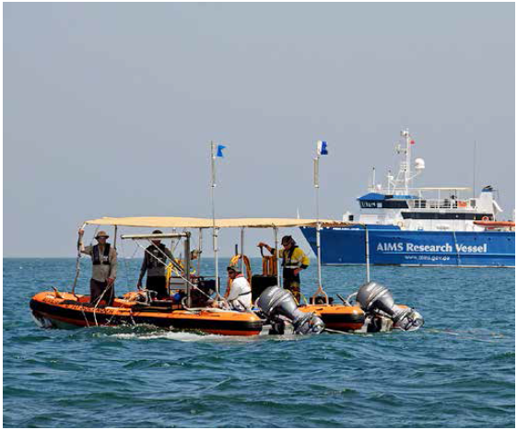
AIMS technical capabilities support a diverse research program aimed at ensuring protection and sustainability of Australia's tropical marine resources. Image: AIMS
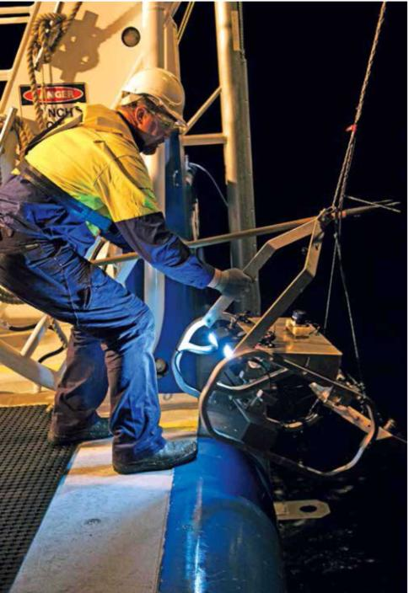
Towed video systems allow AIMS researchers to survey expansive tracts of seafloor quickly and accurately. Image: S. Clarke AIMS

Research
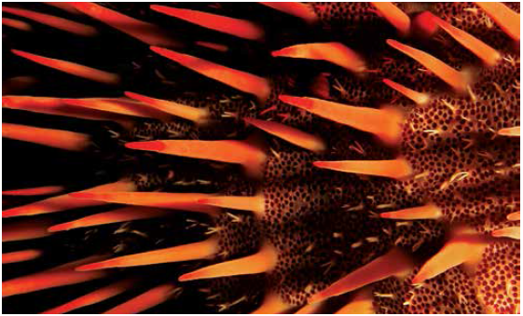

Publications
AIMS has a strong publication record within its fields of expertise, namely climate change, biodiversity, water quality and marine microbiology, which aligns closely with the needs of our major stakeholders and end users.
AIMS scientists produced 260 publications in the 2013 calendar year, including high profile articles in some of the world's most prestigious multidisciplinary journals. The publications comprised:
- 186 journal articles
- 7 other articles
- 7 books and book chapters
- 37 reports
- 4 conference papers
- 20 theses
The full publication list is in Appendix 1.
The average (Thomson ISI) impact factor for all the journal articles was 3.8. Of these, 39 (23 per cent) were in journals with impact factors greater than four.
Number of AIMS publications by year
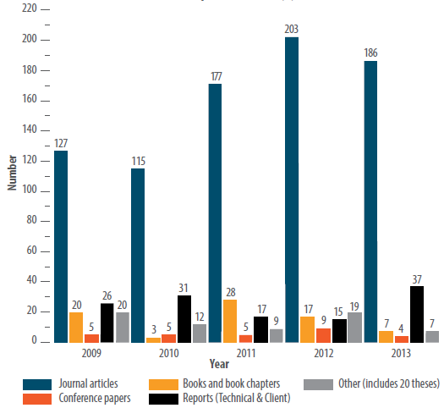

High impact articles
The following studies, arising under the AIMS Research Plan (see p 24), are among those that contributed significantly to the scientific literature during the 2013-14 financial year (authors from AIMS are shown in bold).

A healthy and resilient Great Barrier Reef

Diverse herbivorous fish populations are important for reef resilience
Many ecosystems face degradation unless factors that undermine their resilience can be effectively managed. In tropical reef ecosystems, grazing by herbivorous fishes can prevent coral-macroalgal phase shifts that commonly signal loss of resilience. We explored the idea that resilience is positively related to the diversity within and among functional groups of organisms. Our data suggested that managing the threat of phase shifts in coral reef ecosystems successfully will require strategies that consider local herbivore communities as well as environmental factors. A strong positive correlation between water clarity and herbivorous abundance and diversity underscored the importance of water quality in structuring communities and shaping system resilience.
Cheal AJ, Emslie MJ, MacNeil MA, Miller IR, Sweatman HPA (2013) Spatial variation in the functional characteristics of herbivorous fish communities and the resilience of coral reefs. Ecological Applications 23: 174-188

Coral transported to warmer or cooler waters fails to acclimatise
Knowledge of the degree to which corals undergo physiological acclimatisation or genetic adaptation in response to changes in their thermal environment is crucial to the success of coral reef conservation strategies. The potential of corals to acclimatise to temperatures exceeding historical thermal regimes was investigated by reciprocal transplantation of Acropora millepora colonies between the warm (central) and cool (southern) regions of the Great Barrier Reef for 14 months. Colony fragments retained at native sites remained healthy, whereas transplanted fragments, although healthy over initial months when temperatures remained within native thermal regimes, subsequently bleached and suffered mortality during seasonal temperature extremes. Corals transplanted to the cooler, southern Great Barrier Reef grew 74-80 per cent slower than corals at their native site, and only 50 per cent of surviving colonies reproduced, at least partially because of cold water bleaching of transplants. Despite the absence of any visual signs of stress, corals transplanted to the warmer, central Great Barrier Reef grew 52-59 per cent more slowly than corals at their native site before the summer bleaching (that is, from autumn to spring).
Howells EJ, Berkelmans R van Oppen MJH, Willis BL, Bay LK (2013) Historical thermal regimes define limits to coral acclimatization. Ecology 94(5): 1078-1088

Priorities for conservation planning for high acid coral reefs
Ocean acidification is a direct consequence of increasing atmospheric carbon dioxide concentrations and is expected to compromise the structure and function of coral reefs within this century. To date, few ocean acidification studies have been designed to address conservation planning and management priorities. We discussed how existing marine protected area design principles developed to address coral bleaching may be modified to address ocean acidification. We also identified five research priorities needed to incorporate ocean acidification into conservation planning and management: (1) establishing an ocean carbon chemistry baseline, (2) establishing ecological baselines, (3) determining species/habitat/community sensitivity to ocean acidification, (4) projecting changes in seawater carbonate chemistry, and (5) identifying potentially synergistic effects of multiple stressors.
McLeod E, Anthony KRN, Andersson a, Beeden R, Golbuu Y, Kleypas JA, Kroeker K, Manzello P Salm RV, Schuttenberg HZ, Smith J (2013) Preparing to manage coral reefs for ocean acidification: lessons from coral bleaching. Frontiers in Ecology and the Environment 11: 20-27

Coral sea surface temperature records to reconstruct variation in climate and currents
AIMS scientists and colleagues analysed annual growth bands in coral cores to understand how the unique coral reefs of Western Australia are affected by changing ocean currents and water temperatures. The findings give new insights into how La Nina, a climate swing in the tropical Pacific, affects the Leeuwin current and how changing winds and ocean currents in the eastern Indian Ocean are driven by climate variability in the western tropical Pacific Ocean.
The international team found that in addition to warming sea surface temperatures, sea level variability and Leeuwin current strength have increased since 1980. The coral cores also reveal that the strong winds and extreme weather of 2011 off Western Australia are highly unusual in the context of the past 215 years. The authors conclude that this is clear evidence that global warming and sea level rise is increasing the severity of these extreme events which impact the highly diverse coral reefs off Western Australia, including the Ningaloo Reef World Heritage site.
Zinke J, Rountrey a, Feng M, Xie S-P, Dissard D, Rankenburg K, Lough JM, McCulloch MT (2014) Corals record long-term Leeuwin current variability including Ningaloo Nino/Nina since 1795. Nature Communications 5: Article 3607

Fish become bolder and vulnerable to predation in acidic waters
Continuous exposure to increased levels of carbon dioxide dramatically alters the way fish respond to predators, making them more vulnerable. Juvenile reef fishes from around natural CO₂ seeps in Papua New Guinea were bolder than fish from control reefs in less acidic waters; they were attracted to the odour of predators and did not distinguish between odours of different habitats. Fish communities around seeps differed little from communities at control reefs, but this may be because juveniles are currently recruited from outside the seeps, and because the seeps support fewer predators. The study found that fish cannot adjust to rising carbon dioxide levels over time, causing concern for their ability to adapt as more CO₂ dissolves in the oceans over the next few decades. This could be a serious problem for fish communities in the future when ocean acidification becomes widespread as a result of continued uptake of anthropogenic CO₂ emissions.
Munday PL, Cheal AJ, Dixson DL, Rummer JL, Fabricius KE (2014) Behavioural impairment in reef fishes caused by ocean acidification at CO₂ seeps. Nature Climate Change 4, 487-492

Rethinking the 'Neutral Theory of Biodiversity'— Abundance as important as rarity for biodiversity
AIMS researchers and their collaborators overturned a long-held theory used to explain diversity and the relative abundances of species within ecosystems. The neutral theory posits that species become common or rare as a consequence of random processes—chance variation in who a predator happens to eat, or whose dispersing offspring happen to land on a vacant area of the seafloor. But this study showed that these random processes are not strong enough to explain the large differences between common and rare species. Rather, the really abundant species of plants and animals had traits that made them the most important to healthy ecosystems—they often offered important ecosystem services, such as providing habitats for fishes, or keeping reefs clear of seaweed.
The new understanding has critical implications for how marine conservation areas are managed. For example, it no longer makes sense to treat species as swappable, as under the neutral theory which says that if you lose a really abundant species, then another can simply increase in abundance to take its place. Biodiversity theory and conservation managers need to be alert to the important traits of common species, because it is often the those species, not the rare ones, who are most important to healthy ecosystems.
Connolly SR, MacNeil MA, Caley MJ, Knowlton N, Cripps E, Hisano M, Thibaut LM, Bhattacharya BD, Benedetti-Cecchi L, Brainard RE, Brandt a, Bulleri F, Ellingsen KE, Kaiser S, Krbncke I, Linse K, Maggi E, O'Hara TD, Plaisance L, Poore GCB, Sarkar SK, Satpathy KK, Schuckel U, Williams a, Wilson RS (2014) Commonness and rarity in the marine biosphere. Proceedings of the National Academy of Sciences 111(23): 8524-8529

Wide variation in estimates of global species richness
Knowing how many species share the planet with us is an important yardstick of how well we understand our natural world and how well we are likely to be able to remediate environmental impacts, no matter what the cause. If we don't have a good estimate of species richness on Earth, we do not have an adequate baseline against which to measure future species losses or the effectiveness of management actions undertaken to prevent further losses. In this paper, the researchers show that after more than six decades, estimates of global species richness have failed to converge, remain highly uncertain, and in many cases, are logically inconsistent. As one example, some estimates of all marine species are less than other estimates for coral reefs alone. Clearly some of these estimates must be wrong.
One of the main difficulties in achieving consensus estimates of global species richness is that such estimation relies on extrapolation beyond the data we have, and consequently, there is no opportunity to verify them. An alternative analytical approach suggested by these authors is to adopt adaptive learning methods, whereby the estimation of uncertainty is prioritised and used to guide future research. Adopting such an approach could help accelerate convergence in these estimates.
Caley MJ, Fisher R, Mengersen K (2014) Global species richness estimates have not converged. Trends in Ecology and Evolution 29(4): 187-188

Sustainable coastal ecosystems and industries in tropical Australia

Declining diversity around natural carbon dioxide seeps are a warning of future depletion
Increased CO₂ in the atmosphere causes ocean acidification, whereby pH is lower and carbonate availability declines. Natural CO₂ seeps in Papua New Guinea served as 'windows into the future'in this study of the ability of marine invertebrates to acclimatise to ocean acidification. Benthic foraminifera, simple amoeba-like organisms with carbonate shells, showed declines in both population densities and species diversity with increasing acidity. Foraminifera were almost absent at sites with pH < 7.9 (>700 uatm pCO₂). Foram species symbiotically associated with photosynthetic algae where also vulnerable to extinction at <7.9 pH. Non-calcifying taxa declined less steeply along pCO₂ gradients, but were also absent in samples at pH < 7.9. Data suggest the possibility of an ocean acidification-induced ecological extinction of shallow tropical benthic foraminifera by 2100; similar to extinctions observed in the geological past.
Uthicke S, Momigliano P, Fabricius KE (2013) High risk of extinction of benthic foraminifera in this century due to ocean acidification. Scientific Reports 3: Article number 1769.

Ocean acidification reduces establishment of new corals
Experiments showed that ocean acidification (to the levels predicted for the end of this century) will affect the microbial community living on the surface of crustose coralline algae, which are a critical component of coral reefs. Significantly, the altered microbial community decreased the likelihood of coral larvae settling and metamorphosing into the adult forms that create the reef.
Webster NS, Uthicke S, Botte E, Flores F, Negri AP (2013). Ocean acidification reduces induction of coral settlement by crustose coralline algae. Global Change Biology 19: 303-315.

Ocean acidification favour boulder-like corals, reducing habitat for macroinvertebrates
A survey of bottom-dwelling macroinvertebrates around natural CO₂ seeps found reduced population density and diversity of taxa (at the class and phylum level) in areas of long-term exposure to CO₂ compared with reefs with present day CO₂. Some of this decrease is attributable to physiological sensitivity to the elevated acidity, but decreases were also seen in crustaceans and some other groups that can tolerate such conditions in laboratory studies.
An indirect cause of their decline was identified in the study: the acidic conditions reduced the growth of structurally complex corals in favour of corals with a simpler boulder-like form. This loss of habitat complexity was associated with losses in many macroinvertebrate groups, especially those prone to predation who rely on concealment in nooks and crevices to escape. Coral death and subsequent loss of living coral cover further exacerbated the decline in macroinvertebrate communities.
Fabricius KE, De'ath G, Noonan S, Uthicke S (2014) Ecological effects of ocean acidification and habitat complexity on reef-associated macroinvertebrate communities. Proceedings of the Royal Society B Biological Sciences 281: 1775

Large river floods affect Reef water quality for many months
Long-term water quality records reinforce the need for improved land management practices in order to prevent unnecessary sediment run-off that is affecting the health of the Great Barrier Reef. Using a variety of new and improved techniques to analyse 10 years of satellite data of the water clarity in the reef waters off the Burdekin coast, AIMS researchers showed that large river flood events have a large impact on water quality. After large floods, turbid water reaches very far off the coast and the water remains turbid for several months after the floods have subsided. High levels of turbidity in the water can harm the growth of the photosynthetic algae that live in corals and provide them with energy, and sea grasses, which are important food for mammals and fish.
Fabricius KE, Logan M, Weeks S, Brodie J (2014) The effects of river run-off on water clarity across the central Great Barrier Reef. Marine Pollution Bulletin 84 (1-2): 191-200

Sustainable use of north-western marine ecosystems

Corals play an unexpected role in cloud formation
Globally, reef-building corals are the most prolific producers of dimethylsulphoniopropionate (DMSP), a central molecule in the marine sulphur cycle and precursor of climate-active gas associated with cloud formation. Our results overturned the paradigm that photosynthetic organisms are the sole biological source of DMSP, and correspondingly highlighted the double jeopardy represented by worldwide declining coral cover, as the potential to alleviate thermal stress through coral-produced DMSP declines.
Raina JB, Tapiolas DM, Foret S, Lutz AH, Abrego D, Ceh J, Seneca FO, Clode PL, Bourne DG, Willis BL, Motti CA (2013) DMSP biosynthesis by an animal and its role in coral thermal stress response. Nature 502: 677-680

Isolated coral reefs show impressive recovery after disturbance
Coral reef recovery from major disturbance is hypothesised to depend on the arrival of propagules (such as planktonic larvae) from nearby undisturbed reefs. Therefore, reefs isolated by distance or current patterns are thought to be highly vulnerable to catastrophic disturbance. We found that on an isolated reef system in north-western Australia, coral cover increased from 9 per cent to 44 per cent within 12 years of a coral bleaching event, despite a 94 per cent reduction in larval supply for six years after the bleaching. The initial increase in coral cover was the result of high rates of growth and survival of remnant colonies, and this was followed by a rapid increase in juvenile recruitment as colonies matured. We showed that isolated reefs can recover from major disturbance, and that the benefits of their isolation from chronic anthropogenic pressures can outweigh the costs of limited connectivity.
Gilmour JP, Smith LD, Heyward AJ, Baird AH, Pratchett MS (2013) Recovery of an isolated coral reef system following severe disturbance. Science 340(6128): 69-71

Healthy shark populations may aid coral reef recovery
Healthy shark populations may aid the recovery of coral reefs whose futures are threatened throughout the globe. Long-term monitoring of reefs off Australia's northwest coast showed that where shark numbers were lower due to fishing, herbivores—important fishes in promoting reef health—were also significantly lower in number.
Where shark numbers were reduced the data showed a fundamental change in the structure of food chains on reefs, with increasing numbers of mid-level predators, such as snappers, and a reduction in the numbers of herbivores, such as parrotfishes. The parrotfishes are very important because they eat the algae that would otherwise overwhelm young corals on reefs recovering from natural disturbances.
Ruppert JLW, Travers MJ, Smith LD, Fortin M-J, Meekan MG (2013) Caught in the middle: Combined impacts of shark removal and coral loss on the fish communities of coral reefs. PLoS ONE 8(9): e74648

Other significant publications
Discovering Scott Reef
AIMS researchers, in collaboration with scientists from other organisations, developed and produced the high quality book Discovering Scott Reef, which presents an account of the two-decade research effort at this isolated reef system off Australia's north-western coast. The richly illustrated publication shares a new understanding of this remote and beautiful part of Australia.
Gilmour J, Smith L, Cook K, Pincock S (2013) Discovering Scott Reef: 20 years of exploration and research. Woodside, Australian Institute of Marine Science, 179 pp. http://www.aims.gov.au/publications/discovering-scott-reef.
Australia 2025: Smart Science
John Gunn (AIMS CEO) was invited by Australian Chief Scientist Ian Chubb to contribute to a series of articles published under the title Australia 2025: Smart Science, in which senior figures described how their discipline or area will contribute to the future of Australia. His article 'Marine Science: challenges for a growing "blue economy"' was published in The Conversation in May 2014.

Reports
AIMS published many reports for a range of clients on topics of significance to effective management and sustainable development of our marine resources, including:
- a highly influential report on how to include estimates of resilience and cumulative impact in managing and monitoring the Great Barrier Reef World Heritage Area (GBRWHA) featured prominently in the recent Strategic Assessment for the Great Barrier Reef (see Key outcomes: Developing the Reef 2050 Plan p 11).
Anthony KRN, Dambacher JM, et al. (2013) a framework for understanding cumulative impacts, supporting environmental decisionmaking, and informing resilience-based management of the Great Barrier Reef World Heritage. Final report to GBRMPA and the Department of the Environment. Townsville/Canberra.
- a report providing a crucial knowledge baseline from which ongoing research and management plans for the Gladstone Harbour region are being developed
Llewellyn LE, McIntosh E, Wakeford M (2013) Mapping and synthesis of data and monitoring in Gladstone Harbour. Gladstone Healthy Harbour Partnership, 179 pp.
- two reports explaining the relationships between river run-off, phytoplankton blooms and primary outbreaks of crown-of-thorns starfish
Brodie J, Waterhouse J, Maynard J, Bennett J, Furnas M, Devlin M, Lewis S, Collier CJ, Schaffelke B, Fabricius K, Petus C, Teixeira da
Silva E, Zeh D, Randall L, Brando VE, McKenzie L, O'Brien D, Smith R, Warne M, Brinkman R, Tonin H, Bainbridge S, Barley R, Negri A, Turner R, Davis AM, Bentley C, Mueller JF, Alvarez-Romero JG, Henry N, Waters D, Yorkston H, Tracey D (2013) Assessment of the relative risk of water quality to ecosystems of the Great Barrier Reef. TropWATER Report 13/28, Townsville Australia. 136 pp.
Furnas M, Brinkman R, Fabricius K, Tonin H, Schaffelke B (2013) Chapter 1: Linkages between river runoff, phytoplankton blooms and primary outbreaks of crown-of-thorns starfish in the northern GBR. In: Assessment of the relative risk of water quality to ecosystems of the Great Barrier Reef: Supporting Studies. a report to the Department of the Environment and Heritage Protection, Queensland Government, Brisbane. TropWATER Report 13/30, Townsville, Australia.

Leadership
AIMS plays a number of important science leadership roles, including setting research agendas through strategic research workshops on key issues, giving keynote talks at international symposiums, and contributing to issues of national importance through input to government committees and policy projects. Here we outline key leadership examples.

Contributing to issues of national importance
World Heritage Committee concerns over the Great Barrier Reef World Heritage Area
In response to the possible listing of the Great Barrier Reef World Heritage Area as 'World Heritage in danger', the Commonwealth and Queensland governments, together with the Great Barrier Reef Marine Park Authority, conducted a comprehensive strategic assessment of the reef and coastal zones, for which AIMS provided key inputs. Building on the assessments, a Reef 2050 Plan is being developed to guide the sustainability and management of the Great Barrier Reef and inform its future development and protection from 2015 to 2050 (see Key outcomes: Developing the Reef 2050 Plan p 11).
Our role as a trusted independent adviser to government, and the importance of our inputs into the assessment reports, are underlined by our appointment to the Great Barrier Reef 2050 Long-term Sustainability Plan Partnership Group and our advisory role in the development of an investment plan for the Reef Trust, an important funding source for Reef 2050 initiatives.
Ocean Policy Science Advisory Group
John Gunn is Chair of the Oceans Policy Science Advisory Group (OPSAG). The Advisory Group promotes coordination and information sharing between Commonwealth Government marine science agencies and the broader Australian marine science community. OPSAG functions as an informal and voluntary body to inform and coordinate institutional responses to national research matters in the marine domain.
OPSAG includes representatives of:
- relevant Commonwealth Government publicly funded research agencies—CSIRO and AIMS;
- Commonwealth Government departments of Environment, Education, Defence, Industry, and Agriculture;
- departmental research agencies—such as the Australian Antarctic Division, Australian Bureau of Agricultural; and Resource Economics and Sciences, Defence Science and Technology Organisation, GeoScience Australia; and the Bureau of Meteorology;
- research funding organisations—such as the Fisheries Research and Development Corporation;
- universities—such as the Sydney Institute of Marine Science;
- regulatory agencies—such as the Australian Fisheries Management Authority, the Australian Marine Safety; Authority, and the Great Barrier Reef Marine Park Authority; and
- marine science community peak bodies—such as the Australian Marine Sciences Association.
Dredge synthesis project
AIMS and the Great Barrier Reef Marine Park Authority have come together to examine current knowledge on the effects of dredging and spoil disposal on the Great Barrier Reef region. They will produce an in-depth review of the biophysical effects of dredging and disposal to develop statements of what is known, what (if anything) is considered scientifically contentious and what knowledge gaps hamper our current understanding of the impacts of dredging in the Great Barrier Reef World Heritage Area.
In 2013-14 financial year the partners sought input from interested groups, including traditional owners, scientists, technical experts, representatives from ports, members of the fishing and tourism industries, and conservation groups. They also held an expert panel workshop in Townsville on 12-14 May 2014.

International engagement

Ninth World Sponge Conference 'New Frontiers in Sponge Science, Fremantle, Western Australia, 4-8 November 2013
Nicole Webster, Christine Schonberg and Libby Evans-Illidge helped organise this AIMS-sponsored international conference, which was held in Fremantle, in November 2013. This international conference saw 204 scientists, managers and industry representatives gather to discuss disciplines spanning ecology, evolution, microbiology, marine natural products chemistry, taxonomy, genetics and molecular biology.

First Technical Expert Workshop for the Global Ocean Observing System (GOOS) Biology and Ecosystem, and Biogeochemistry Panels, Townsville, 13-15 November 2013
AIMS hosted a technical expert workshop to guide the establishment of two new panels of the Global Ocean Observing System (GOOS). GOOS is a permanent global system for observations, modelling and analysis of marine and ocean variables sponsored by the Intergovernmental Oceanographic Commission, the United Nations Environment Program, the World Meteorological Organization and the International Council for Science.
Australia has received support to host the secretariat for the Biology and Ecosystems Panel, which is chaired by former AIMS CEO, Ian Poiner. Current CEO, John Gunn, is a member of the panel's interim advisory committee, and also co-chair of the GOOS steering committee.
The new panels will guide the expansion of observations from the original focus on physics and climate to encompass key biological, ecosystem and biogeochemistry variables. This enhanced information base will contribute critical information to policy development and management decisions on ocean and coastal resource sustainability and health.
Participants from 13 countries (Australia, USA, Canada, Germany, Japan, China, Norway, Poland, Italy, Portugal, Belgium, Switzerland and France) attended the workshop.

Invited presentations
AIMS scientists gave a number of invited presentations at international conferences, including the following:
- Michelle Heupel gave the plenary presentation 'Trials and triumphs of tracking in coastal systems' at the 2nd International Conference on Fish Telemetry, Grahamstown, South Africa, 14-19 July 2013.
- Richard Brinkman gave a keynote talk 'Coastal oceanography: critical knowledge for sustainable development' at the 4th Queensland Coastal Conference, Castles in the Sand, 2-4 October, 2013.
- Libby Evans-Illidge gave a keynote presentation 'The Nagoya Protocol - a new legal binding international regime for access to biodiversity and benefit sharing'at the International Marine Biotechnology Conference, Brisbane, 11-15 November 2013.
- Janice Lough gave the invited Plenary 'Similar but different: corals are not treesl'at the 9th International Conference on Dendrochronology, Melbourne Convention Centre, Melbourne, 13-17 Jan 2014.
- Nicole Webster gave the plenary presentation'How is sponge symbiosis impacted by a changing environment' at the 3rd Annual Symbiomics Meeting held at the Universitat de Valencia, Spain, 19-20 Feb 2014.
- John Gunn visited and gave presentations to a number of marine science institutes in India, April, 2014, in a trip that was sponsored by Australian Academy of Science.

Expert advice
AIMS scientists contribute to the broad-scale planning, coordination and delivery of marine science as members of numerous national and international forums (see Appendix 2). Key contributors include:
- AIMS CEO John Gunn was invited by the Hon Greg Hunt MP, Federal Minister for the Environment, and the Hon Andrew Powell MP, State Minister for Environment and Heritage Protection, to join the Reef 2050 Long-Term Sustainability Plan Partnership Group. John Gunn was also invited to participate in the Queensland Plan Brisbane Summit in Brisbane, October 2013.
- Michelle Heupel is a member of the Commonwealth Threatened Species Scientific Committee, and is also Vice -Chair for Strategy, International Union for Conservation of Nature (IUCN) Shark Specialist Group.
- Jamie Oliver serves on the International Advisory Committee for the Coral Triangle Initiative Regional Marine Protected Areas Technical Working Group.
- Katharina Fabricius is a member of the Biophysical Technical Advisory Group of the Great Barrier Reef Foundation.
- Peter Doherty is a member of Marine National Facility Scientific Advisory Committee.
- Britta Schaffelke is on the Darwin Harbour Integrated Monitoring and Research Program Committee and the Fitzroy Partnership for River Health Science Panel.
AIMS scientists also provide expert advice to various state, Commonwealth and international standing committees and working groups, including to:
- Australia's draft model for implementing the Nagoya Protocol in Australia
- the Senate Inquiry into Management of the Great Barrier Reef
- the Great Barrier Reef Marine Park Authority (GBRMPA) Outlook 2014 Consensus Workshop, October 14-16, 2013, to assess/review biodiversity and ecosystem health assessment component draft scores and summary statements for Outlook Report 2014
- GBRMPA's draft science information needs to for an integrated research, monitoring and reporting program for the Great Barrier Reef 2014-2019
- an independent review of the Great Barrier Reef Strategic Assessment, December, 2013
- the terms of reference for the Strategic Assessment of the Environmental Management Authorisation Process for Petroleum and Greenhouse Gas Storage Activities, under the Environment Protection and Biodiversity Conservation Act 1999
- the Offshore Streamlining Taskforce on the Streamlining Offshore Petroleum Environmental Approvals Strategic Assessment and Program Report and the Offshore Petroleum and Greenhouse Gas Storage (Environment) Amendment—Exposure Draft (04/12/2013) and Explanatory Document
- the Senate Inquiry into Environmental Offsets
- the joint Select Committee on northern Australia
- Queensland Department of Science, Information Technology, Innovation and the Arts' review of the draft aquatic ecosystem water quality guidelines for the Capricorn Curtis Coast
- the Queensland Ports Strategy for the Queensland Department of State Development, Infrastructure and Planning.

Conference sponsorship
AIMS supported Australian marine science conferences with financial sponsorship to the Australian Coral Reef Symposium and Australian Marine Science Association Conference. AIMS was a major contributor to the Ninth World Sponge Conference.

Partnerships
AIMS has created or participated in an array of joint ventures, strategic alliances and significant collaborations that maximise the Institute's capacity to deliver high quality science. These arrangements increase the critical mass and diversify the skill base that can be applied to answer complex questions about the sustainable use and protection of marine resources. In 2013-14, the majority of AIMS' scientific tasks received external co-investment involving stakeholders and partners who have actively participated in the research design, implementation and knowledge dissemination.
AIMS is a member of the following partnerships:
- The Arafura Timor Research Facility
- The North Australia Marine Research Alliance
- The ARC Centre of Excellence for Coral Reef Studies
- The Reef Rescue Marine Monitoring Program
- The National Environmental Research Program Tropical Ecosystems Hub
- The Integrated Marine Observing System
- The Western Australian Marine Science Institution
- AIMS@JCU
- The ARC Centre of Excellence for Mathematical and Statistical Frontiers of Big Data, Big Models, New Insights
A brief synopsis of each of these partnerships is detailed below.
The Arafura Timor Research Facility (ATRF) was initiated in 2006 as a joint venture between AIMS and the Australian National University (ANU) with a mission to support marine science across northern Australia and other countries bordering the Arafura and Timor Seas (Indonesia, New Guinea, and Timor). With construction funding as a Major National Research Facility provided by the Commonwealth Government, ATRF consists of an office and laboratory complex located in Darwin, adjacent to the campus of Charles Darwin University (CDU). A $5 million upgrade during 2011-12 under the Commonwealth Government's Super Science (Marine and Climate) Initiative added a seawater research aquarium, modern meeting facilities, workshop facilities to support oceanographic research and additional offices to house, among others, postdoctoral fellows and PhD students under the North Australia Marine Research Alliance.
In 2013-14, the ATRF has continued to support a wide variety of marine research across northern Australia. The oceanographic, environmental chemistry and microbiological/ecological studies projects have ranged in location from close by in Darwin Harbour, supporting Darwin Port Corporation and Power and Water Corporation, to other regional ports in the Gulf of Carpentaria and Gladstone Harbour for mining and mineral processing companies.
At the end of June 2014, AIMS assumed sole management of the ATRF. The Institute perceives a bright future for marine research in the region, and finds itself well placed to realise this with the ATRF (see Research facilities p 60).
Further details at www.atrf.org.au
The North Australia Marine Research Alliance (NAMRA) brings together AIMS, CDU, ANU and the Northern Territory Government to build marine research capacity and capability in northern Australia. The NAMRA partnership focuses on postdoctoral fellowships and numbers are now at a peak for this current phase of NAMRA, with eight postdoctoral fellows and three PhD scholars in place. The Alliance partners need to decide about the continuation of the initiative before the current five-year agreement finishes in mid-2015.
Further details at www.namra.net.au
The ARC Centre of Excellence for Coral Reef Studies (Coral CoE) was established in 2005, and in 2013 the Coral CoE received a further seven years and $28 million of ARC funding. AIMS CEO John Gunn is a member of the Centre's Advisory Board and two senior AIMS scientists, Drs Janice Lough and Madeleine van Oppen, are Partner Investigators in the Centre.
The Coral CoE undertakes world-best integrated research to provide the scientific knowledge necessary for sustaining ecosystem goods and services of the world's coral reefs. The renewed centre seeks to build bridges between the natural and social sciences, strengthening capacity and informing and supporting transformative changes in coral reef governance and management. The Centre involves 30 Chief and Partner Investigators from 10 organisations including James Cook University, AIMS, University of Queensland, Australian National University, University of Western Australia, Great Barrier Reef Marine Park Authority, WorldFish Center, Stanford University, the International Union for Conservation of Nature and the National Centre for Scientific Research.
The Centre cements Australia's global leadership in coral reef sciences, and fosters stronger collaborative links between the major partners and international collaborators from 40 countries.
Further details at www.coralcoe.org.au
The Reef 2050 Plan Marine Monitoring Program (MMP) supports the Reef Water Quality Protection Plan 2013 (Reef Plan 2013), to which the Commonwealth and Queensland governments have collectively committed $375 million over the next five years. Reef Plan 2013 has a renewed focus with the explicit long-term goal to "ensure that by 2020 the quality of the water entering the reef has no detrimental impacts on the health and resilience of the Great Barrier Reef". The monitoring program is coordinated by the Great Barrier Reef Marine Park Authority in partnership with AIMS, CSIRO, James Cook University (JCU) and the National Research Centre for Environmental Toxicology (Entox), which is based at the University of Queensland.
Since 2005, AIMS has monitored the quality of the receiving waters at 20 fixed sites along more than 1,000 km of coastline, using the Research Vessel (RV) Cape Ferguson. This data collection is supplemented by small boat-based diving operations to monitor the health of 32 coastal and inshore coral reefs within this region. The December 2013 assessment showed that the water and sediment quality around inshore reefs declined after each of the major river floods of the past five years, and that this led to a widespread decline in the condition of the coral reefs. These findings demonstrates that inshore coral communities are adversely affected by the elevated loads of sediments, nutrients and pollutants that are introduced by run-off.
AIMS' data, together with data from the monitoring partners, feed into the Paddock to Reef Integrated Monitoring and Reporting Program, which is coordinated by the Reef Plan Secretariat within the Queensland Department of Premier and Cabinet. The most recent report card, describing the progress towards targets up to June 2013, was published in 2014 (see Key outcomes: Contributing to the Reef Report Card p 14).
Further details at www.gbrmpa.gov.au/managing-the-reef/how-the-reefs-managed/reef-2050-marine-monitoring-program
The National Environmental Research Program Tropical Ecosystems (NERP TE) Hub is the largest of five transdisciplinary programs undertaking applied environmental science research as a part of the National Environmental Research Program of the Commonwealth Government. The NERP TE Hub delivers research for the Great Barrier Reef, the wet tropics rainforests, and the marine and terrestrial habitats of the Torres Strait. The research program is designed to: improve environmental decision-making processes in regionally based natural resource management agencies (such as the Torres Strait Regional Authority, the Wet Tropics Management Authority and the Great Barrier Reef Marine Park Authority); influence the formation of environmental policy by Australian governments; and, inform and influence other stakeholders (industries, non-government organisations and Indigenous organisations).
With co-investment from the five research partners (AIMS, CSIRO, Griffith University, James Cook University and the University of Queensland), this joint venture represents expenditure on environmental research in north Queensland of more than $63 million between 2011 and 2014.
The NERP TE Hub is administered by the Reef and Rainforest Research Centre in Cairns and the science program is led by Peter Doherty from AIMS. Hub research laid the framework for the 2013 Scientific Consensus Statement on Reef water quality that preceded a joint Ministerial announcement from the Commonwealth and Queensland governments that they would extend Reef Water Quality Protection Plan (see above).
Further details at www.nerptropical.edu.au
The Integrated Marine Observing System (IMOS) was established in 2006 by the Commonwealth Government with five years of funding as part of its National Collaborative Research Infrastructure Strategy (NCRIS) and matching co-investment from partners, including AIMS. IMOS is a national system of sustained observations on ocean variability, conducted throughout the Australian marine jurisdiction and designed to understand and predict the connections between ocean conditions and climate and the performance and health of selected marine ecosystems.
IMOS has been a highly successful NCRIS investment, bringing together universities and publicly funded research agencies in the marine sector in a cooperative model that is without precedent. To date, it has attracted cash co-investment of $7 million from the Queensland Government and $6 million from the Western Australian Government reflecting the importance of the strong southern currents coursing down both coastlines. For example, a marine heat wave in the Western Australian boundary current in 2011 cause the collapse of several regional fisheries with lasting economic impacts.
The Commonwealth Government allocated $150 million in the 2014-15 budget to extend NCRIS to 2015-16, which will allow time to review the performance of investment programs like IMOS.
AIMS is the major operator of IMOS infrastructure collecting ocean observations across northern Australia from the Ningaloo Marine Park in Western Australia to the bottom of the Great Barrier Reef in Queensland and AIMS staff have carried key leadership roles in the design and implementation of this crucial program since its inception.
Further details at www.imos.org.au
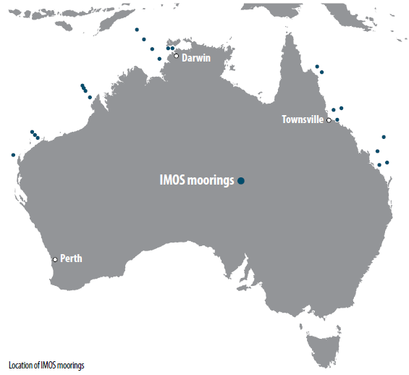
The Western Australian Marine Science Institution (WAMSI) is a partnership to improve knowledge and understanding of Western Australia's marine environment for better resource development, management and conservation outcomes.
In 2013-14 AIMS researchers established a series of dredging sediment impact experiments in the new National Sea Simulator aquarium facility in Townsville. The Dredging Node was established in 2011-12, with funding from industry, to understand and mitigate the impacts of coastal dredging, which is a critical component of most major marine infrastructure developments in Western Australia.
Projects also commenced in the Kimberley region with significant engagement and partnership with local Indigenous community groups.
WAMSI was launched in May 2007 with an initial investment of $21 million over five years from the State Treasury. In 2011-12, the Western Australian Government provided $12 million over six years for the institution's continued development.
The Western Australian Government Office of the Environmental Protection Agency was admitted in 2011 as a sixteenth partner, joining four Perth universities, two major resource companies, two publicly funded research agencies (CSIRO and AIMS), three state government departments, the Western Australian Museum, the Bureau of Meteorology, ChemCentre, and a regional ocean observing network for the Indian Ocean.
WAMSI's ability to deliver programs such as the $30 million Kimberley Marine Research Program draws on its capability of 200 scientists from 11 partner organisations. WAMSI also partners with industry to deliver programs that benefit both industry and the community such as the $18 million dredging science node
Further details at www.wamsi.org.au
The Indian Ocean Marine Research Centre (IOMRC) is a joint venture that unites the four leading Australian research organisations working in and around the Indian Ocean (AIMS, CSIRO, the University of Western Australia (UWA) and the Western Australian Department of Fisheries).
The collaboration includes developing new multidisciplinary research teams and creating a graduate training environment that will significantly advance Australia's marine science capacity, capability, and profile.
The start of construction of works for the Crawley building was officiated by the Hon Julie Bishop MP on Friday 30 May 2014. Due for completion in December 2017, the new building will contain the largest concentration of marine research capability in the Southern Hemisphere and the largest research capability in marine research in the Indian Ocean Rim.
Refurbishment of the Department of Fisheries' Waterman Bay Marine Centre recently commenced, with occupancy expected in 2015. The facility will undergo significant refurbishment including upgrades to the internal laboratories, offices and marine cultural facilities, with direct access to quality seawater.
These building projects were initiated in the 2010-11 financial year with UWA awarded $34 million from the Australian Government through the Education Investment Fund Round 3 for the IOMRC project and co-investment of $29 million.
Further details at www.oceans.uwa.edu.au/iomrc
AIMS@JCU is a strategic partnership between two global leaders in tropical marine science—James Cook University (JCU) and AIMS. It was created to provide enhanced opportunities for the joint supervision of postgraduate students in tropical marine sciences and also to facilitate the sharing of research infrastructure in Townsville. It is an unincorporated joint venture between AIMS and JCU that began in 2004 with a special allocation of funds from the Commonwealth Government.
Under Research Director Libby Evans-Illidge, AIMS@JCU focuses on the skills gap in quantitative marine science (QMS), through allocation of four new four-year PhD scholarships each year in this area. The additional funded scholarship year (on top of a standard three-year scholarship) allows each postgraduate student to complete 120 hours of professional development in QMS, some of which may need to be undertaken interstate or overseas.
In addition to the sponsored PhD scholarships, the program facilitates a wide range of PhD projects at James Cook University which lie within AIMS' research strategy and are co-supervised by an AIMS staff member.
AIMS@JCU currently has 169 members, of which 70 are JCU postgraduate and undergraduate students co-supervised by an AIMS staff member. Twenty-four of these students are recipients of an AIMS@JCU scholarship.
Further details at aims.jcu.edu.au
The ARC Centre of Excellence for Mathematical and Statistical Frontiers of Big Data, Big Models, New Insights successfully attracted Commonwealth Government funding in December 2013, and will commence operation next financial year.
The centre will tackle the massive amounts of data collected daily in a variety of forms and from a multitude of sources. Many of the resulting data sets have the potential to make vital contributions to society, business and government, but are so large or complex they are difficult to process and analyse using traditional tools.
The aim of this centre is to create innovative mathematical and statistical models that can uncover the knowledge concealed within the size and complexity of these big data sets. From a marine science perspective, the collaboration will allow AIMS, and others, to add value to the data collected on the Great Barrier Reef in order to increase our knowledge of the Reef and its processes, and improve Reef management.
The new centre, which is led by the University of Melbourne, will bring AIMS scientists together with a world-class set of collaborators and partner organisations, including the University of California, Berkeley; Queensland University of Technology; University of Adelaide; University of Oxford; University of Technology, Sydney; University of New South Wales; University of Queensland; Harvard School of Public Health; CSIRO; Sax Institute; Australian Bureau of Statistics; Mathematics of Information Technology and Complex Systems, Canada; University of British Columbia; Vic Roads; and, AT&T Labs-Research.

Fostering research capability
AIMS is committed to early-career research training to help develop the research and innovation capacity needed to meet the opportunities and challenges facing the marine environment, and to keep Australia globally competitive. AIMS maximises its impact through a number of research career development opportunities including:
- postdoctoral studies;
- postgraduate studies;
- scholarship funding for postgraduates;
- occupational trainees;
- careers in marine science for Indigenous high school students; and
- communication skills development.
Postdoctoral research
As at 30 June 2014, AIMS supports 26 postdoctoral fellows:
- five receiving ARC Super Science Fellowships;
- two NERP Marine Biodiversity Hub;
- one funded by BHP-Billiton;
- eight under the North Australia Marine Researh Alliance (NAMRA) partnership;
- four under the Indian Ocean Marine Research Centre (IOMRC) partnership (rounds one and two);
- two supported by the ARC Centre of Excellence Coral Reef Studies (Coral CoE);
- one funded by Mitsubishi;
- one funded by the Northern Research Futures Collaborative Research Network;
- one supported by the Northern Territory Research and Innovation Board/ Rio Tinto Alcan; and
- one at AIMS.
That number will decrease when a number of the co-funded fellowships come to their end date: ARC Super Science, National Environmental Research Program (NERP) Marine Biodiversity Hub and IOMRC partnership fellowships finish.
Number of AIMS postgraduate and postdoctoral researchers
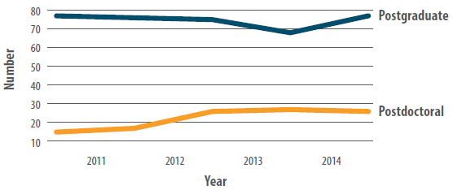
AIMS postgraduate student numbers
Postgraduate student | 2009-10 | 2010-11 | 2011-12 | 2012-13 | 2013-14
AIMS science staff enrolled in postgraduate studies | 3 | 2 | 1 | 0 | 0
Students working at AIMS supervised by AIMS staff | 26 | 28 | 29 | 26 | 31
Students working externally supervised by AIMS staff | 48 | 46 | 45 | 42 | 46
Postgraduate studies
AIMS' involvement in early-career researcher training is reflected in the fact that 26 staff members hold adjunct academic appointments at Australian and/or international institutions, including at:
- James Cook University, primarily within the Coral CoE and the School of Marine and Tropical Biology
- the University of Queensland;
- the University of Western Australia;
- Charles Darwin University;
- Queensland University of Technology;
- Deakin University;
- Swinburne University of Technology;
- the Bermuda Institute of Ocean Sciences, Bermuda;
- Dalhousie University, Canada;
- the University of Windsor, Canada;
- the University of Auckland, New Zealand; and
- Victoria University, New Zealand.
Most of these adjunct positions reflect a large personal contribution to postgraduate supervision.
AIMS staff supervised 77 postgraduate students during 2013-14, comprising:
- 25 at AIMS Townsville;
- six at UWA Oceans Institute; and
- 46 studying externally at their respective universities.
Nine postgraduate students submitted theses and 21 postgraduate degrees were conferred during 2013-14, including four at overseas universities.
Of note, Rachel Simister was awarded the Vice-Chancellor's award for best thesis of 2013 at the University of Auckland, New Zealand. Rachel was supervised by Nicole Webster (AIMS) and Mike Taylor (University of Auckland). The title of her thesis is "Microbial ecology of marine sponge-associated microorganisms".

Top-up scholarships
Under the AIMS@JCU partnership, AIMS provides four scholarships each year to top up a standard three-year postgraduate scholarship and help close the skills gap in quantitative marine science (see AIMS@JCU p 38).

Occupational trainees
AIMS supported nine trainees who improved their occupational skills through on-the-job training with AIMS researchers and technicians.
Trainee | 2009-10 | 2010-11 | 2011-12 | 2012-13 | 2013-14
Occupational trainees | 9 | 15 | 18 | 13 | 9

Careers in marine science for Indigenous high school students
In 2013 and 2014, AIMS-Coral CoE postgraduate student Joe Pollock founded and then developed the Aboriginals and Torres Strait Islanders in Marine Science's (ATSIMS) Indigenous Scholars Initiative. Joe provided a five-week course in marine science, mainly in field-based science programs, to Indigenous high school students. The students participated in interactive workshops at four high schools, a weekend-long field trip to James Cook University's Orpheus Island Research Station, a briefing on current AIMS research and a tour of the National Sea Simulator. The ATSIMS program is funded by a grant from the Higher Education Participation and Partnerships Program with support from Coral CoE, AIMS and JCU.

Communication skills
Line Bay organised an AIMS@JCU round of the University of Queensland's Three Minute Thesis competition in September 2013. The event, which helps to develop communication skills by testing competitors' ability to explain their work to a non-specialist audience in three minutes, attracted eight entrants in three categories.
Joe Pollock won the PhD Student category, Rebecca Albright won Early-Career and Scott Bainbridge won Established Researcher. A science photography competition awarded on the same day attracted around 30 entries on a range of natural subjects and science in action. The event was judged by Russell Reichelt, Chairman and Chief Executive of the Great Barrier Reef Marine Park Authority and Liz Tynan from the JCU Graduate Office who both commended the AIMS speakers and photographers for their skill in science communication.

Collaboration
AIMS has a strong culture of collaborating with external organisations worldwide (see map next page), which helps us leverage our science capabilities and capacity. Across the reporting period AIMS scientists participated in 168 collaborative projects with Australian and international scientists.
Number of AIMS collaborative projects by year
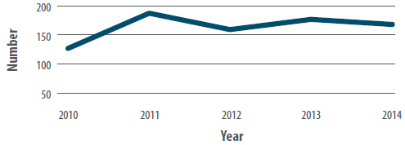
The statistics are impressive. In 2013-14, AIMS scientists were involved in:
- 168 collaborative projects;
- conducted in 21 countries;
- involving 145 Australian scientists;
- from 48 Australian organisations;
- with 84 overseas colleagues; and
- from 67 overseas organisations.
Schema illustrating location and intensity of AIMS international collaborations
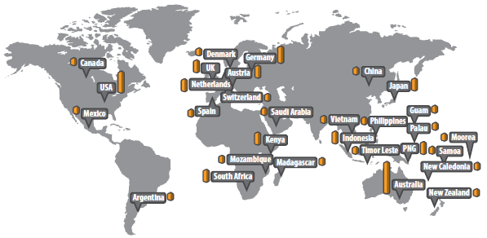
This collaborative research accounts for a high proportion of our scientific publications: out of the 186 journal articles published by AIMS scientists, 97 (52 per cent) had co-authors from other Australian research organisations and 72 (39 per cent) involved international colleagues. Only 17 articles (9 per cent) were solely authored by AIMS staff.
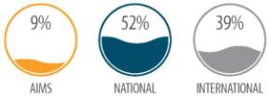
In addition to these research collaborations, in 2013-14 AIMS signed memorandums of understanding with three international research organisations:
- the Chinese Academy of Sciences Institute of Oceanology at Qingdao, to investigate coastal health and sustainable industries;
- the Okinawa Institute of Science And Technology, to investigate the genome of the crown-of-thorns starfish; and
- the King Abdullah University of Science and Technology (KAUST) in Thuwal, Saudi Arabia to work on coral genomics.
Case study: RV Solander assists ocean researchers
During April 2014, AIMS stepped in to provide the services of RV Solander and personnel to CSIRO and IMOS when delays prevented the commissioning of the Marine National Facility's RV Investigator. AIMS Oceanographic personnel John Luetchford and Chris Bartlett managed the cruise for a CSIRO scientific party and Timor-Leste observers.
This undertaking showcases AIMS' ability to perform blue water oceanographic research and confirms that AIMS' research vessel and management abilities are of international standard.
The CSIRO/IMOS trip was to visit the Indonesian Throughflow deepwater mooring array, which comprises three in-line moorings extending to a depth of over 3 km with instrumentation attached throughout the length of the mooring. The deepwater array extends and complements the shelf mooring array also operated by AIMS on behalf of IMOS.
Two of the Indonesian Throughflow moorings are located in the Timor Trough and the third is in Ombai Strait. These components combined make up almost four-fifths of the total inter-basin exchange between the Pacific and Indian Oceans.
Data from these moorings provides a direct measure of the leakage of Pacific thermocline and intermediate waters from the western equatorial Pacific into the South Indian Ocean. The Indonesian Passages represent an important 'choke point' of the global ocean overturning circulation and the climate system. The variability, on a yearly to decadal scale, in the size and depth distribution of the flow through this choke point remains a troublesome unknown. In particular, changes in this flow will reflect long-term changes in the Pacific and Indian Ocean wind fields, particularly any change in the east-west circulation of the atmosphere above the tropical Pacific, as predicted by coupled climate models forced by increasing greenhouse gas scenarios
RV Solander voyage to the Indonesian Throughflow deepwater mooring arrays
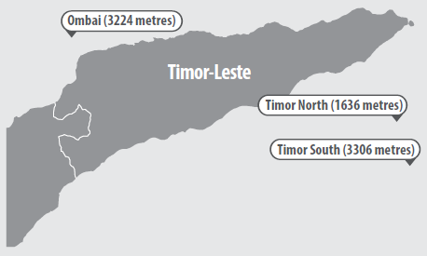

Visiting scientist program
The 2013-2014 financial year saw a continuation of the successful visiting scientist program which enabled AIMS researchers to work more closely with collaborators. This allowed AIMS to improve its capacity and skills for future science needs.
Case study: Ocean acidification research
The research on the acclimatisation potential of marine life to long-term ocean acidification at Papua New Guinea's natural CO₂ seeps (see High impact articles p 29) has initiated new collaborations with 18 scientists from 12 research organisations, including nine international organisations, within the last two years.
In 2013-14, AIMS scientists made two fieldwork trips to the seeps:
- The first expedition, funded by the not-for-profit Great Barrier Reef Foundation, supported nine researchers investigating the effects of ocean acidification on coral reefs, seagrasses and plankton communities over 15 days. The first expedition, funded by the not-for-profit Great Barrier Reef Foundation, supported nine researchers investigating the effects of ocean acidification on coral reefs, seagrasses and plankton communities over 15 days.
- The second expedition was funded by the German research network BIOACID (Biological Impacts of Ocean Acidification). Over 17 days, 11 researchers investigated the effects of ocean acidification on sedimentary biogeochemistry, microbial communities, photo pigments, photosynthesis, and coral-plankton interactions.

Science quality assurance
AIMS uses a centralised Milestone Reporting System to ensure it remains on track to deliver on its research to stakeholders and end users. The nature and timing of milestones are agreed between AIMS and external clients and partners.
Fifty-seven per cent of AIMS' external contract milestones were completed by the original negotiated date. The remaining milestones were delayed; mostly due to setbacks beyond AIMS control, such as bad weather and delayed delivery by collaborators and/or suppliers. In all cases, acceptable alternative arrangements and revised milestone dates were successfully negotiated with the external party.

Data management and dissemination
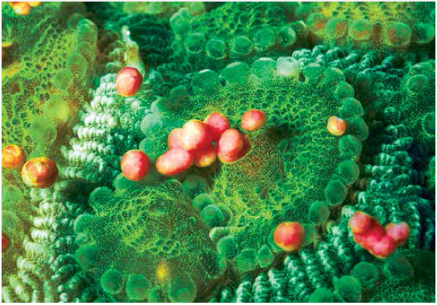
AIMS' Data and Technology Innovations Research Program underpins AIMS' other three research programs by supporting, promoting and advancing the Institute's research data management capability. AIMS has a dedicated Research Data Centre which manages and secures our data and ensures it is globally accessible via the AIMS data portal. Our metadata and maps of AIMS research data are also included in the Australian Ocean Data Network (AODN) Portal, and Research Data Australia (RDA) data catalogue giving AIMS research assets greater exposure to the broader research community.
AIMS also collects data from a wide array of Integrated Marine Observing System (IMOS) infrastructure across the tropical domain and delivers it to the IMOS data portal, the Australian Ocean Data Network. Data is captured from ships-of-opportunity measurements from our two research vessels; numerous oceanographic moorings off the Western Australia coast, Darwin Harbour and throughout the Great Barrier Reef; wireless sensor networks at seven reefs in the Great Barrier Reef; our satellite data receiving station; and animal movements via numerous acoustically tagged animals and underwater listening stations.
Among its data assets, AIMS maintains some landmark datasets critical to national and international stakeholders in marine science. Examples include:
- The AIMS Long-term Monitoring Program which has been surveying numerous reefs throughout the Great Barrier Reef for several decades. To date, this database includes 32 years of observations and measurements from 164 reefs.
- Data for the Reef Rescue Marine Monitoring Program (see p 40), an initiative within the Reef Water Quality Protection Plan. Some of the most substantial data holdings at end of 2013 are shown in the table below.
Measurements | Number of sites | Number of records | Increase from previous year
Chlorophyll, turbidity and temperature | 14 | 6,055,174 | 14 per cent
Particulate and dissolved carbon and nitrogen levels in seawater | 275 | 43,063 | 4 per cent
- The e-Atlas, an interactive mapping tool developed at AIMS to help users display, access and interrogate marine data and information. Several versions now exist tailored to needs of specific stakeholders with the largest being that for the NERP Tropical Ecosystems Hub (see p 41). The e-Atlas currently hosts over 2,320 data layers produced from 44 projects involving 15 organisations.
- eReefs, a $25 million, five-year collaboration, which started in January 2012, to develop a whole-of-Reef model that will provide information for the Reef akin to that provided by the Bureau of Meteorology for weather. This model will benefit government agencies, Reef managers, policy makers, researchers, industry and local communities. eReefs links models of catchments, rivers, estuaries and the marine environment that enable simulation of the effects and impacts of terrestrial activities and events. AIMS data both informs model development and validates model outputs.
Our web-site is one of the major avenues by which data is delivered to stakeholders. Some examples of the intensity of access to our data are given below:
Purpose | per cent increase in web visits from previous year  Number of visitor sessions | per cent increase in web visits from previous year  Number page views
Data searches | 11,830 (82 per cent increase) | 17,900 (16 per cent increase)
Reef weather | 23,710 (11 per cent increase) | 362,250 (5 per cent increase)
Coral factsheets | 96,480 (44 per cent increase) | 98,560 (28 per cent increase)
Figures in brackets denote percentage increase from previous years information.
AIMS also engages with our data stakeholders by involvement in national efforts dedicated to achieving nationally consistent approach to Australia's environmental data. For example, AIMS staff are members of the Australian Ocean Data Network Technical Advisory Group and the Australian Government Science ICT Network Committee.

Stakeholder engagement
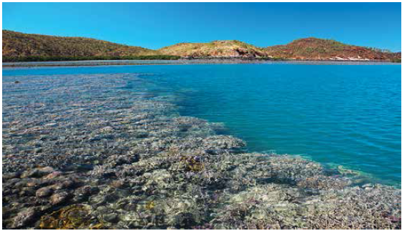
A suite of operating principles guide AIMS' research, internal and external relationships and the organisational ethos. They inform and underline the Institute's focus on supporting its key stakeholders.
Our guiding principles are:
- Trust—AIMS is a trusted adviser, delivering independent, evidence-based scientific advice to our stakeholders for the economic, environmental and social good of Australia.
- Focused research—AIMS executes focused research plans with identified pathways to impact.
- Knowledge transfer—AIMS documents and widely disseminates findings through a variety of mechanisms and formats to a wide range of stakeholders and collaborators.
- Excellence and innovation—AIMS undertakes high-calibre research.
- Return on investment—AIMS maximises the returns on investment in marine science through collaborations, co-investment and contracting of industry-funded research.
- Health, safety and environment—AIMS leads the way in providing safe working conditions and ensuring that our activities are planned to minimise any adverse environmental impacts.
AIMS works closely with stakeholders to identify their needs, and develop research programs with the highest possible value to these stakeholders, over both short and longer timeframes. We achieve this by mapping how the research will be utilised and who will benefit, then reviewing outcomes and the completion of research programs. Within this process AIMS takes a big-picture view of Australia's marine science challenges, asks questions, anticipates future needs and strategically invests in research targeted at reducing future uncertainty.
Stakeholders benefitting from AIMS' activities in 2013-14 include those listed in the table below.
Stakeholder category | Sector/organisation | Examples of AIMS' support
Industry | North-western Australia oil and gas industry | - developing environmental baselines that enable industry to better plan and manage their environmental risks and regulatory compliance  - providing a rapid response research capability to optimise the management actions should a spill occur  - providing advice on guiding dredging operations to minimise adverse environmental impact as a member of industry expert panels
Industry | Commodity ports/ Northern Territory Government, Darwin Ports Corporation | - developing systems to improve Darwin Harbour operational efficiency and research to allow environmental informed development decisions  - researching the impacts of dredging with the objective of developing improved risk-based dredging protocols
Industry | Coastal industries | - researching inputs to monitoring programs for regulatory compliance  - applying new technologies for in situ monitoring to more effectively manage dredging operations and environmental regulatory compliance  - studying water quality to validate hydrodynamic modelling of effluent diffusion
Public and government | Commonwealth government and public | - developing a framework to assess the cumulative impact of natural and development stresses on the Great Barrier Reef  - researching coral health in a variable and changing marine environment to assess coral reef resilience along with potential intervention and management options  - researching ecosystem processes and crown-of-thorns starfish outbreaks to increase our understanding of outbreak impacts and improve our ability to forecast and manage outbreaks  - developing a mapping system for presenting environmental research data in an accessible form that promotes greater information use  - monitoring the impacts of saltwater intrusion on floodplain soil communities of Kakadu National Park and South Alligator River floodplains, Northern Territory  - educating the public and stakeholders, via the website and with site tours, on the state of environmental knowledge and any gaps and risks  - supporting postgraduate students as a means of enhancing the marine research workforce in tropical Australia
Public and government | Queensland Government | - researching the impact of changed land use practices on water quality in the Great Barrier Reef Marine Park
Public and government | Western Australia Government | - researching ecosystem drivers and processes in the Kimberley region to enable improved resource management  - surveying coral populations, including tagging selected colonies to evaluate impacts of dredging operations
Managers and regulators | Great Barrier Marine Park Authority | - monitoring the Great Barrier Reef health in ongoing surveys  - providing specialist advice to and peer review of development activity impacts.

Communication
The AIMS Communication Group increased its capacity to produce written and visual content, and to deliver this material in modern media formats. The Group has developed an integrated communication strategy supported by a clear framework for benchmarking performance that aims to:
- encourage and support more proactive and effective communication by AIMS staff;
- clearly and consistently focus messages on the value and relevance of AIMS' work; and
- improve visibility of the AIMS 'brand'.
The communication team's highlights in 2013-14 include:
- the official opening of the National Sea Simulator (SeaSim) on 1 August 2013 by the then federal Minister for Innovation, Industry, Science and Research, Senator the Hon Kim Carr;
- contributions to broadcast documentaries, for example, Acid Oceans (SBS), Coast Australia (ABC/BBC), and another series in production;
- running the AIMS Public Tour Program at the Cape Ferguson facility outside Townsville, which entails approximately 70 tours per year; and
- distributing 14 media releases on significant research outcomes and events to the media.
The August 2013 launch of the National Sea Simulator (SeaSim), at AIMS in Townsville, was reported in The China Post, The French Tribune and on Radio Australia as well as local print and online outlets.

Communication seminars
Two workshops were organised by Alistair Cheal and Elisha Wood-Charlson to equip AIMS staff with stakeholder engagement skills. The objective of the first workshop, "AIMS's Vision for Stakeholder Engagement" on 20 November 2013, was to increase the overall knowledge base regarding the goals and directions of AIMS with respect to stakeholder engagement. The second workshop on 6 February 2014, "Effective communication with stakeholders", was designed to promote an understanding of current AIMS stakeholders, to develop practical skills in effective communication with those stakeholders, and to understand generic do's and don'ts for stakeholder initiatives.
Two three-hour workshops, organised by Alistair Cheal and titled "Turbocharge your writing"and "Early Career Researcher Writing Masterclass", were held for AIMS staff on 29-30 May 2014. The Masterclass involved small group coaching of 14 AIMS early career staff and was designed to provide hands on help with issues that may impact their scientific output.

Marine science seminars
AIMS hosts a seminar series in which researchers from other institutions and within AIMS present their most recent findings to AIMS staff and other visitors. The seminars are shared across AIMS' different locations through the videoconferencing system, which allows distant participants to watch the presentation and interact with the speaker Thirty-six seminars were presented in 2013-14, of which three-quarters were presented by visitors to AIMS. Thirteen presenters were from international research institutions in Canada, China, Denmark, Netherlands, Saudi Arabia, United States of America and the United Kingdom. Among Australian institutions, CSIRO was best represented, contributing six speakers.
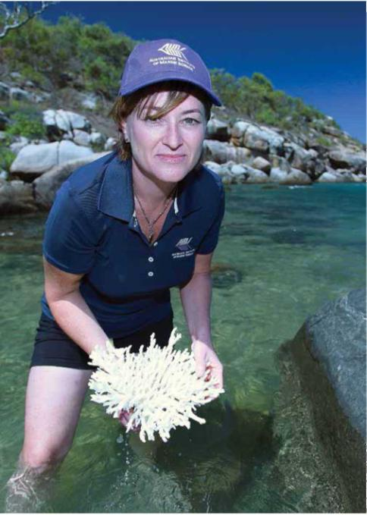
AIMS research publications continued to attract international media attention during 2013-2014. The paper DMSP biosynthesis by an animal and its role in coral thermal stress response (Raina JB, Tapiolas DM, Foret S, Lutz AH, Abrego D, Ceh J, Seneca FO, Clode PL, Bourne DG, Willis BL, Motti CA (2013). Nature 502: 677-680) was covered by science media and general news outlets in the UK and Europe, North and Central America, and Australia. Image shows one of the authors, Dr Cherie Motti, examining the skeleton ofa coral colony. Image: S.Clarke, AIMS

Revenue
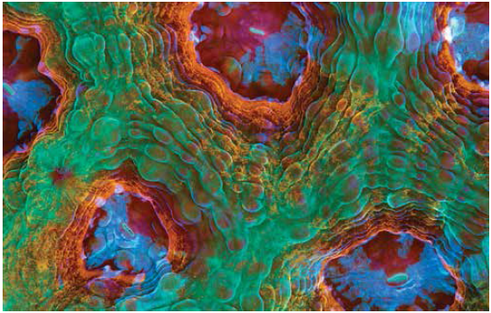
AIMS operations are supported by a mix of Commonwealth Government appropriation funding, non-appropriation funding from state and territory governments, competitive research funds, environmental regulators and the private sector. AIMS' total revenue for 2013-14 was $52.7 million, an increase of $1 million on 2012-13 financial year.
AIMS revenue over time
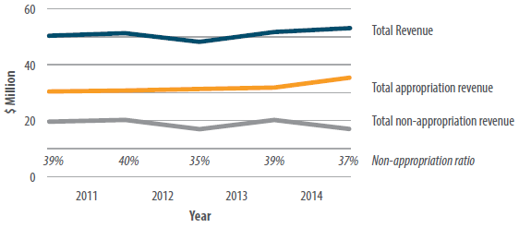

External revenue
External revenue generated from research projects amounted to $16.909 million in 2013-14, which represented 32 per cent of AIMS' total revenue. This compares with $16.971 million (33 per cent of total revenue) the previous year. External revenue achieved was slightly less than to 2012-13 with the mix of funds being similar. Over 80 per cent of AIMS' external revenue comes from major grants and project contracts from Australian Government departments and agencies.
The first chart compares AIMS' external revenue over the last five years. The second chart shows the breakdown of government and industry funding for 2013-14.
See Part Three (p 87) for AIMS' detailed financial statements.
External revenue
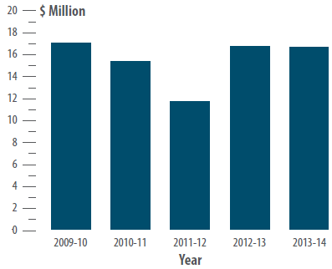
Source of co-investment funding 2013-14
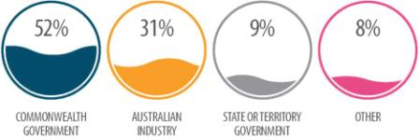

Facilities and resource management
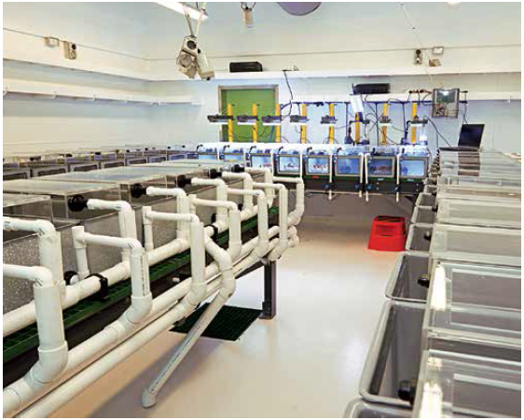

Research facilities
AIMS' research activities primarily focus on Australia's tropical marine environments, from the southern end of the Great Barrier Reef on the east coast to Shark Bay and the Abrolhos Islands in the west. Field activities are supported by laboratory and administrative facilities located at Townsville, Darwin and Perth.
AIMS' headquarters at Cape Ferguson, about 50 km from Townsville, is close to the centre of the Reef and surrounded by national park and marine reserve. AIMS' Darwin facility is the Arafura Timor Research Facility, a joint venture with the Australian National University, located adjacent to the Charles Darwin University campus. In Western Australia, AIMS is co-located with the UWA Oceans Institute at the university's Crawley campus in Perth.
In January 2014, construction commenced on the Indian Ocean Marine Research Centre, a state-of-the-art marine research facility, located on the UWA Crawley campus, where AIMS, UWA and CSIRO marine researchers will be co-located under a collaborative agreement. The collaboration includes developing new multi-disciplinary research teams and creating a graduate training environment that will significantly advance Australia's marine science capacity, capability, and profile. The new facility is due to be completed mid-2016.
Opened in August 2013, the National Sea Simulator (SeaSim), funded by the Commonwealth Government as part of the AIMS Tropical Marine Research Facilities Project, is a world-leading experimental aquarium facility that provides researchers with unprecedented experimental control of a range of variables, allowing investigation of individual and combined effects on tropical marine ecosystems and organisms. It provides a step change in capability compared with previous technologies and is an essential element for the success of all of our research programs. AIMS has made up to 50 per cent of the SeaSim capability available to scientists and research institutions from around Australia and the world to work on collaborative research projects with AIMS staff.
AIMS' field activities are supported by a research fleet that provides access to all of Australia's tropical marine environments. Two large purpose-built ships, the RV Cape Ferguson and the RV Solander, and a number of smaller vessels, take researchers to the diverse habitats that make up Australian waters.

Marine operations
AIMS' field activities are supported by a research fleet that provides access across Australia's tropical marine environments. Two large purpose-built ships, the RV Cape Ferguson and the RV Solander, and a number of smaller vessels, take researchers to the diverse habitats that make up Australian waters.
AIMS' major vessels are equipped with a wide range of facilities essential for long research trips, such as:
- on-board dive compressors;
- a recompression chamber on the RV Solander;
- a-frame, hydrographic and connectivity, temperature and depth winches;
- wet and dry laboratories;
- flow-through aquaria;
- large deck spaces;
- inflatable tenders; and
- sophisticated navigation, satellite communication and computing facilities.
AIMS researchers took part in 168 field trips during the 2013-14 financial year; of which 91 (54 per cent) were on AIMS vessels, 23 (14 per cent) were on charter vessels and 54 (32 per cent) were based from research stations or were non-boating related. Seventy-nine (79) trips involved diving and snorkelling, with a total of 3,549 scuba and surface supply breathing apparatus (SSBA) dives.
AIMS vessels were highly utilised, and researchers very busy in the field, during the reporting period. Research trips involving the two largest AIMS vessels (the RV Solander and RV Cape Ferguson) covered over 43,000 nautical miles. Together the AIMS research vessels spent 611 days in the field. Of the 91 field trips conducted on these vessels, 417 research personnel participated - equating to 3911 researcher days in the field. In addition to researcher days on our own vessels, there was another 1289 researcher days spent on charter vessels.
The table below gives a summary of the number of trips taken by each of the AIMS vessels during the reporting period.
AIMS vessel | Research trips | Number of researchers involved on field trips | Time in the field | Distance travelled | Researcher Days in Field
RV Solander | 20 | 127 | 247 days | 26,909 nautical miles | 1739
RV Cape Ferguson | 24 | 151 | 268 days | 16,250 nautical miles | 1901
RV Apollo | 31 | 89 | 34 days | N/A | 124
RV Pisces | 11 | 33 | 31 days | N/A | 61
RV Aquila | 4 | 12 | 23 days | N/A | 46
RV Capricornus | 1 | 5 | 8 days | N/A | 40
Total | 91 | 417 | 611 days | – | 3911
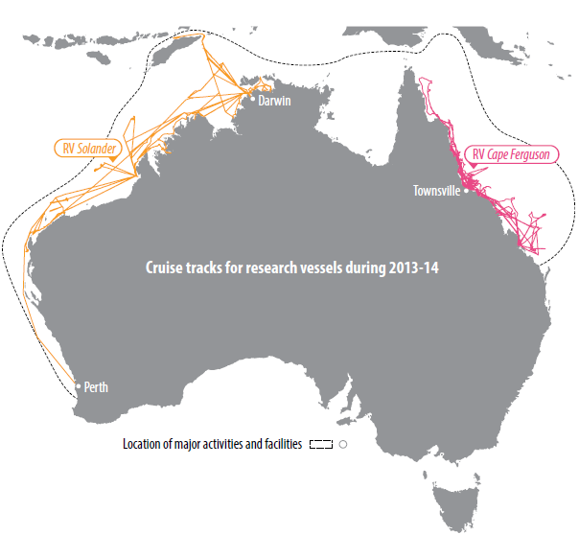
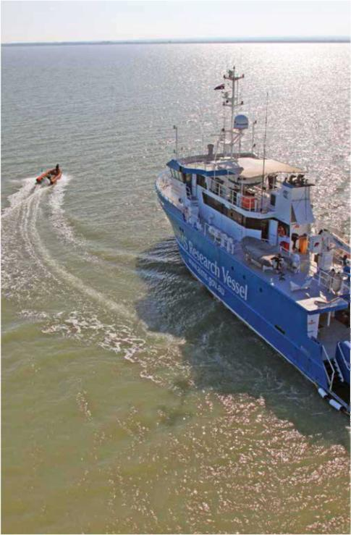
RV Solander near the mouth of the East Alligator River, Northern Territory. Image S. Clarke AIMS

PART TWO: OUR ORGANISATION
MANAGEMENT AND ACCOUNTABILITY 66
Role and legislation 66
Responsible Minister 66
Ministerial directions and statutory requirements 67
CORPORATE GOVERNANCE 68
Role of Council 68
Council members 69
Education and performance review processes for Council members 72
Ethics 72
Disclosure of interest 72
Council attendance 72
Audit Committee 73
Audit Committee attendance 73
Independent professional advice 74
Financial risk management framework 74
Fraud control 74
Financial reporting 74
Internal audit 74
External audit 75
Investing and financing activities 75
Indemnities and insurance premiums for officers 75
Consultancy services 75
Public accountability 75
Freedom of information 76
Risk management 77
Health and safety 77
ENVIRONMENTAL PERFORMANCE 82
Reducing AIMS' environmental impacts 82
Water usage 83
Recycling 83
Energy usage 83
Radiation safety 83
Gene technology 83
STAFF 84
Our people 84
Staffing 86
Women in science 86
Staff consultation 88
Equal employment opportunity and workplace diversity 88
Code of conduct 88
Harassment 89
Disability strategy 89
Employee Assistance Program 89

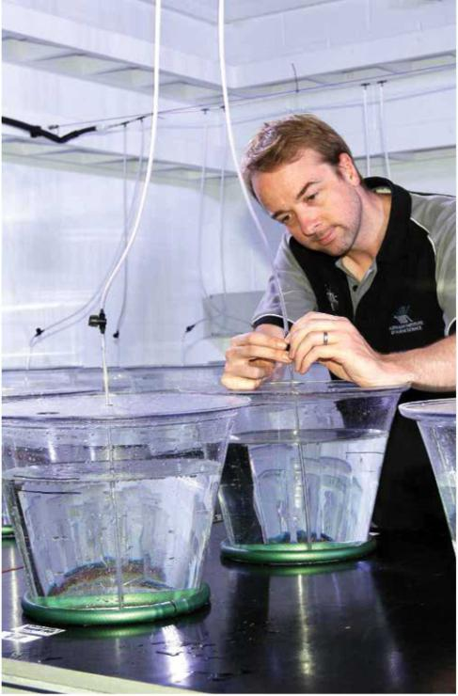
David Francis prepares equipment for an investigation into the feeding biology of crown-of-thorns starfish larvae. Image: S. Clarke AIMS

MANAGEMENT AND ACCOUNTABILITY
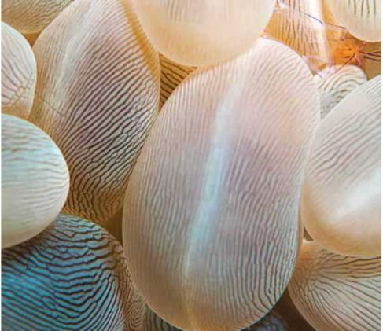
The Australian Institute of Marine Science (AIMS) has in place a comprehensive system of corporate governance practices that provide control, disclosure and accountability of its activities.

Role and legislation
AIMS has two main roles under its governing legislation:
- to carry out research and development in marine science and technology
- to encourage and facilitate the non-commercial and commercial application of the results arising from such activities.
AIMS is a Commonwealth statutory authority established by the Australian Institute of Marine Science Act 1972 (AIMS Act). The Institute's functions and powers are set out in sections 9 and 10 of the Act (and shown in Appendix 3). The Commonwealth Authorities and Companies Act 1997 (CAC Act) sets out reporting, accountability and other rules for AIMS' operations, management and governance. This annual report has been produced in accordance with the Commonwealth Authorities (Annual Reporting) Orders 2011.

Responsible Minister
At 30 June 2014, the responsible Minister was the Hon Ian Macfarlane MP, Minister for Industry. Prior to Minister Macfarlane's appointment on 18 September 2013, the Minister responsible for AIMS during the 2013-14 financial year reporting period was Senator the Hon Kim Carr, Minister for Innovation, Industry, Science and Research.

Ministerial directions and statutory requirements
Ministerial directions: No new Ministerial directions were received during the reporting period.
General policies of the Commonwealth Government: Under Section 28 of the CAC Act, the Minister may, after consultation with the Council, notify the Council of a general policy of the Commonwealth Government that is to apply to AIMS. General policies of the Commonwealth Government that applied to AIMS under Section 28 of the CAC Act during the reporting period are:
- Commonwealth Fraud Control Policy
- Commonwealth Government Foreign Exchange Risk Management Guidelines
- Commonwealth Procurement Rules as they apply to AIMS.
AIMS participated in consultation processes relating to arrangements for engagement between Commonwealth bodies and the Parliamentary Budget Office and the Commonwealth Government's Protective Service Policy Framework. These processes, which may lead to the making of General Policy Orders, were ongoing as of 30 June 2014.
AIMS did not form, or participate in the formation of, any new companies, trusts or partnerships; nor were there any changes to AIMS' enabling legislation during the reporting period.
In accordance with Senate Standing Order 25 (20), AIMS Annual Report 2012-13 was submitted for review by the Senate Economics Legislation Committee. In its document "Annual Reports (No. 1 of 2014)" dated March 2014, the committee confirmed that AIMS had met its 2012-13 reporting requirements under the CAC Act.
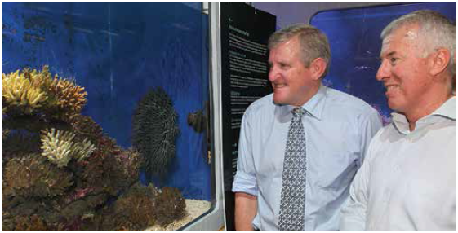
Minister Macfarlane (left) visits the National Sea Simulator with AIMS CEO John Gunn. Image: S. Clarke AIMS

CORPORATE GOVERNANCE
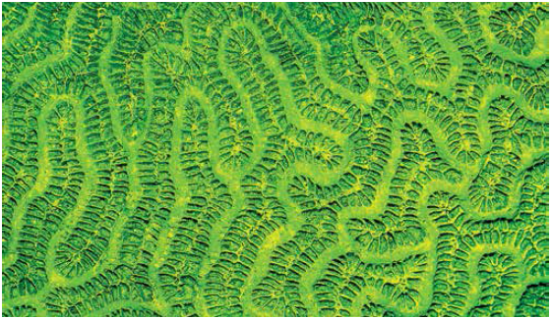
AIMS is governed by a Council that reports to the relevant Minister.

Role of Council
The AIMS Council sets AIMS' key objectives and research strategies and oversees AIMS' management. The Council regularly advises the Minister and the Department of Industry of AIMS' progress against the four-year research plan. The Minister is also provided with advice on developments of significance, as appropriate.
The CAC Act requires the Council to comply with certain accountability and corporate governance principles, including:
- maintenance of the Audit Committee;
- specific financial and reporting provisions;
- disclosure of Board Members' personal interests; and
- provision of indemnities and indemnity insurance in certain circumstances.
Since October 2007, AIMS has been required to provide an Annual Compliance Report to the Commonwealth Government regarding AIMS' compliance with the CAC Act and its financial sustainability. Internal procedures are in place to support this declaration.
During 2013-14 AIMS met all CAC Act requirements. The AIMS Audit Committee was responsible for monitoring financial risks and making recommendations to Council. Internal auditors carried out quarterly reviews of various functions within the Institute. AIMS management and the Audit Committee assisted Council in ensuring that AIMS complied with the requirements of the CAC Act.

Council members
The AIMS Council consists of a Chair, AIMS' Chief Executive Officer, a member nominated by James Cook University, and four other members. The AIMS Act requires that at least three members of Council must have scientific qualifications.
All members of Council, with the exception of the Chief Executive Officer, are non-executive appointments made by the Governor General on the nomination of the Minister. Appointments can be up to five years and re-appointment is permissible. The Chief Executive Officer is appointed by the Council for a period not exceeding five years and is eligible for re-appointment.

Mr Wayne Osborn, Dip Eng., MBA, FTSE, FAICD
Council Member and Chair: current term 1 January 2010 - 31 December 2014
Wayne Osborn retired as Managing Director of Alcoa of Australia Ltd in 2008 and has since pursued non-executive director roles. He started his career in telecommunications and moved to the iron ore industry in the mid-1970s. He joined Alcoa in 1979 and worked in a variety of roles and locations across the Australian business sector including accountability for Alcoa's Asia Pacific operations prior to being appointed Managing Director in 2001. Mr Osborn is currently a non-executive director Wesfarmers Ltd and Iluka Resources Ltd and Alinta Energy Pty Ltd.
Mr Osborn has an interest in whale conservation and wildlife photography. He was elected an International Fellow of the New York-based Explorers club in 2004 for his work in marine science and archaeology. His support of the arts though the Australian Business Arts Foundation was recognised with the 2007 Business Leadership Award at the Western Australia Business and the Arts Partnership Awards.

Mr John Grace, BSc, FTSE, FAICD
Council Member: 16 December 2004 - 15 December 2014
John Grace has worked for 40 years in industry, primarily biotechnology, for 20 years of which he was a CEO. His particular skill is dealing with the complexities of commercialisation of research, particularly from the public sector. He has applied this experience in organisations ranging from Burns Philip to CSIRO and AMRAD, where he served as Managing Director for 11 years. Mr Grace is an experienced director of listed and private companies. He operates a consulting business TechAdvisory Pty Ltd that offers services in research planning and commercialisation. He is Chair of ITEK Ventures Pty Ltd, which is the commercial arm of the University of South Australia, and a Director of the Cooperative Research Centre (CRC) for Polymers.
Formerly Mr Grace has been a director of a number of private companies and served on a number of federal and state government boards/committees. His previous committees include: TransTasman Commercialisation Fund (as Director), the Australia-India Strategic Research Fund Committee, Academy of Technological Sciences and Engineering (Vice-President), AMRAD Corporation Ltd, CRC for Cellular Growth Factors, Victorian Science Agenda investment fund (Chair), the Australian Research Council, the Victorian Premier's Knowledge Innovation Science and Engineering Task Force, the Industry Research and Development Board, and the Australian Biotechnology Association (President/Director).

Ms Elizabeth Montano, BA, LLB, FAICD
Council Member: 16 December 2004 - 15 December 2014
Elizabeth Montano has worked in senior positions in the private and public sectors for over 25 years and is currently Chair of the AIMS Audit Committee. She runs an advisory business focusing on strategy, governance, change management, culture, audit and risk. Ms Montano has extensive senior experience in regulation, natural resource management, financial services sector and legal practice and is currently the Chair and Member of various Commonwealth Audit and Risk Committees.
Ms Montano's non-executive roles include being Commissioner of the Australian Fisheries Management Authority, Chairman of the Board of Management of Centrelink, Chair of Centrelink's Audit and Risk Committee, Strategic Adviser to the Chief Federal Magistrate, Federal Magistrates Court of Australia, independent member of the Executive Management Board and Strategic Leadership Group of the Australian Federal Police (AFP) and independent member of the AFP's Security and Audit Committee. She is a former Chief Executive Officer of AUSTRAC, Australia's anti-money laundering regulator and financial intelligence unit, and was a regulatory policy Branch Head at the Australian Securities Commission (ASIC's predecessor). Ms Montano holds Bachelor of Arts, majoring in Industrial Relations, and Bachelor of Law degrees from the University of New South Wales. Ms Montano was awarded the Centenary Medal in recognition of her services to the Commonwealth.

Mr Nicholas Mathiou, BCom(Hons), LLB, MMktg, MAICD
Council Member: 1 September 2005 - 31 August 2013
Mr Mathiou vacated his role as Council member and Audit Committee Chair at the end of his term of appointment, on 31 August 2013.
Nicholas Mathiou has over 25 years of professional investment, transaction and corporate advisory experience with particular emphasis on private equity investment in emerging enterprises. He is the Director of Griffith Enterprise, the commercialisation office of Griffith University, where he is responsible for its overall strategic direction and management. He has significant experience in the establishment of new ventures, technology transfer, and commercial practices.
Mr Mathiou is a fellow of the Financial Services Institute of Australasia, a barrister of the Supreme Court of Queensland, a barrister and solicitor of the Supreme Court of Victoria, a member of Chartered Secretaries Australia, a member of Certified Practising Accountants Australia and a member of the Australian Institute of Company Directors.

Professor Sandra Harding, BSc(Hons), MPubAdmin, PhD, Hon Doc, FACE, FQA, FAICD, FAIM
Council Member: 10 May 2007 - 9 May 2015
Sandra Harding was appointed Vice-Chancellor and President of James Cook University in January 2007. In this role, she is responsible for ensuring clear and effective leadership and management of the University across all operating sites, including campuses in Townsville, Cairns and Singapore.
Professor Harding has extensive academic and academic leadership experience. An economic sociologist by training, her areas of enduring academic interest include work, organisation and markets and how they work. She also has a keen interest in public policy, particularly education policy and other policy domains affecting higher education.
Professor Harding has undertaken a wide variety of external roles within the business community and the higher education sector. Her current roles include: Chair of Universities Australia; Director of the Regional Australia Institute; Director of the North Queensland Cowboys National Rugby League club; Member of the Defence Science and Technology Organisation (DSTO) Advisory Board; the Australian Research Council Advisory Council; and Director of two regional economic development bodies, Townsville Enterprise and Advance Cairns.

Dr Brian Fisher, AO, PSM, BScAgr(Hons), PhD, DScAgr
Council Member: 26 September 2007 - 25 September 2015
Brian Fisher is currently Managing Director of BAEconomics Pty Ltd, having previously held the position of Executive Director of the Australian Bureau of Agricultural and Resource Economics (ABARE). Following his retirement from ABARE, Dr Fisher was Vice-President at global consulting firm CRA International and then CEO of Concept Economics.
Prior to heading up ABARE, Dr Fisher was Professor of Agricultural Economics at the University of Sydney, becoming Dean of the Faculty of Agriculture at the University in 1987. He was appointed Adjunct Professor of Sustainable Resources Development in 2003. Dr Fisher has been the government board member on a number of statutory corporations. He has published over 270 papers and monographs. In addition to his position with ABARE in 2003 and 2004 he was an Associate Commissioner of the Productivity Commission, in 2005 the Chairman of the Prime Minister's Exports and Infrastructure Taskforce and in 2014 a member of the Commonwealth Government's Renewable Energy Target Panel.
Dr Fisher received the Farrer Memorial Medal in 1994, became a fellow of the Academy of Social Sciences in Australia in 1995, was awarded the Public Service Medal in 2002 and received an Order of Australia in the Queen's Birthday Honours List in 2007. He holds a PhD in agricultural economics and a DScAgr from the University of Sydney.

Mr John Gunn, BSc(Hons), MAICD
Council Member: 28 November 2011 - 27 November 2016
John Gunn is the Chief Executive Officer of AIMS. He has significant experience in leading development of strategy, scientific research and capability, and stakeholder engagement across a research portfolio encompassing marine ecology, fisheries, coastal systems, physical and chemical oceanography, atmospheric chemistry and climate science. Mr Gunn joined AIMS from the position of Chief Scientist of the Australian Antarctic Program, where he played a key role in developing the new Australian Antarctic Science Strategy Plan: 2011-2021. Prior to this he was Deputy Chief of CSIRO's Marine and Atmospheric Research Division, the culmination of a 29-year career with CSIRO.
Mr Gunn has held a number of important advisory and policy development roles through his membership of the Scientific Steering Committee for the Global Ocean Observing System, the Australian Academy of Science National Committee for Antarctic Research, the Antarctic Climate and Ecosystems Cooperative Research Centre Board, the Oceans Policy Science Advisory Group, the Commonwealth Government's High Level Coordination Group on Climate Change Science, and Australia's Integrated Marine Observing System Board.
Mr Gunn also has an extensive academic record. Having graduated from James Cook University, Townsville, in 1978 with a first class honours in marine biology, he has authored over 150 peer-reviewed publications, book chapters, papers to international commissions and technical reports, and has presented at more than 100 conferences and symposiums, in many instances as the keynote speaker. He has an international reputation in the fields of pelagic fish ecology and in the development of marine biological observing technology and systems.
Having worked within and led a number of world-leading multidisciplinary teams and programs, Mr Gunn is a passionate advocate for science, and in particular marine science, and its role in securing a prosperous and sustainable future for Australia. While addressing the needs and demands of a broad user community, he is determined to maintain and further enhance the scientific excellence for which AIMS has gained an enviable international reputation.

Education and performance review processes for Council members
Council members are provided at their induction with a comprehensive set of documents, including: the AIMS Code of Conduct; the Commonwealth Government's Corporate Governance Handbook for Company Directors and Committee Members; the CAC Act; the AIMS Research, Business Continuity Management, Enterprise Agreement and Fraud Control Plans; AIMS Strategic Directions; and the AIMS Act.
Council members are encouraged to maintain their membership with the Australian Institute of Company Directors (AICD).
Council members' performance is reviewed regularly, alternately by the Chair and by an external reviewer. During 2013-14, a review of Council performance was undertaken by the AICD. The review assessed the governance of the Institute and found that AIMS had a very "mature" Board with no significant shortcomings.

Ethics
Council members sign a code of conduct that complies with Division 4 of the CAC Act. New Council members are briefed on the code during induction. Council members abide by the Code of Conduct for Directors published by the AICD.

Disclosure of interest
Section 27F-27K of the CAC Act provides for the disclosure of material personal interests in a matter that is being considered by the Council and prohibits participation, deliberation and decision-making by any member on such matters, unless so resolved by the Council or entitled by the Minister. Details of such disclosure are recorded in the minutes of the meeting. All of these requirements are currently being met.

Council attendance
Attendance | 21 August 2013 (telecon) | 23 September 2013 | 9 December 2013 | 24 March 2014 | 16 June 2014
Mr Wayne Osborn | Yes | Yes | Yes | Yes | Yes
Mr John Grace | Yes | Yes | Yes | Yes | Yes
Ms Elizabeth Montano | Yes | Yes | Yes | Yes | Yes
Mr Nicholas Mathiou | Yes | n/a | n/a | n/a | n/a
Professor Sandra Harding | Yes | No | Yes | No | Yes
Dr Brian Fisher | LH | Yes | Yes | Yes | Yes
Mr John Gunn | LH | Yes | Yes | Yes | Yes

Audit Committee
The Audit Committee is a formal subcommittee of the Council that meets quarterly. The 2013-14 Audit Committee members were Mr Nicholas Mathiou (Chair to September 2013), Ms Elizabeth Montano (Chair from October 2013), Mr John Grace (member from September 2013) and an independent member, Mr Roy Peterson. The AIMS Chief Executive Officer, Chief Finance Officer, representatives of the Australian National Audit Office (ANAO), and Internal Auditor attend all meetings, or relevant parts of all meetings, by invitation.
In accordance with best practice, all Council members receive copies of Audit Committee Agenda and Meeting minutes, and can attend meetings as a right.
The Audit Committee is responsible for providing independent assurance and assistance to Council on:
- financial risk management;
- the financial control framework;
- external accountability;
- legislative compliance;
- internal audit; and
- external audit.
Four full meetings of the committee were held during 2013-2014 (see table).

Audit Committee attendance
Attendance | 12 Aug 2013 | 12 Nov 2013 | 3 Mar 2014 | 2 Jun 2014
Members | – | – | – | –
Mr Nicholas Mathiou (outgoing Chair) | Yes | n/a | n/a | n/a
Ms Elizabeth Montano (incoming Chair) | Yes | Yes | Yes | Yes
Mr John Grace (Council member) | n/a | Yes | Yes | Yes
Mr Roy Peterson (Independent member) | Yes | Yes | Yes | Yes
Invitees | – | – | – | –
Mr John Gunn (CEO) - AIMS management representative | No | Yes | No | No
Mr David Mead (AIMS General Manager) - representing John Gunn | Yes | n/a | Yes | No
Mr Vic Bayer (Chief Finance Officer) | Yes | Yes | No | Yes
Ms Pamela Giese (AIMS Finance Team Leader) | Yes | Yes | Yes | Yes
Mr Phil Clarke (Price Waterhouse Coopers, Australian National Audit Office (ANAO) External Auditor) | Yes | n/a | n/a | n/a
Mr Chris King (HLB Mann Judd Internal Auditor) | Yes | Yes | Yes | Yes
Mr Jonathan Grasso (Price Waterhouse Coopers, ANAO External Auditor) | Yes | n/a | n/a | n/a
Mr Ron Wah (Australian National Audit Office) | Yes | Yes | Yes | n/a
Ms Serena Buchanan (Australian National Audit Office) | n/a | n/a | n/a | No
Mr John Zabala (Moore Stephens, ANAO External Auditor) | n/a | n/a | n/a | Yes

Independent professional advice
The Council has the right to obtain, at AIMS' expense, relevant independent professional advice in connection with the discharge of its responsibilities. They did not seek such advice in 2013-14.

Financial risk management framework
The Audit Committee is responsible for reviewing AIMS' financial risk framework (and monitoring management's compliance with that framework) and making recommendations to Council. The Council is responsible for the review of the risk management framework for strategic, commercial, operational and compliance risks.

Fraud control
AIMS remains committed to the Commonwealth Fraud Control Guidelines as set out by the Attorney-General's Department, Criminal Justice Division. AIMS has reported its 2013-14 fraud data to the Australian Institute of Criminology. Council adopted a new Fraud Control Plan in June 2013 following a review the previous year. The AIMS Council and Management are not aware of any instances of fraud in 2013-14.

Financial reporting
AIMS' financial statements are prepared in accordance with:
- Finance Minister's Orders (Financial Statements for reporting periods ending on or after 1 July 2011)
- Australian Accounting Standards and Accounting Interpretations issued by the Australian Accounting Board that apply for the reporting period.
The financial statements are accompanied by a Management Representation letter to the ANAO, signed by the Chair of Council, Chief Executive Officer and Chief Finance Officer, declaring that the statements present a true and fair view of the financial position, the operating results and the cash flows of AIMS for the year ended 30 June 2014. There were no related entity transactions during financial years 2012-13 or 2013-14.

Internal audit
The Audit Committee reviews the internal audit plan for Council. Council approves the annual internal audit plan and receives regular reports on progress against the plan. The internal audit function was performed by HLB Mann Judd. The Internal Auditor is responsible for independently reviewing the financial risk in accordance with the annual plan.

External audit
Under the CAC Act, the Commonwealth Auditor-General, through the ANAO, is the external auditor for AIMS. The Audit Committee reviews the ANAO audit plan and reports and meets with ANAO representatives prior to recommending to the Council that the annual financial statements be accepted and the Statement by Council be signed.

Investing and financing activities
AIMS invested its surplus money in accordance with Section 18(3) of the CAC Act, and in accordance with AIMS' policy on investments.

Indemnities and insurance premiums for officers
During the reporting period there were no liabilities to any current or former officers. No premium was paid (or was agreed to be paid) against a current or former officer's liability for legal costs. AIMS paid premiums for the Directors' and Officers' insurances, as required under the CAC Act.

Consultancy services
AIMS engages individuals and companies as external consultants from time to time where it lacks specialist expertise or when independent research, review or assessment is required.
Consultants are engaged to: investigate or diagnose a defined issue or problem; carry out defined reviews or evaluations; or, provide independent advice, information or creative solutions to assist in AIMS' decision-making.
Decisions to engage consultants takes into consideration the skills and resources required for the task, the skills and/ or resources available internally and the cost-effectiveness of these options. Engagement of a consultant is made in accordance with AIMS' Procurement Policy and Procedures and other relevant internal policies.
AIMS spent $100,265 (excluding GST) on consultancies during 2013-14.

Public accountability

Judicial decisions and reviews by outside bodies
No judicial decisions relating to AIMS were handed down during the reporting period.

Ombudsman
No issues relating to AIMS were referred to the Commonwealth Ombudsman during the reporting period.

Industrial relations
No significant industrial issues arose during the reporting period.

Customer service charter
AIMS has a formal service charter for dealing with clients, a copy of which is posted on the website. AIMS welcomes feedback on how well it is delivering services against the standards set in this charter. Both the charter and details about how to provide feedback may be found at www.aims.gov.au/docs/about/corporate/service-charter.html

Privacy principles
To ensure the proper management, administration and safety of its Offices, Employees, Visitors and Volunteers the AIMS is required to collect personal and from time to time sensitive information. AIMS is committed to the Australian Privacy Principles contained within the Privacy Act 1988 (Cth) and as such AIMS has developed this Privacy Policy Statement. AIMS also has a Privacy Officer who is responsible for ensuring that AIMS' Privacy Policy and Collection Statement are adhered to, updated and are in accordance with the Privacy Act 1988.

Freedom of information

FOI requests, reviews, decisions and statements
One request was made for documents under the provisions of the Freedom of Information Act 1982 (FOI Act), and this request was duly complied with.
In 2013-14, no applications were received:
- for internal review of decisions made under the FOI Act;
- for external review by the Administrative Appeals Tribunal of decisions made under the FOI Act; and
- to amend records under the FOI Act.
No reports were produced on the operations of AIMS by the Auditor-General (except for on AIMS' Financial Statements), a parliamentary committee or the Commonwealth Ombudsman.

FOI operations
Agencies subject to the FOI Act are required to publish information to the public as part of the Information Publication Scheme (IPS). This requirement is in Part II of the FOI Act and has replaced the former requirement to publish a Section 8 statement in an annual report.
The documents listed in AIMS' IPS Agency Plan are generally freely available to any person requesting them. The availability of other information is subject to assessment, which is made on a case-by-case basis in accordance with the relevant provisions of the FOI Act as supplemented and explained in the Fact Sheets and Guidelines published on the website of the Office of the Australian Information Commissioner (www.oaic.gov.au/freedom-of-information/foi-resources/all/). The grounds for assessment include considerations of commercial confidentiality, legal professional privilege and personal privacy. The FOI Act and the above website explain these and other exemptions and conditional exemptions contained in the current legislation.
Requests for any such information must be made in writing, addressed to the relevant person and must contain the information set out on page 2 in Fact Sheet 6 'Freedom of information—How to apply' on the above website. The request should be addressed to the Freedom of Information Officer at the address below. There is no fee payable for the request. However, fees and charges may apply and if they do will be set in accordance with Part 4 of the FOI Guidelines, which are available from the FOI website.

Information Publication Scheme
AIMS continues to undertake actions consistent with compliance requirements under the Information Publication Scheme introduced in May 2011 under the relevant provisions of the FOI Act. The objective of the IPS is the promotion of open, accountable and transparent information by governments and government agencies in formats that are easy to understand and freely accessible. AIMS' IPS Agency Plan is available on the AIMS' website at www.aims.gov.au/ips.

Contact
All enquiries and requests for information or concerning access to documents or any other matters relating to FOI should be directed to:
Freedom of Information Officer
Australian Institute of Marine Science
PMB No 3, Townsville Mail Centre MC, Qld 4810
Telephone: (07) 4753 4444
Facsimile: (07) 4772 5852
Email: privacy@aims.gov.au

Risk management
AIMS has a comprehensive corporate risk management strategy which includes processes to identify and assess new risks to AIMS along with the refinement of existing control measures.
Operational risk management is established across the Institute, with processes, procedures and systems of work in place to manage health and safety risks that may affect AIMS workers. AIMS participated in the annual Comcover risk management benchmarking survey, and in late 2013-14 undertook an independent review of our risk management policy and framework. Improvements identified from these activities will be implemented in 2014-15.

Health and safety
AIMS understands its responsibilities under Schedule 2 of the Work, Health and Safety Act 2011 and has focused on the ongoing implementation of the harmonised work health and safety legislation and proposed changes in maritime safety laws.
AIMS is committed to protecting the health and safety of its staff and visitors and recognises the importance of a providing a safe work environment, a robust and accessible Health and Safety Management System and an ongoing focus on the development of AIMS' safety culture.
AIMS holds that 'safe science is good science' and that safety is a shared value embedded in everything we do. AIMS focuses on communication and empowerment, safety briefings, proactive hazard identification and incident reporting. All risks and hazards are assessed in line with the complexities of the research work, activities and supporting functions required.
The Institute fosters a 'stop work and speak up' culture to ensure that all personnel feel comfortable to delay or stop work where an unacceptable risk may be present or develop.
Management is committed to understanding and managing our health and safety risk profile, and dedicates significant resources towards continual improvement projects and strategies.
Key areas of focus include:
- hazardous chemical management;
- risk management;
- safety management systems improvement;
- training and competency assessments;
- audit and inspection;
- cultural development;
- laboratory management;
- fieldwork and diving;
- ergonomics and manual task management;
- health, fitness and wellbeing; and
- incident reporting, investigation and action closeout.
Our commitment to the ongoing health and safety of all of our workers is demonstrated through the number and diversity of roles, resources and training dedicated to health and safety management at AIMS. Roles include:
- two dedicated Health and Safety Officers;
- six Health and Safety Representatives and a Safety Committee;
- Chief Emergency Warden, Deputy Emergency Wardens and House Wardens;
- Diving Officer (safety focus);
- Boating Officer (safety focus);
- Laboratory Operations Manager, with each laboratory having a dedicated manager;
- staff with advanced medical care training;
- a high percentage of staff with first aid qualifications;
- contracted emergency response and first aid providers;
- Harassment Contact Officers;
- Quarantine Officer (statutory position);
- Radiation Safety Officer (statutory position);
- Biosafety Officer (statutory position);
- Fire Safety Adviser (statutory position); and
- Return-to-Work and Rehabilitation Officer.
Recent training provided includes:
- hazardous materials and dangerous goods;
- crane operations;
- working at height;
- elevated work platform operations;
- first aid and advanced resuscitation;
- elements of shipboard safety;
- coxswains training and assessment;
- rescue diver;
- ADAS commercial diving accreditation;
- manual task training; and
- site-specific inductions.

Continuous improvement
AIMS identified and implemented a range of improvements to our Health, Safety and Environmental Management System (HSEMS) to improve performance and position ourselves for accreditation with, AS/NZ 4801:2001 Occupational Health and Safety Management Systems. Improvements ranged from the development of a new operational risk management process to improvements in chemical management to the implementation of an injury Management and Prevention Plan designed to reduce the frequency of manual task-related injuries in the workplace
Continuous improvement initiatives in the area of Hazardous Chemical Management practices have resulted in the risks of hazardous chemical use and storage being better understood and managed, with particular emphasis on training and awareness, risk management and inventory control.

Incidents and hazard reporting
During 2013-2014, 118 potential safety matters were formally recorded in our incident management system, of which a large proportion (43 per cent) were hazards. Appropriate preventative actions were implemented, demonstrating a commitment to continuously improve safety at AIMS.
Three incidents were notified to Comcare, the workplace health and safety regulator, under the requirements of Part 3, Sections 36 and 37 of the Commonwealth Work Health and Safety Act 2011, in relation to serious injury or illness and dangerous incident.
On 14 October 2013, an AIMS worker received an electric shock after making contact with electrical conductors while replacing a neon light tube. Comcare accepted the root causes and corrective actions identified by AIMS. All corrective and preventative actions have been subsequently addressed, and additional measures implemented, to ensure the safety of workers dealing with electrical equipment.
On 29 October 2013, an AIMS worker sustained a severe laceration, resulting in the partial amputation of the individual's left index finger. The injury resulted when the worker was operating a bench saw and was struck by an offcut of material that 'kicked back' and made contact with the operator's hand. As a result of the incident, a prohibition notice was placed on the equipment in use at the time of the incident. Comcare was satisfied that the AIMS investigation identified the factors congruent to the incident, identified appropriate corrective and preventative actions, and that the requirements of the prohibition notice were met. All actions and recommendations have been subsequently implemented.
On 19 June 2014, an AIMS volunteer received an electric shock when they made contact with a wet equipment controller. A liaison inspection process is currently under way, with an analysis of the root cause of the incident and corrective action plan in development.
One workers' compensation claim was made under the Comcare Workers' Compensation Scheme.
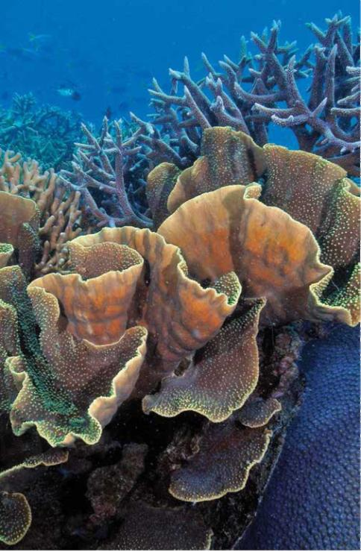
Diverse coral community on the Great Barrier Reef. Image: E. Matson, AIMS

ENVIRONMENTAL PERFORMANCE
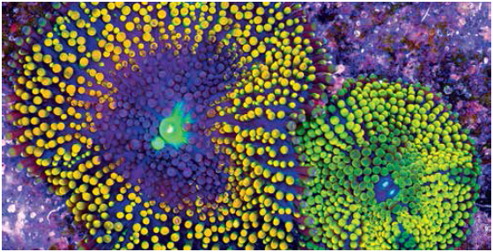
In its 40-year history AIMS has demonstrated an extensive commitment to environmental protection and biodiversity conservation. The Institute has worked with industry, government, the community and other scientific institutions and agencies on programs and projects dedicated to conserving and sustainably managing tropical marine resources. As both a community leader in tropical Australia and a Commonwealth statutory authority, AIMS has an obligation, both statutorily, through the Environment Protection and Biodiversity Conservation Act 1999 (EPBC Act), and morally, to protect and maintain biodiversity and heritage under its control.
In addition our many activities contributing to environmental protection and biodiversity conservation, we are committed to minimising any adverse effects on the environment arising from our own activities.

Reducing AIMS' environmental impacts
The green@AIMS program, which commenced in 2008, continues to deliver energy efficiencies for AIMS. The energy monitoring system commissioned in June 2010 has established consumption baselines and trends, which allows targeted energy reduction programs and initiatives.
Construction of an off-peak chilled water plant, a component of the AIMS Tropical Marine Research Facilities Project, was completed in June 2012. Predicted electricity savings from the installation of new air-conditioning chillers that are 40 per cent more efficient than those used previously have been confirmed. However, commissioning issues with the thermal energy storage tank have delayed benefits associated with moving electrical demand for air-conditioning into off-peak periods.
As well as focusing on step change improvements in electricity consumption, AIMS continues to promote energy efficiency among the workforce.
AIMS operates a car-pooling program whereby staff are provided with access to shared vehicles. Approximately 91 per cent of all staff, visitors and students travel to and from AIMS each day in a commuter vehicle. The vehicles AIMS selects for the commuter fleet must achieve a Green Vehicle Guide rating of 10.5 or higher. It is estimated that the commuter program reduces the number of vehicles travelling to and from AIMS each day by between 80 and 100.
Furthermore, fuel consumed by the commuter fleet is included in AIMS' carbon reporting under the Commonwealth Government Energy Efficiency in Government Operations Policy. Reporting carbon dioxide emissions generated by employee travel to and from the workplace is considered leading practice.

Water usage
AIMS used 81.1 megalitre (ML) of water in 2013-14, an increase from 70.1 ML the previous year. The increase was due to re-filling of the chiller storage tank after repair works to the tank liner.

Recycling
AIMS continues to operate an active recycling program, including paper, cardboard, batteries, printer cartridges, lubricants and metals.

Energy usage
AIMS Cape Ferguson's site electricity consumption for 2013-14 is forecast to be 7.613 gigawatts for the year, compared with 6.622 gigawatts in 2012-13. The increase is due to the electrical consumption added with the commissioning of the National Sea Simulator. Final figures will be available in October 2014.

Radiation safety
AIMS continues to hold a source licence issued by the Australian Radiation Protection and Nuclear Safety Agency. The source licence fee increased by 55 per cent from the previous year to $7,979 and a similar increase is expected for the 2014-15 year. The provision of this source licence is subject to conditions including quarterly reporting, maintenance of a source inventory and compliance with relevant regulations, codes and standards.

Gene technology
One new proposal for dealing with a genetically modified organism (GMO) was assessed by the AIMS Biosafety Committee as a Notifiable Low Risk Dealing (NLRD), and two NLRD projects were completed. With projects ongoing from previous years, AIMS now has one licensed GMO project, six GMO projects that are defined by the Office of the Gene Technology Regulator as NLRDs, and seven defined as exempt.

STAFF
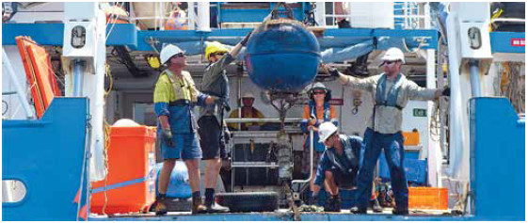

Our people
AIMS employs a core of 203 full-time equivalent science and support staff, including 11 full-time equivalent causals. In addition AIMS employed 42 full-time equivalent contract staff.
Many of our scientists are world authorities in their field who have achieved international acclaim for their research. Support staff provide specialised skills in data management, information technology, engineering, field operations, information services, communication, financial and corporate services. Contract staff provide a variety of AIMS services such as vessel crewing, catering and maintenance.
AIMS core staff numbers over time
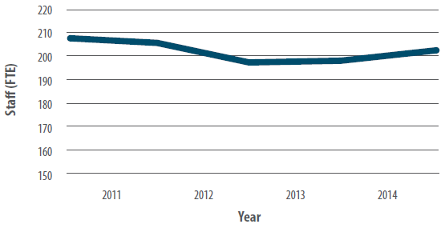
Number of Core AIMS Staff
Core AIMS Staff | 2009-10 | 2010-11 | 2011-12 | 2012-13 | 2013-14
Total FTE excl. Casuals Casuals/Temp FTE | 208 | 190 15 | 189 11 | 191 7 | 192 11
Post Doc Researchers included in FTE | – | (5) | (10) | (13) | (11)
Total FTE | 208 | 205 | 200 | 198 | 203
Number of contractors engaged by AIMS
Contractors | 2009-10 | 2010-11 | 2011-12 | 2012-13 | 2013-14
Contractors | 30 | 30 | 30 | 30 | 42
Total staff numbers
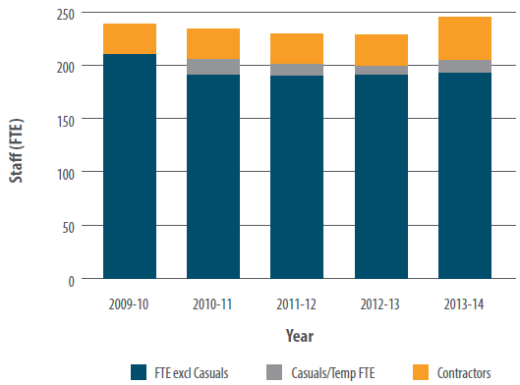
We maintain a strong educational program, particularly through co-funded postdoctoral positions and PhD scholarships through the North Australia Marine Research Alliance (with James Cook University, Charles Darwin University, University of Western Australia and the Australian National University) and with CSIRO.
In 2013-14 AIMS supported 26 postdoctoral fellows and AIMS staff supervised 77 postgraduate students, drawn from universities throughout Australia and overseas, but predominantly those in Queensland, Western Australia and the Northern Territory (see Fostering research capability p 44).
AIMS' exemplary safety record has benefited staff and has been achieved through an organisation-wide commitment to identifying and minimising risks associated with working in potentially hazardous environments. A robust, regularly audited, system of procedures is in place with emergency drills and scenario testing undertaken regularly.

Staffing
The average full-time equivalent value of research scientists and support and technical staff (including casuals) was 203 over the 12-month period. All members of staff are employed under the AIMS Act. AIMS funds these staff though a combination of Commonwealth Government appropriation and revenue generated from contracted research.
The work of the research scientists is supported by a variety of professional research support staff skilled in research, laboratory services, data collection and data management. Technical and corporate support staff deliver commercial services, intellectual property portfolio management, engineering services, field operations, information technology, information services, science communication, financial, human resource, supply, property, and general management services.
The Executive Management Group is made up of the CEO, General Manager, and Research Director.
Number of AIMS staff by gender
Category | Female | Male | Total
Research scientists | 18 (18) | 32 (30) | 50 (48)
Research support | 21 (20) | 46 (44) | 67 (64)
Technical and corporate support | 29 (28) | 57 (58) | 86 (86)
Total staff (full time equivalent) | 68 (66) | 135 (132) | 203 (198)
2012-13 figures in brackets.

Women in science
The goal of the Women@AIMS Reference Group is to promote diversity and equity within the organisation. The group formed in 2009 and seeks opportunities for creating a flexible and family friendly work environment. In particular it identifies issues and barriers that are specific to women in the workplace and aims to provide solutions. Originally this was a focus group for AIMS' female scientists, but in late 2010 it was modified to include all women at AIMS.
During 2013-14 the group established a personal coaching and empowerment program for women at AIMS. If successful, it will be made available for all staff later in 2014.
Organisational Structure of the Australian Institute of Marine Science
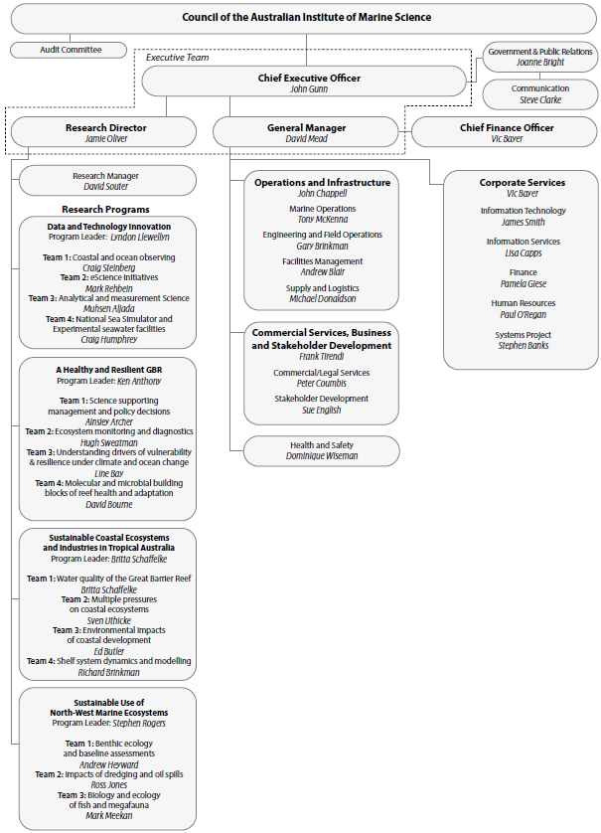

Staff consultation
Staff consultation and communication take place via a range of mediums such as all-staff meetings, emails and newsletters. The Joint Consultative Committee, comprising AIMS CEO (Chair), a management representative, the Human Resources Manager, a Community and Public Sector Union (CPSU) representative (internal), a CPSU organiser (external), and a staff representative, met four times in 2013-14. This committee provides a forum for discussion and consultation between management and staff representatives.

Equal employment opportunity and workplace diversity
AIMS' Diversity Policy acknowledges differences and adapts work practices to create an inclusive work environment in which diverse skills, perspectives and cultural backgrounds are valued.
AIMS' staffing policies and procedures align with the requirements of the Equal Employment Opportunity (Commonwealth Authorities) Act 1987. Designed to ensure that workplace diversity and equality of opportunity are fundamental operating principles for AIMS, they include:
- regularly reviewing employment policies and practices and taking steps to implement ongoing instruction for user groups;
- promoting AIMS as an equal opportunity employer in all recruitment advertisements placed in the print media and on AIMS' website;
- supporting equity of access and providing amenities for people with disabilities in AIMS' public access facilities such as conference rooms, theatre, library, canteen and display areas;
- constructing new facilities that support equity of access;
- catering to those with a disability, and providing a wheelchair if required, on public tours of AIMS; and
- putting mechanisms in place to handle complaints and grievances (formal and informal) to address issues and concerns raised by staff and visitors.
EEO status by full-time equivalent
EEO Category | Per cent of total staff
Aboriginal and Torres Strait Islander | 0.5 per cent (0.5 per cent)
Non-English speaking background | 15.2 per cent (17.6 per cent)
Staff with disability | 1.8 per cent (1.5 per cent)
Women | 33.5 per cent (33.2 per cent)
2012-13 figures in brackets.

Code of conduct
AIMS has a code of conduct to which the Council, management, staff, and long-term visitors are required to adhere. The code complies with Division 4 of the CAC Act. New Council members, staff and visitors are briefed on the code during induction. Council members abide by the Code of Conduct for Directors published by the AICD.

Harassment
Management staff and visitors at AIMS share the responsibility of providing and working in an environment free of harassment. In accordance with the AIMS Code of Conduct, staff are required to treat others with courtesy, respect, dignity, fairness and equity, and to have concern for their rights, freedoms and individual needs. A high standard of behaviour is expected and AIMS has a set of principles outlining the way staff are expected to behave towards others.
Workplace Harassment Contact Officers are available throughout AIMS to discuss, in confidence, matters of concern regarding harassment and associated issues raised by a staff member. In 2013-14 AIMS had no formal reported cases of harassment.

Public interest disclosure (whistleblower policy)
The objective of this policy is to facilitate the effective notification, assessment and management of the disclosure of serious wrongdoings in accordance with the Commonwealth Public Interest Disclosure Act 2013.
AIMS strongly encourages the reporting of serious wrongdoing and will take appropriate and necessary action to uphold the integrity of the Institute and promote the public interest. To achieve our goals and obligations in this regard, AIMS is committed to creating and maintaining an environment and culture in which the disclosure of serious wrongdoings is fully supported and protected. In 2013-14 AIMS had no formal reported public interest disclosure cases.

Disability strategy
AIMS is committed to ensuring that people with disabilities are given opportunities for independence, access and full participation. AIMS assesses cases individually and endeavours to implement the most appropriate measures to assist people with disabilities.
All vacancy advertisements placed in the print media and on the AIMS web site clearly state that AIMS is an equal opportunity employer.
AIMS' physical resources continue to be upgraded to meet access needs for people with disabilities, which includes provision for people with a disability in building modifications and in the construction of new facilities.

Employee Assistance Program
Optum Health and Technology Pty Ltd (formerly PPC Worldwide) is contracted by AIMS to provide an independent Employee Assistance Program (EAP). The EAP is free to staff, their family members and authorised visitors and provides for up to 10 sessions to assist with an issue in the following areas:
- relationship and family problems;
- maximising personal potential and/or performance;
- anxiety, depression and stress;
- changes at work or home;
- financial and legal concerns;
- alcohol and/or drug abuse;
- gambling problems;
- coping skills to handle a difficult set of circumstances (such as, grief, serious illness, difficult personality and a wayward child or children);
- work-life balance issues;
- conflict at work, home or elsewhere; and
- coping skills in dealing with a range of pressures.
Participants can refer themselves or be encouraged by a colleague, a supervisor, human resource staff or occupational health and safety staff to access the program. Seventeen staff accessed the counselling service during the reporting period, an increase on the previous year when 14 people used the service. Analysis reveals that staff accessed the service primarily for issues of a personal nature.
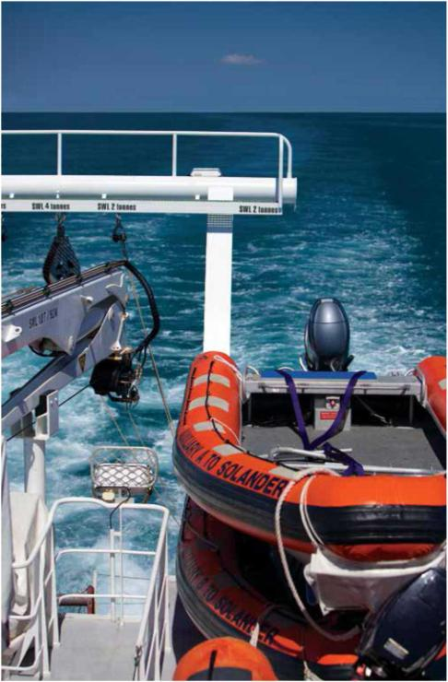
AIMS vessels are well equipped for offshore work. Image: S. Clarke AIMS

PART THREE: FINANCIAL STATEMENTS
Independent Auditor's Report 93
Statement by the Directors, Chief Executive Officer and Chief Financial Officer 95
Statement of Comprehensive Income for the period ended 30 June 2014 96
Statement of Financial Position as at 30 June 2014 97
Statement of Changes in Equity for the period ended 30 June 2014 98
Cash Flow Statement for the period ended 30 June 2014 99
Schedule of Commitments as at 30 June 2014 100
Schedule of Contingencies as at 30 June 2014 102
Notes to and forming part of the Financial Statements 103
Note 1: Summary of Significant Accounting Policies 104
Note 2: Events after the reporting period 115
Note 3: Expenses 116
Note 4: Income 117
Note 5: Fair Value Measurements 118
Note 6: Financial Assets 121
Note 7: Non-Financial Assets 122
Note 8: Payables 126
Note 9: Non-Interest Bearing Liabilities 126
Note 10: Provisions 127
Note 11: Cash Flow Reconciliation 128
Note 12: Contingent Assets and Liabilities 129
Note 13: Directors Remuneration 129
Note 14: Related Party Disclosures 129
Note 15: Senior Executive Remuneration 130
Note 16: Remuneration of Auditors 133
Note 17: Financial Instruments 133
Note 18: Financial Assets Reconciliation 136
Note 19: Reporting of Outcomes 137
Supplementary Financial Information (Unaudited) 138
Note 1: Revenue Comparison 138
Note 2: Source of sale of goods and rendering of services by sector 138
Note 3: Cost of output by Research Programs 139
Note 4: Supplier Expenses 139

Independent Auditor's Report
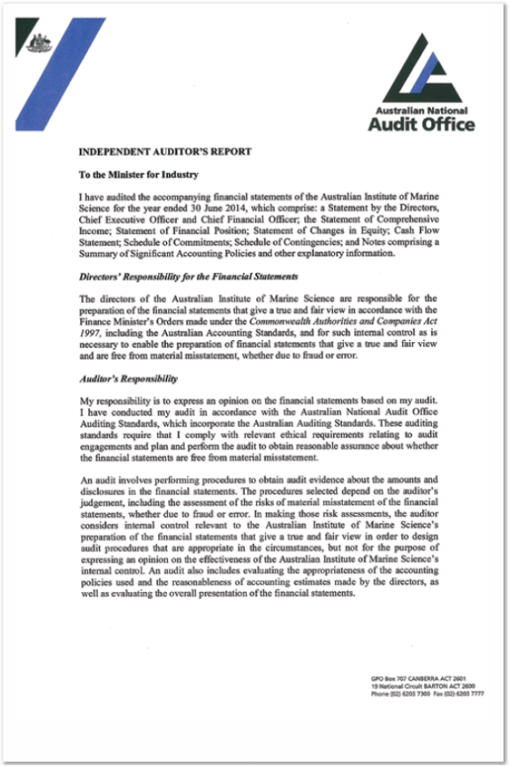
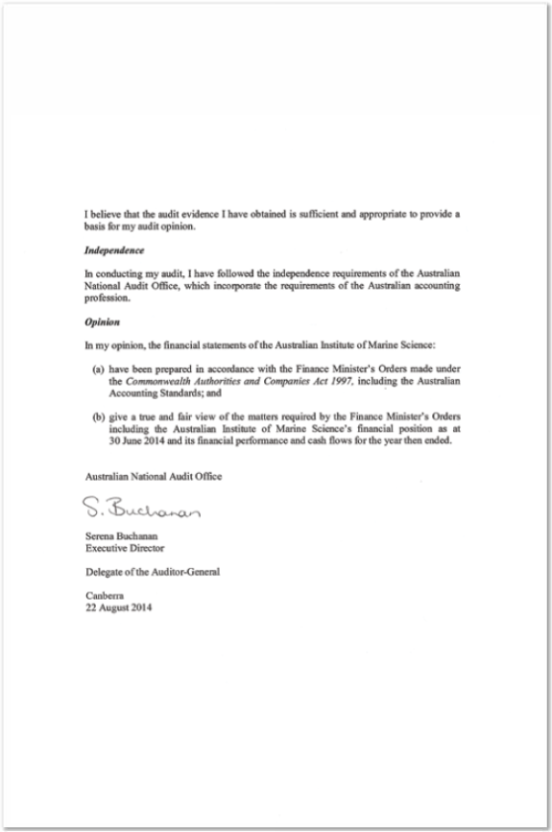

Statement by the Directors, Chief Executive Officer and Chief Financial Officer
In our opinion, the attached Financial Statements for the year ended 30 June 2014 are based on properly maintained financial records and give a true and fair view of the matters required by the Finance Minister's Orders made under the Commonwealth Authorities and Companies Act 1997, as amended.
In our opinion, at the date of this statement, there are reasonable grounds to believe that the Australian Institute of Marine Science will be able to pay its debts as and when they become due and payable.
This statement is made in accordance with the resolution of the Directors.
Signed

Mr Wayne Osborn
Chairman
22 August 2014
Signed

Mr John Gunn
Chief Executive Officer
22 August 2014
Signed

Mr Victor Bayer
Chief Finance Officer
22 August 2014

Statement of Comprehensive Income for the period ended 30 June 2014
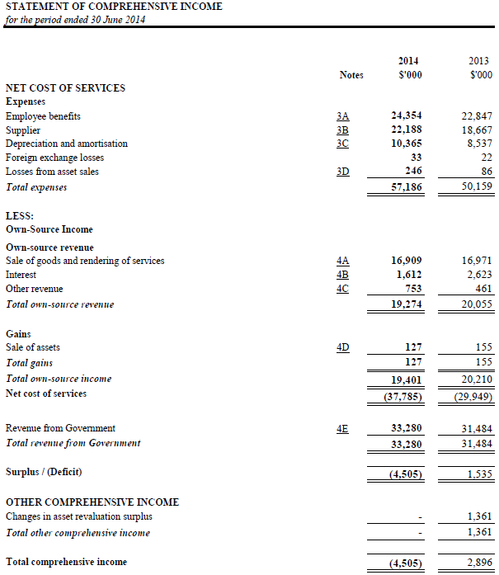
The above statement should be read in conjunction with the accompanying notes.

Statement of Financial Position as at 30 June 2014
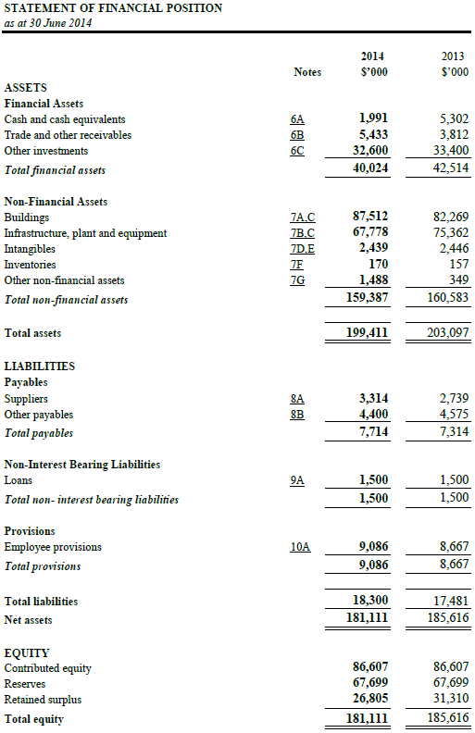
The above statement should be read in conjunction with the accompanying notes.

Statement of Changes in Equity for the period ended 30 June 2014
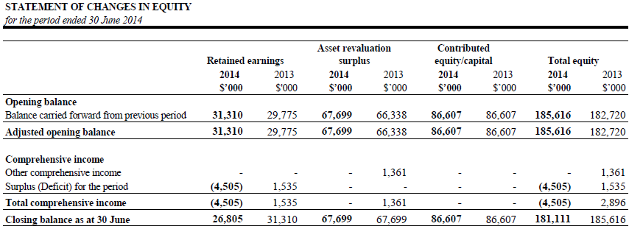
The above statement should be read in conjunction with the accompanying notes.

Cash Flow Statement for the period ended 30 June 2014
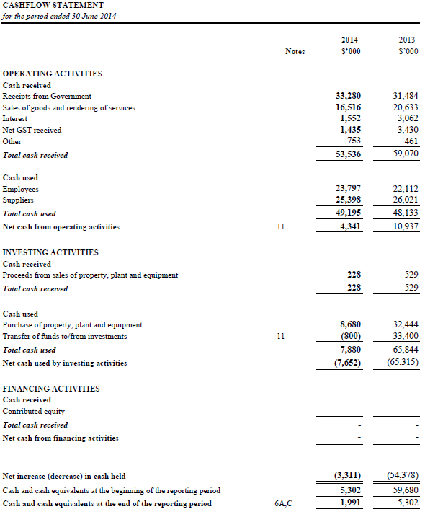

Schedule of Commitments as at 30 June 2014
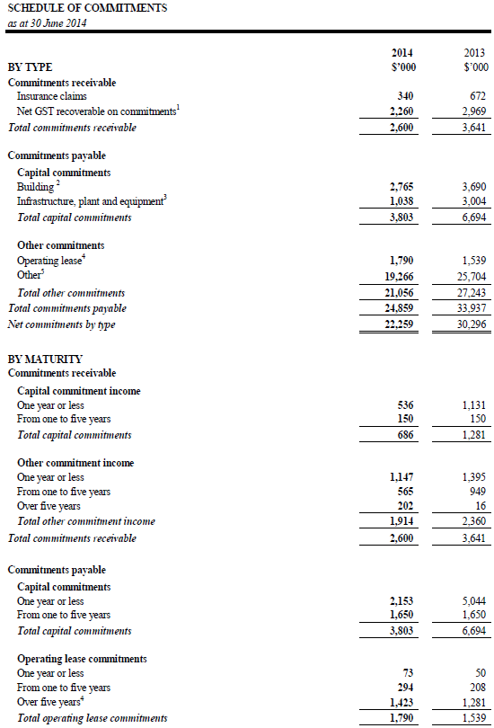
The above statement should be read in conjunction with the accompanying notes.
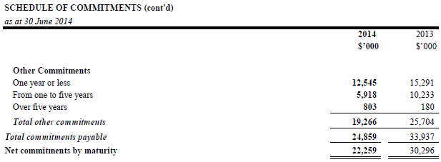
Note:
- Commitments are GST inclusive where relevant.
- Contract for construction of the Australian Tropical Marine Research Facilities Project (ATMRFP) and Indian Ocean Marine Research Centre at the University of Western Australia.
- Purchase orders for the construction of the Great Barrier Reef Ocean Observing System, scientific equipment and vehicles.
- Operating lease refers to Port of Townsville Ltd, water leases, library franking machine and the ANU licence for the ATRF land for 20 years from 1 July 2014.
- Comparative information has been restated in order to reflect the total operating lease commitment in relation to the Port of Townsville lease. This has resulted in an additional $1.281 million now being disclosed as "over 5 years".
- Purchase orders for scientific research, contractual obligations for support services and externally funded research.

Schedule of Contingencies as at 30 June 2014
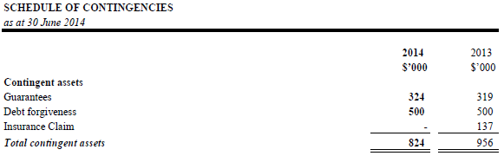
Details of each class of contingent assets and contingent liabilities including those not included above because they cannot be quantified, are disclosed in Note 12: Contingent Assets and Liabilities.
The above schedule should be read in conjunction with the accompanying notes.

Notes to and forming part of the Financial Statements
Note 1: Summary of Significant Accounting Policies
Note 2: Events After the Reporting Period
Note 3: Expenses
Note 4: Income
Note 5: Fair Value Measurements
Note 6: Financial Assets
Note 7: Non-Financial Assets
Note 8: Payables
Note 9: Non-Interest Bearing Liabilities
Note 10: Provisions
Note 11: Cash Flow Reconciliation
Note 12: Contingent Assets and Liabilities
Note 13: Directors Remuneration
Note 14: Related Party Disclosures
Note 15: Senior Executive Remuneration
Note 16: Remuneration of Auditors
Note 17: Financial Instruments
Note 18: Financial Assets Reconciliation
Note 19: Reporting of Outcomes

Note 1: Summary of Significant Accounting Policies

1.1 Objective of Australian Institute of Marine Science
Australian Institute of Marine Science (AIMS) is an Australian Government controlled entity. It is a not-for-profit entity. The objective of AIMS is to undertake scientific research in support of the protection and sustainable development of Australia's marine resources.
AIMS is structured to meet one outcome:
Outcome 1: To enhance scientific knowledge supporting the protection and sustainability of Australia's marine resources.
The continued existence of AIMS in its present form and with its present programs is dependent on Government policy and on continuing funding by Parliament for AIMS administration and programs.

1.2 Basis of preparation of the financial statements
The Financial statements are general purpose financial statements and are required by clause 1 (b) of the Commonwealth Authorities and Companies Act 1997.
The financial statements have been prepared in accordance with:
- Finance Minister's Orders (FMOs) for reporting periods ending on or after 1 July 2011; and
- Australian Accounting Standards and Interpretations issued by the Australian Accounting Standards Board (AASB) that apply for the reporting period.
The financial statements have been prepared on an accrual basis and in accordance with the historical cost convention, except for certain assets and liabilities at fair value. Except where stated, no allowance is made for the effect of changing prices on the results or the financial position.
The financial statements are presented in Australian dollars and values are rounded to the nearest thousand dollars unless otherwise specified.
Unless an alternative treatment is specifically required by an accounting standard or the FMOs, assets and liabilities are recognised in the statement of financial position when and only when it is probable that future economic benefits will flow to the entity or a future sacrifice of economic benefits will be required and the amounts of the assets or liabilities can be reliably measured. However, assets and liabilities arising under executory contracts are not recognised unless required by an accounting standard. Liabilities and assets that are unrecognised are reported in the schedule of commitments or the schedule of contingencies.
Unless alternative treatment is specifically required by an accounting standard, income and expenses are recognised in the Statement of Comprehensive Income when and only when the flow, consumption or loss of economic benefits has occurred and can be reliably measured.

1.3 Significant accounting judgements and estimates
In the process of applying the accounting policies listed in this note, AIMS has made the following judgements that have the most significant impact on the amounts recorded in the financial statements:
i) Fair value of buildings, plant and equipment
The buildings, plant and equipment have been valued at depreciated replacement cost by an independent valuer. The independent valuer deemed that the assets would seldom trade on the open market due to their specialised nature and have therefore adopted this revaluation approach.
ii) Remaining useful lives of buildings, infrastructure, plant and equipment
The independent valuers have undertaken an assessment of the remaining useful lives of buildings, infrastructure, plant and equipment based on their condition and expected usage. The remaining useful lives have been reviewed and adopted by AIMS.
iii) Recognition of revenue for rendering of services
Revenue recognised for rendering of services is accounted for on a percentage completed basis which determines the timing of revenue recognition and amount of revenue recognition. The determination of the percentage of complete requires judgements in relation to determining the costs to date of the project, budgeted costs to complete and contract values including variations.
iv) Impairment of trade receivables
Collectability of trade receivables is reviewed on an ongoing basis. Debts which are known to be uncollectible are written off as an expense. An allowance account (provision for impairment of trade receivables) is used when there is objective evidence that AIMS will not be able to collect all amounts due according to the original terms of the receivables.
v) Employee Entitlement Provision
The liability for employee benefits includes provision for annual leave and long service leave.
The liability for long service leave has been determined by reference to the work of an actuary as at 30 June 2014. The estimate of the present value of the liability takes into account attrition rates and pay increases through promotion and inflation.
vi) Contingent liabilities and contingent assets
Contingent liabilities and contingent assets are not recognised in the statement of financial position but are reported in the relevant schedules and notes. They may arise from uncertainty as to the existence of a liability or asset or represent an asset or liability in respect of which the amount cannot be reliably measured. Contingent assets are disclosed when settlement is probable but not virtually certain and contingent liabilities are disclosed when settlement is greater than remote
No accounting assumptions or estimates have been identified that have a significant risk of causing a material adjustment to carrying amounts of assets and liabilities within the next accounting period.

1.4 New Australian Accounting Standards
Adoption of New Australian Accounting Standard Requirements
No accounting standard has been adopted earlier than the application date as stated in the standard.
The following new standards, revised standards, interpretations, amending standards were issued prior to the signing of the statements by the Chairman of Council, Chief Executive Officer and Chief Financial Officer, were applicable to the current reporting period and had impact as to disclosure on AIMS financial statements.
i) AASB 13 Fair Value Measurement and AASB 2011-8 Amendments to Australian Accounting Standards arising from AASB 13 (effective 1 January 2013)
AASB 13 was released in September 2011. AASB 13 outlines how to measure fair value and aims to enhance fair value disclosures. AASB 13 defines fair value as "the price that would be received to sell an asset or paid to transfer a liability in an orderly transaction between market participants at the measurement date".
Key factors included in AASB13 are: the requirement to value non-financial assets at their highest and best use; identification of a principal (or most advantageous) market; and disclosure of all fair value measurements based on the fair value hierarchy.
AASB 13 also introduces additional disclosures. It extends the fair value hierarchy disclosures previously required for financial instruments alone to all assets and liabilities carried at fair value.
ii) AASB 119 Employee Benefits, AASB 2011-10 Amendments to Australian Accounting Standards arising from AASB 119 (September 2011) (effective 1 January 2013)
In September 2011, the AASB released a revised standard on accounting for employee benefits.
The revised AASB 119 Employee Benefits introduces a single approach for the recognition and measurement of defined benefit plans.
Previously, entities were permitted a number of measurement options, including the ability to defer some gains/losses into future periods via the corridor approach. Service costs are recognised in the profit or loss, including past service costs arising from a plan amendment, curtailment or settlement. Financing income/expense is also recognised in the profit or loss depending on whether the overall plan is in a surplus or deficit position. Any return on plan assets in excess of the discount rate is recognised in other comprehensive income.
Disclosure requirements are also revised and include disclosure of fair value information for plan assets, sensitivity analysis for major assumptions and descriptions of the risks associated with the plan. The recognition rules and definitions related to termination benefits have been revised, which could impact when entities recognise termination expenses within their financial statements.
Short-term employee benefits are now defined as employee benefits that are expected to be settled wholly within twelve months after reporting date. Previously, short-term employee benefits were defined as employee benefits due to be settled within twelve months.
AASB 119 requires retrospective application, with limited exemptions for comparative information and previously capitalised employee costs.
Other new standards, revised standards, interpretations, amending standards that were issued prior to the sign-off date and are applicable to the current reporting period did not have a financial impact, and are not expected to have a future financial impact on AIMS' financial statements.

Future Australian Accounting Standard Requirements
i) AASB 9: Financial Instruments (December 2010) and associated Amending Standards (applicable for annual reporting periods commencing on or after 1 January 2017).
These Standards will be applicable retrospectively (subject to the provisions on hedge accounting outlined below) and include revised requirements for the classification and measurement of financial instruments, revised recognition and derecognition requirements for financial instruments and simplified requirements for hedge accounting.
ii) AASB 2012-3: Amendments to Australian Accounting Standards - Offsetting Financial Assets and Financial Liabilities (applicable for annual reporting periods commencing on or after 1 January 2014).
This Standard provides clarifying guidance relating to the offsetting of financial instruments, which is not expected to impact the AIMS's financial statements.
iii) AASB 2013-3: Amendments to AASB 136 - Recoverable Amount Disclosures for Non-Financial Assets (applicable for annual reporting periods commencing on or after 1 January 2014).
This Standard amends the disclosure requirements in AASB 136: Impairment of Assets pertaining to the use of fair value in impairment assessment and is not expected to significantly impact the AIMS's financial statements.
iv) AASB 1055 Budgetary Reporting (effective 1 January 2014)
AASB 1055 sets out budgetary disclosure requirements for the whole-of-government, the General Government Sector (GGS) and for not-for-profit entities within the GGS of each government.
AASB 1055 requires:
- disclosure of any entity's original budgeted financial statements reflecting controlled items and administered items;
- explanations of major variances between the actual amounts presented in the financial statements and the corresponding original budgeted amounts for departmental and administered items; and
- disclosure of the budgeted information on the same presentation and classification bases adopted in the financial statements for departmental and administered items.
The explanations of major variances required to be disclosed are those relevant to an assessment of the discharge of accountability and to the analysis of performance of an entity. They include high-level explanations of the cause of major variances rather than merely the nature of the variance.
Any revised budget that is presented to parliament during the reporting period may be disclosed in the financial statements in addition to the original budget and might need to be referred to in the explanations of major variances.
If the disclosure of budgeted financial statements is not consistent with the presentation and classification bases adopted in the financial statements of controlled and administered items, the budgeted statements are restated for disclosure purposes to align with presentation and classification bases in the financial statements.
Comparative budgetary information in respect to the previous reporting is not required to be disclosed. AIMS will adopt this standard from 1 July 2014.
Other new standards, revised standards, interpretations, amending standards that were issued prior to the sign-off date and are applicable to future reporting periods are not expected to have a future material impact on AIMS' financial statements.

1.5 Revenue
Revenue from the sale of goods is recognised when:
- the risks and rewards of ownership have been transferred to the buyer;
- AIMS retains no managerial involvement or effective control over the goods;
- the revenue and transaction costs incurred can be reliably measured; and
- it is probable that the economic benefits associated with the transaction will flow to AIMS.
Revenue from rendering of services is recognised by reference to the stage of completion of contracts at the reporting date. The revenue is recognised when:
- the amount of revenue, stage of completion and transaction costs incurred can be reliably measured; and
- the probable economic benefits associated with the transaction will flow to AIMS.
The stage of completion of contracts at the reporting date is determined by reference to the proportion that costs incurred to date bear to the estimated cost of the transaction. Where losses are anticipated they are provided for in full.
Receivables include trade receivables and contract works in progress based on stage of completion.
Receivables for goods and services, which have 30 day terms, are recognised at the nominal amounts due less any impairment allowance account. Collectability of debts is reviewed as at the end of reporting period. Allowances are made when collectability of the debt is no longer probable.
Interest revenue is recognised using the effective interest method as set out in AASB 139 Financial Instruments: Recognition and Measurement.

Revenue from Government
Funding received or receivable from agencies (appropriated to the agency as a CAC Act body payment item for payment to AIMS) is recognised as Revenue from Government unless they are in the nature of an equity injection or loan.

1.6 Gains

Sale of Assets
Gains from disposal of assets are recognised when control of the asset has passed to the buyer.

1.7 Transactions with the Government as owner

Equity Injections
Amounts appropriated that are designated as 'equity injections' for a year are recognised directly in contributed equity in that year.

Other Distributions to Owners
The FMOs require that distributions to owners be debited to contributed equity unless it is in the nature of a dividend. In 2013-14, by agreement with the Department of Finance, AIMS did not relinquish control of any surplus output appropriation funding.

1.8 Employee benefits
Liabilities for 'short-term employee benefits' (as defined in AASB 119 Employee Benefits) and termination benefits due within twelve months of the end of reporting period are measured at their nominal amounts. The nominal amount is calculated with regard to the rates expected to be paid on settlement of the liability.
Other long-term employee benefits are measured as net total of the present value of the defined benefit obligation at the end of the reporting period minus the fair value at the end of the reporting period of plan assets (if any) out of which the obligations are to be settled directly.

Leave
The liability for employee benefits includes provision for annual leave and long service leave. No provision has been made for sick leave as all sick leave is non-vesting and the average sick leave taken in future years by employees of the entity is estimated to be less than the annual entitlement for sick leave.
The leave liabilities are calculated on the basis of employees' remuneration at the estimated salary rates that will be applied at the time the leave is taken, including AIMS' employer superannuation contribution rates to the extent that the leave is likely to be taken during service rather than paid out on termination.
The liability for long service leave as at the end of June 2014 has been determined by the short hand method and reference to the work of the Australian Government Actuary (AGA). The estimate of the present value of the liability takes into account attrition rates and pay increases through promotion and inflation.

Separation and redundancy
Provision is made for separation and redundancy benefit payments. AIMS recognises a provision for termination when it has developed a detailed formal plan for the terminations and has informed those employees affected that it will carry out the terminations.

Superannuation contributions
AIMS' staff are members of the Commonwealth Superannuation Scheme (CSS), the Public Sector Superannuation Scheme (PSS), the PSS accumulation plan (PSSap), Uni Super, Australian Super (AUS), Australian Ethical and Sunsuper.
The CSS and PSS are defined benefit schemes for the Australian Government. The PSSap, Uni Super, AUS, Australian Ethical and Sunsuper are defined (accumulation funds) contribution schemes.
The liability for defined benefits is recognised in the financial statements of the Australian Government and is settled by the Australian Government in due course. This liability is reported in the Department of Finance's administered schedules and notes.
AIMS makes employer contributions to the employees' superannuation scheme at rates determined by an actuary to be sufficient to meet the current cost of the superannuation entitlements of AIMS employees to the Government. AIMS accounts for the contributions as if they were contributions to defined contribution plans.
The liability for the superannuation recognised as at 30 June represents outstanding contributions for the final pay of the year.

1.9 Cash
Cash is recognised at its nominal amount. Cash and cash equivalents include:
- cash on hand, and
- demand deposits in bank accounts with an original maturity of 3 months or less that are readily convertible to known amounts of cash and subject to insignificant risk of changes in value.

1.10 Financial assets
AIMS classifies its financial assets in the following categories:
- held-to-maturity investments, and
- loans and receivables.
The classification depends on the nature and purpose of the financial assets and is determined at the time of initial recognition. Financial assets are recognised and derecognised upon trade date.

Held-to-maturity investments
Non-derivative financial assets with fixed or determinable payments and fixed maturity dates that the group has the positive intent and ability to hold to maturity are classified as held-to-maturity investments. Held-to-maturity investments are recorded at amortised cost.

Loans and receivables
Trade receivables, loans and other receivables that have fixed or determinable payments that are not quoted in an active market are classified as 'loans and receivables". Loans and receivables are measured at amortised cost.

Impairment of financial assets
Financial assets are assessed for impairment at the end of each reporting period.
Financial assets held at amortised cost - if there is objective evidence that an impairment loss has been incurred for loans and receivables or held to maturity investments held at amortised cost, the amount of the loss is measured as the difference between the asset's carrying amount and the present value of estimated future cash flows discounted at the asset's original effective interest rate. The carrying amount is reduced by way of an allowance account. The loss is recognised in the statement of comprehensive income.

1.11 Jointly controlled assets
AIMS has interests in:
- AIMS@JCU Joint Venture
- Arafura Timor Research Facility Joint Venture
AIMS' proportionate interests in the assets, liabilities and expenses of each joint venture activities have been incorporated in the financial statements under the appropriate headings.

AIMS@JCU Joint Venture
AIMS has an interest in the AIMS@JCU Joint Venture with James Cook University (JCU) to:-
- increase research activities by the participants in determined programs; and
- to improve participants' individual research capabilities and research outputs and outcomes of all participants.
The joint venture has a Board which determines the research objective for funding. The agreement specifies that the share that each participant is to receive from the joint venture is to be determined by the Board.
AIMS' proportionate interests in the assets and revenue of the joint venture activities have been incorporated in the financial statements under the appropriate headings.

Arafura Timor Research Facility Joint Venture
AIMS has an interest in the Arafura Timor Research Facility Joint venture with the Australian National University. AIMS has a 50% share. The purpose of the venture is to maintain a research facility in Darwin that will create a centre of excellence in the field of physical, chemical engineering, information and biological sciences with the capability of pursuing world class research and training in that field. The Australian National University is responsible for managing the financial affairs of the joint venture.
AIMS' proportionate interests in the assets of the joint venture activities have been incorporated in the financial statements under the appropriate headings.

1.12 Financial liabilities
Financial liabilities are classified as either financial liabilities at 'fair value through profit or loss' or other financial liabilities. Financial liabilities are recognised and derecognised upon 'trade date'.

Financial liabilities at fair value through profit or loss
Financial liabilities at fair value through profit or loss are initially measured at fair value. Subsequent fair value adjustments are recognised in profit or loss. The net gain or loss recognised in profit or loss incorporates any interest paid on the financial liability.

Other financial liabilities
Other financial liabilities, including borrowings, are measured at fair value, net of transaction costs.
Supplier and other payables are recognised at amortised cost. Liabilities are recognised to the extent that the goods or services have been received (and irrespective of having been invoiced).

1.13 Acquisition of assets
Assets are recorded at cost on acquisition except as stated below. The cost of acquisition includes the fair value of assets transferred in exchange and liabilities undertaken. Financial assets are initially measured at their fair value plus transaction costs where appropriate.
Assets acquired at no cost, or for nominal consideration, are initially recognised as assets and income at their fair value at the date of acquisition, unless acquired as consequence of restructuring of administrative arrangements. In the latter case, assets are initially recognised as contributions by owners at the amounts at which they were recognised in the transferor's accounts immediately prior to the restructuring.

1.14 Property, plant and equipment

Asset recognition threshold
Purchases of property, plant and equipment are recognised initially at cost in the statement of financial position, except for purchases costing less than $2,000, which are expensed in the year of acquisition (other than where they form part of a group of similar items which are significant in total).

Revaluations
Fair values for each class of asset are determined as shown below:
Class of Asset | Fair value measured at
Buildings | Depreciated Replacement Cost
Plant and equipment | Open Market Value where such a market exists or Depreciated Replacement Cost
Computer equipment | Open Market Value where such a market exists or Depreciated Replacement Cost
Vehicles | Open Market Value where such a market exists or Depreciated Replacement Cost
Office equipment | Open Market Value where such a market exists or Depreciated Replacement Cost
Ships, launches and vessels | Open Market Value where such a market exists or Depreciated Replacement Cost
Library books | Open Market Value where such a market exists or Depreciated Replacement Cost
Following initial recognition at cost, property, plant and equipment are carried at fair value less subsequent accumulated depreciation and accumulated impairment losses. Valuations are conducted with sufficient frequency to ensure that the carrying amounts of assets do not differ materially from the assets' fair values as at the reporting date. The regularity of independent valuations depended upon the volatility of movements in market values for the relevant assets but are carried out at least every three years.
Revaluation adjustments are made on a class basis. Any revaluation increment was credited to equity under the heading of asset revaluation reserve except to the extent that it reversed a previous revaluation decrement of the same asset class that was previously recognised in the surplus/deficit. Revaluation decrements for a class of assets are recognised directly in the surplus/deficit except to the extent that they reversed a previous revaluation increment for that class.
Any accumulated depreciation as at the revaluation date is eliminated against the gross carrying amount of the asset and the asset restated to the revalued amount.

Depreciation
Depreciable property, plant and equipment assets are written-off to their estimated residual values over their estimated useful lives to the entity using, in all cases, the straight-line method of depreciation. Depreciation rates (useful lives), residual values and methods are reviewed at each reporting date and necessary adjustments are recognised in the current, or current and future reporting periods, as appropriate.
Depreciation rates applying to each class of depreciable asset are based on the following useful lives:
Class of Asset | 2014 | 2013
Buildings | 9 - 69 years | 9 - 69 years
Plant and equipment | 3 - 47 years | 3 - 47 years
Computer equipment | 3 - 28 years | 3 - 28 years
Vehicles | 3 - 20 years | 3 - 20 years
Office equipment | 4 - 56 years | 4 - 56 years
Ships, launches and vessels | 4 - 25 years | 4 - 25 years
Library books | 3 - 100 years | 3 - 100 years

Impairment
All assets were assessed for impairment at 30 June 2014. Where indications of impairment exist, the asset's recoverable amount is estimated and an impairment adjustment made if the asset's recoverable amount is less than its carrying amount.
The recoverable amount of an asset is the higher of its fair value less costs to sell and its value in use. Value in use is the present value of the future cash flows expected to be derived from the asset. Where the future economic benefit of an asset is not primarily dependent on the asset's ability to generate future cash flows, and the asset would be replaced if AIMS was deprived of the asset, its value in use is taken to be its depreciated replacement cost.

1.15 Intangibles
AIMS' intangibles comprise software. These assets are carried at fair value less accumulated amortisation and accumulated impairment losses.
Software is amortised on a straight-line basis over its anticipated useful life. The useful lives of the AIMS' software are 2 to 10 years (2012-13: 2 to 10 years).
All software assets were assessed for indications of impairment as at 30 June 2014.

1.16 Inventories
Inventories held for distribution are valued at cost, adjusted for any loss of service potential.
Costs incurred in bringing each item of inventory to its present location and condition are assigned as follows:
- raw materials and stores - purchase cost on a first-in-first-out basis; and
- finished goods and work-in-progress - cost of direct materials and labour plus attributable costs that can be allocated on a reasonable basis.

1.17 Taxation
AIMS is exempt from all forms of taxation except Fringe Benefits Tax (FBT) and the Goods and Services Tax (GST). Revenues, expenses and assets are recognised net of GST except:
- where the amount of GST incurred is not recoverable from the Australian Taxation Office; and
- for receivables and payables.

1.18 Foreign currency
Transactions denominated in a foreign currency are converted at the exchange rate at the date of the transaction. Foreign currency receivables and payables are translated at the exchange rate as at the balance date. Associated currency gains and losses are not material.

1.19 Research, development and intellectual property
Costs associated with research and development, intellectual property, patents and trademarks are expensed as incurred unless it can be established that they are recoverable beyond reasonable doubt.

1.20 Contract research
AIMS has entered into various agreements with external parties for the research and development of technologies and scientific knowledge. Details of the ownership of intellectual property vary from agreement to agreement. These arrangements do not involve sharing in common of liabilities and interest in assets, other than assets represented by intellectual property to which AIMS does not attribute any value in the Financial Statements.

1.21 Consultancies and Grants
Various consultancies and grants have been made to AIMS for specific research projects, seminar, workshops and employment assistance. Monies are paid either in advance or in arrears and the difference at 30 June is reflected as either creditors or receivables respectively.

1.22 Change in accounting policy
There has been no change in accounting policy in respect of transactions with the Government as owner.
The Australian National University (ANU) terminated the Arafura Timor Research Facility Joint Venture as at 30 June 2014. From 1 July 2014 AIMS will hold 100% ownership of the building, equipment and contents. AIMS will be responsible for the operation and maintenance cost of the facility. ANU will retain the land with AIMS paying an annual licence. The term of the licence is 20 years.

Note 2: Events after the reporting period
The Australian National University (ANU) terminated the Arafura Timor Research Facility Joint Venture as at 30 June 2014. From 1 July 2014 AIMS will hold 100% ownership of the building, equipment and contents. AIMS will be responsible for the operation and maintenance cost of the facility. ANU will retain the land with AIMS paying an annual licence. The term of the licence is 20 years.

Note 3: Expenses
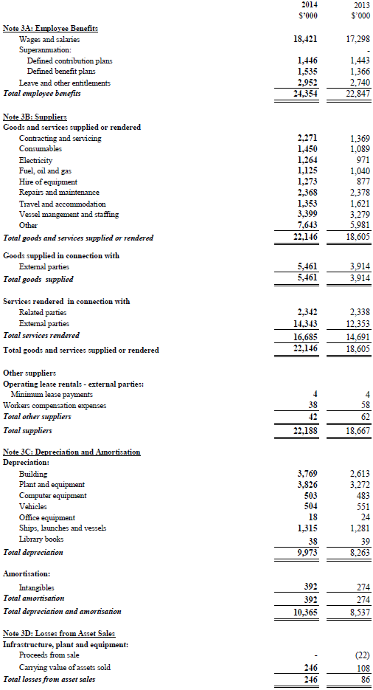

Note 4: Income
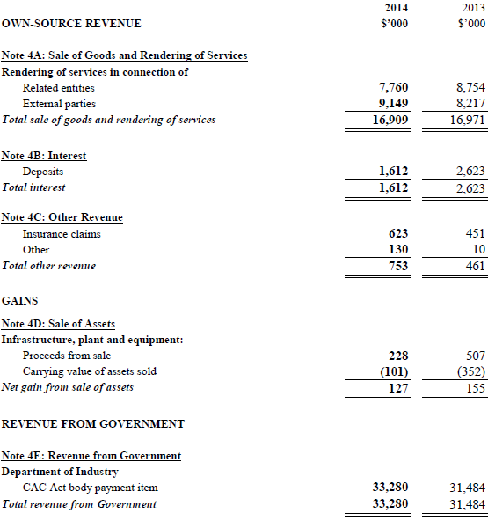

Note 5: Fair Value Measurements
The following tables provide an analysis of assets and liabilities that are measured at fair value. The different levels of the fair value hierarchy are defined below.
Level 1: Quoted prices (unadjusted) in active markets for identical assets or liabilities that the entity can access at measurement date.
Level 2: Inputs other than quoted prices included within Level 1 that are observable for the asset or liability, either directly or indirectly.
Level 3: Unobservable inputs for the asset or liability.

Note 5A: Fair Value Measurements

Fair value measurements at the end of the reporting period by hierarchy for assets and liabilities in 2014
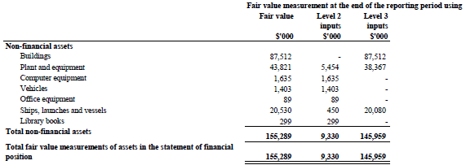
AIMS does not measure any liabilities at Fair Value on a recurring basis.
AIMS has assets and liabilities which are not measured at fair value, but for which fair value are disclosed and in other notes.
AIMS borrowings are measured at amortised cost. The Fair Value of borrowing disclosed in Note 9A is provided by the Queensland Government (Level 2).
The carrying amounts of trade receivables and trade payabales are assumed to approximate their Fair Values due to their short term nature (Level 2).

Fair value measurements - highest and best use differs from current use for non-financial assets (NFAs)
Statement at disclosure that during valuation review management determined that for all asset carried at fair value there is no difference between highest and best use from current use.

Note 5B: Level 1 and Level 2 Transfers for Recurring Fair Value Measurements
There were no transfer between level 1 and level 2 for recurring assets.

Note 5C: Valuation Technique and Inputs for Level 2 and Level 3 Fair Value Measurements
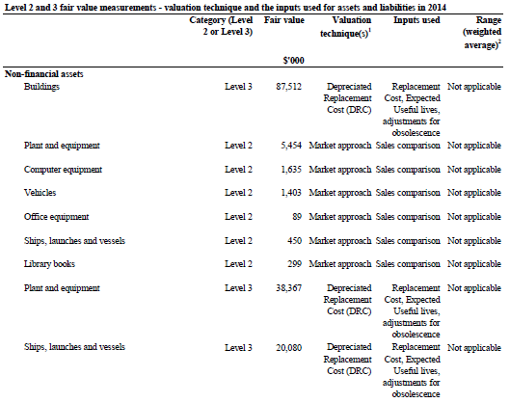
1. No Change in valuation technique occurred during ther period.
2. There were no significant unobserable inputs used in any of the valuations for level 3 assets.

Recurring Level 3 fair value measurements - valuation processes
For assets that Pickles Valuation Services (PVS) were unable to identify a market comparison an alternative approach was required. These assets were tested by a Cost approach valuation, a depreciated replacement cost (DRC) approach, containing Level 3 Inputs. In doing so, PVS reviewed the estimated replacement cost, total useful lives (TUL), and remaining useful lives (RUL) were in line with industry standards to ensure the DRC calculation was accurate. Within the review, PVS tested the new replacement costs obtained from manufactures to ascertain if the most current replacement costs and utilities of the asset were the same or had there been some impairment for technological or functionally factors. Furthermore, from a macro viewpoint the review approached certain economic drivers that may have increased new price e.g. steel price or labour costs. The TUL and RUL of these components were also reviewed as they affect the formula used to ascertain Fair Value, and fall under the Level 3 inputs (DRC). PVS compared market recommended lives for similar assets and trends in the market.

Recurring Level 3 fair value measurements - sensitivity of inputs
The unobservable inputs used in the fair value measurement of the level 3 other property, plant and equipment items are expected useful lives and any adjustment for obsolesce. Increases (decreases) in expected useful lives would result in higher (lower) fair value measurement and increases (decreases) in adjustments for obsolesce would result in lower (higher) fair value measurement.

Note 5D: Reconciliation for Recurring Level 3 Fair Value Measurements

Recurring Level 3 fair value measurements - reconciliation for assets
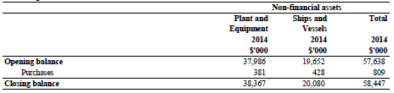

Note 6: Financial Assets
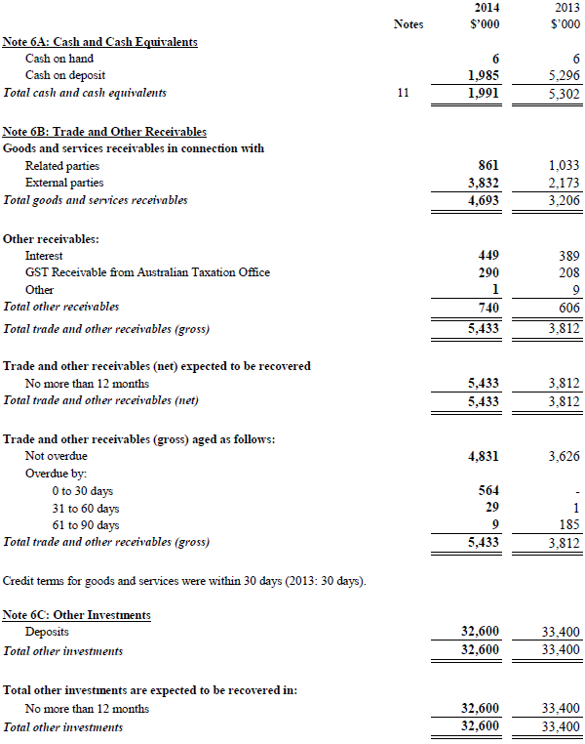

Note 7: Non-Financial Assets
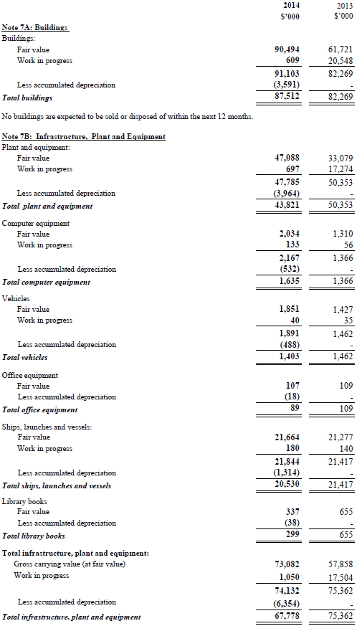
No infrastructure, plant or equipment is expected to be sold or disposed of within the next 12 months.

Note 7C: Reconciliation of the Opening and Closing Balances of Property. Plant and Equipment (2013-14)
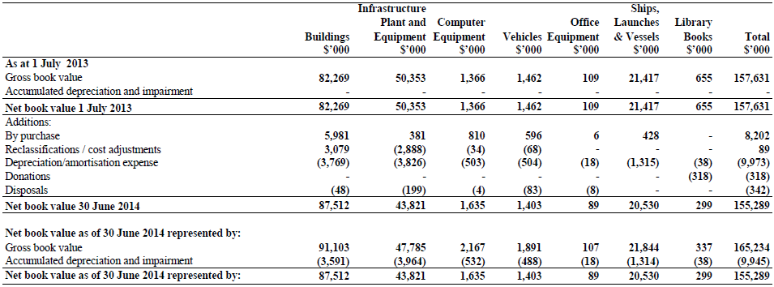

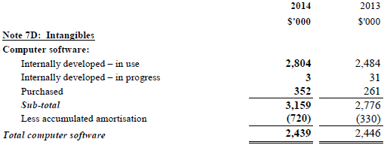
No intangibles are expected to be sold or disposed of within the next 12 months.

Note 7E: Reconciliation of the Opening and Closing Balances of Intangibles (2013-14)
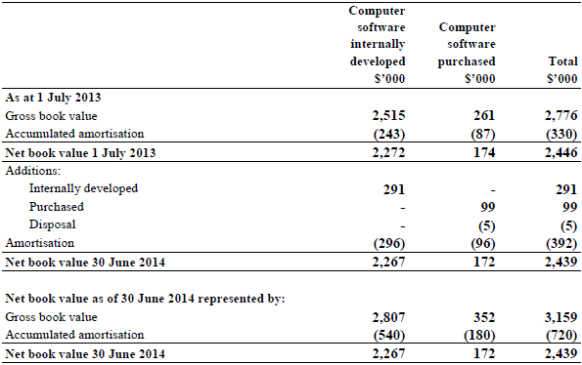

Note 7E (Cont'd): Reconciliation of the Opening and Closing Balances of Intangibles (2012-13)
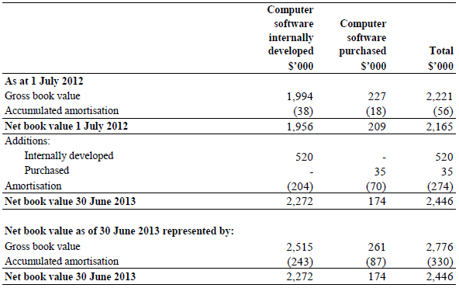
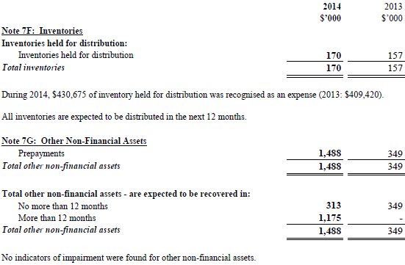

Note 8: Payables
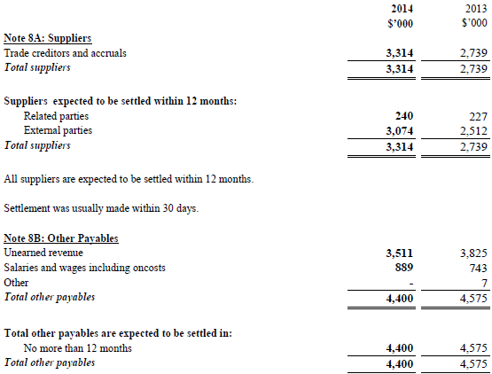

Note 9: Non-Interest Bearing Liabilities
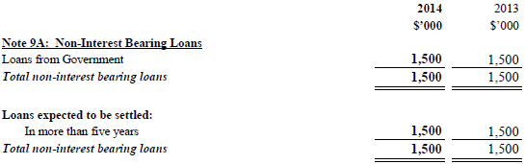
Loan Information:
The loan was provided on 7th November 2007 by the Queensland Government Department of Tourism, Regional Development and Industry, with repayments commencing after 10 years. There is no interest payable on the loan.
For further information regarding loan from Government refer Note 12.

Note 10: Provisions
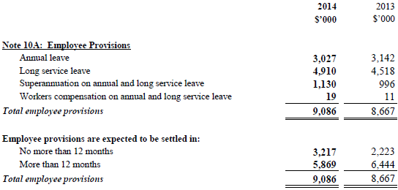

Note 11: Cash Flow Reconciliation
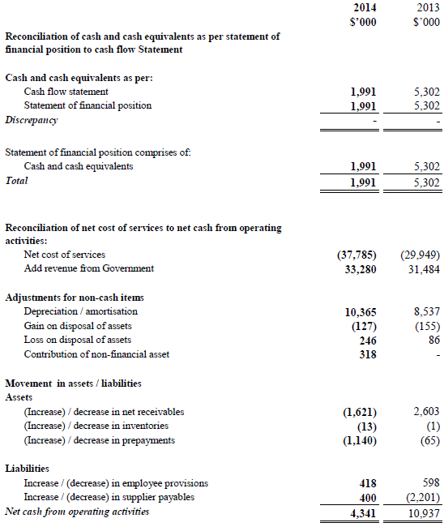

Note 12: Contingent Assets and Liabilities
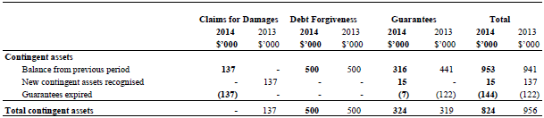
Quantifiable Contingencies
AIMS holds performance guarantees of $324,000 (2013: $319,000)
A contingent asset of $500,000 is reported in respect of a non-current liability funded by the Queensland Government Department of Tourism, Regional Development and Industry for $1.5 million. The contingent asset of $500,000 is a forgiveness amount providing certain criteria is met over the life of the loan to 7 November 2037.
Unquantifiable Contingencies
At 30 June 2014, AIMS has a 25 year lease on a berthing facility with Port of Townsville. At the expiry of the lease AIMS is required to carry out at its own cost remediation work necessary to return the level of contamination in the leased land to a level as prescribed by Assessment and Management of Contaminated Land in Queensland (May 1998). AIMS is unable to reliably estimate the cost of any future remediation.
Significant Remote Contingencies
AIMS had no significant remote contingencies.

Note 13: Directors Remuneration
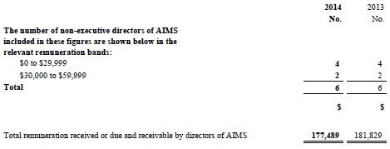
The Directors (members of Council) of AIMS are appointed by the Governor General. Remuneration of Chief Excecutive Officer is included in Note 15: Senior Executive Remuneration.

Note 14: Related Party Disclosures
Loans to Directors and Director-Related Entities
There were no loans made to any Director or Director-related entities during the period (2013: Nil)
Other transactions with Directors or Director-Related Entities
There were no other transactions with Directors or Director- related entities during the period (2013: Nil).

Note 15: Senior Executive Remuneration

Note 15A: Senior Executive Remuneration Expenses for the Reporting Period
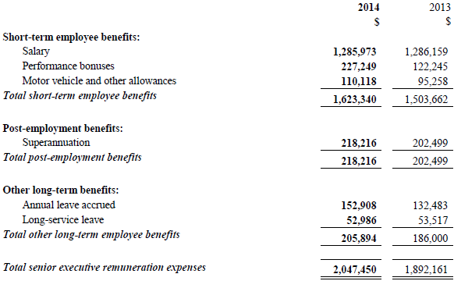
During the year AIMS paid $Nil in termination benefits to senior executives (2013: Nil).
Notes:
1. Note 15A is prepared on an accrual basis (therefore the performance bonus expenses disclosed above may differ from the cash 'Bonus paid' in Note 15B).
2. Note 15A excludes acting arrangements and part-year service where total remuneration expensed for a senior executive was less than $195,000.
3. Comparative amounts have been restated following the allocation of accrued annual leave from short-term employee benefits to other long-term benefits of $60,093.

Note 15B: Average Annual Reportable Remuneration Paid to Substantive Senior Executives During the Reporting Period

Average annual reportable remuneration paid to substantive senior executives in 2014
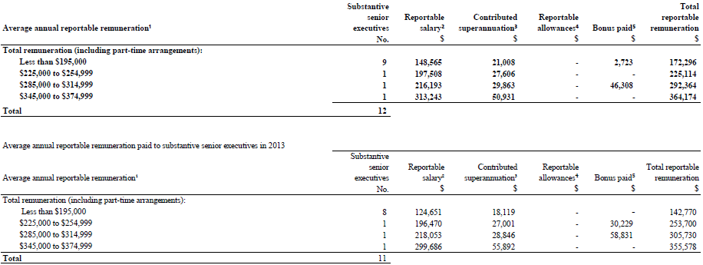
Notes:
1. This table reports substantive senior executives who received remuneration during the reporting period. Each row is an averaged figure based on headcount for individuals in the band.
2. 'Reportable salary' includes the following:
a) gross payments (less any bonuses paid, which are separated out and disclosed in the 'bonus paid' column);
b) reportable fringe benefits (at the net amount prior to 'grossing up' to account for tax purposes); and
c) reportable employer superannuation contributions.
3. The 'contributed superannuation' amount is the average actual superannuation contributions paid to senior executives in that reportable remuneration band during the reporting period.
4. 'Reportable allowances' are the average actual allowances paid as per the 'total allowances' line on individuals' payment summaries.
5. 'Bonus paid' represents average actual bonuses paid during the reporting period in that reportable remuneration band. The 'bonus paid' within a particular band may vary between financial years due to various factors such as individuals commencing with or leaving the entity during the financial year.
6. Salary banding in 2013-14 commenced at $195,000 (2012-13 $180,000).

Note 15C: Average Annual Reportable Remuneration Paid to Other Highly Paid Staff during the Reporting Period

Average annual reportable remuneration paid to other highly paid staff in 2014
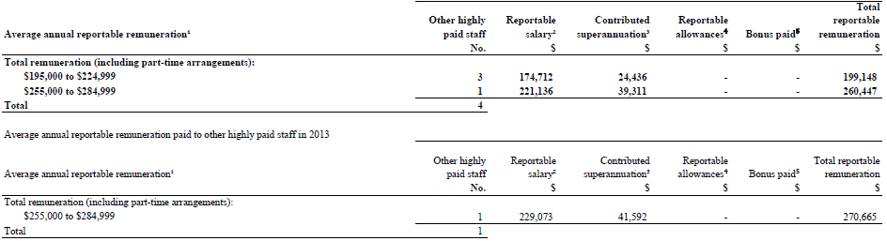
Notes:
1. This table reports staff:
a) who were employed by the entity during the reporting period;
b) whose reportable remuneration was $195,000 or more for the financial period; and
c) were not required to be disclosed in Tables A, B or director disclosures. Each row is an averaged figure based on headcount for individuals in the band.
2. 'Reportable salary' includes the following:
a) gross payments (less any bonuses paid, which are separated out and disclosed in the 'bonus paid' column);
b) reportable fringe benefits (at the net amount prior to 'grossing up' to account for tax benefits); and
c) reportable employer superannuation contributions.
3. The 'contributed superannuation' amount is the average cost to Aims for the provision of superannuation benefits to other highly paid staff in that reportable remuneration band during the reporting period.
4. 'Reportable allowances' are the average actual allowances paid as per the 'total allowances' line on individuals' payment summaries.

Note 16: Remuneration of Auditors
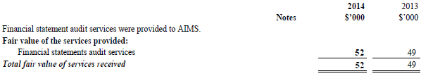
No other services were provided by the auditors of the financial statements.

Note 17: Financial Instruments
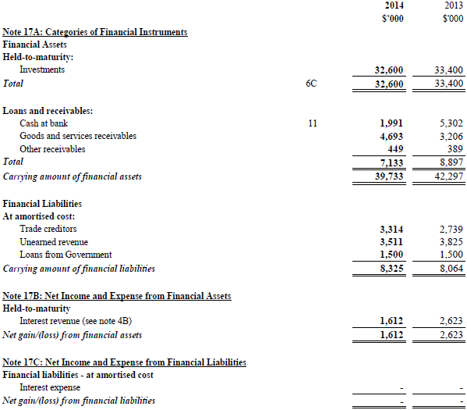
The total interest expense from financial liabilities not at fair value through profit or loss was $Nil (2013: $Nil)

Note 17D: Fair Value of Financial Instruments
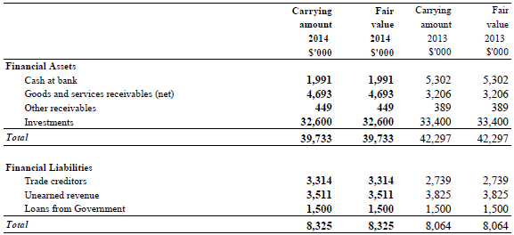
The fair values disclosed in the above table have been determined based on the following methodology: Cash and cash equivalents, receivables for goods and services, trade and other payables are short-term instruments in nature whose carrying value is equivalent to fair value. Trade and other payables excludes amounts relating to the provision of annual leave, which is not considered a financial instrument.

Note 17E: Credit Risk
AIMS is exposed to minimal credit risk as the majority of loans and receivables are cash. The maximum exposure to credit risk is the risk that arises from potential default of a debtor. This amount is equal to the total amount of trade receivables (2014: $4,692,637 and 2013: $3,205,870).
AIMS manages its credit risk by entering into contracts with external parties prior to establishing a debtor relationship.
In addition, AIMS has policies and procedures that guide employees debt recovery techniques that are to be applied.

The following table illustrates the entity's gross exposure to credit risk, excluding any collateral or credit enhancements.
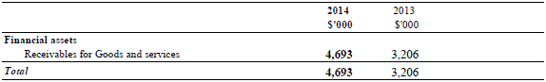
AIMS holds no collateral to mitigate against credit risk.

Credit quality of financial instruments not past due or individually determined as impaired
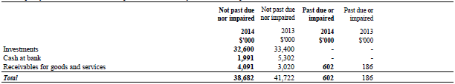
Credit risk related to balances with banks is managed by the management committee in accordance with approved council policy. Such policy requires that surplus funds are only invested with Commonwealth Bank of Australia, Westpac Banking Corporation, National Australia Bank and Australia and New Zealand Banking Group Ltd. The maximum amount invested with an eligible authorised deposit-taking institution shall not exceed 50% of total investments.

Ageing of financial assets that were past due but not impaired for 2014
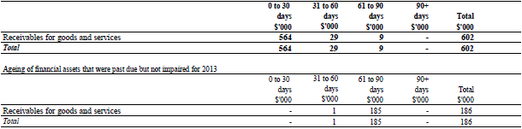

Note 17F: Liquidity Risk
AIMS financial liabilities are payables, consultancies and grants, joint ventures and loans from government. The exposure to liquidity risk is based on the notion that AIMS will encounter difficulty in meeting its obligations associated with financial liabilities. This is highly unlikely due to the appropriation funding available to AIMS. The following table illustrates the maturities of financial liabilities.

Maturities for non-derivative financial liabilities 2014
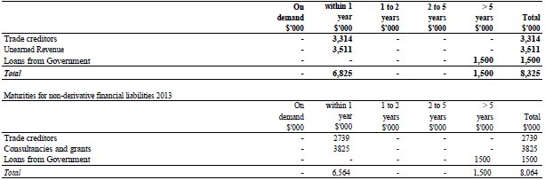
AIMS has no derivative financial liabilities in both the current and prior year.
AIMS receives appropriation funding from the Australian Government. AIMS manages its budgeted funds to ensure it has adequate funds to meet payments as and when they fall due. In addition, AIMS has policies in place to ensure timely payments are made when due and has not past experience of default.

Note 17G: Market Risk
AIMS holds basic financial instruments that do not expose AIMS to certain market risks such as "currency risks" and other "price risks". AIMS is moderately exposed to an 'interest rate risk' but is not significantly exposed to 'other price risk' and 'currency risk'.
The only interest-bearing items on the balance sheet are the cash at bank and investments. Interest earned on cash at bank and investments may be effected by changes in market interest rates. The following table represents the effect to the profit and loss and equity. 0.6% is anticipated to be a reasonable estimate of the maximum movement in market interest rates in financial year 2013-14.

Sensitivity of the analysis that the entity is exposed to for 2014
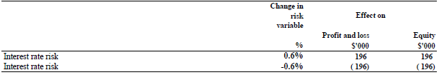

Sensitivity of the analysis that the entity is exposed to for 2013
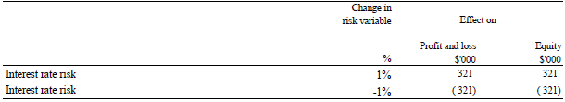

Note 18: Financial Assets Reconciliation
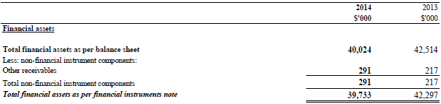

Note 19: Reporting of Outcomes

Note 19A: Net Cost of Outcome Delivery
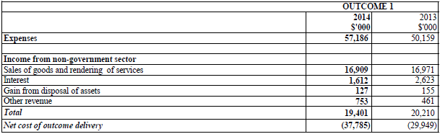

Supplementary Financial Information (Unaudited)
Note 1: Revenue Comparison
Note 2: Source of sale of goods and rendering of services by sector
Note 3: Cost of output by Research Programs
Note 4: Supplier Expenses (as per Note 3B of Financial Statements)

Note 1: Revenue Comparison
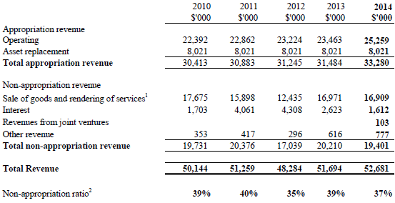
¹ Sale of goods and rendering of services includes consultancies, grants and contract collaborations.
² Non-appropriation ratio is percentage non-appropriation revenue of total revenue.

Note 2: Source of sale of goods and rendering of services by sector
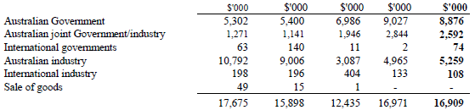
Source of Sale of Goods and Services by Industry
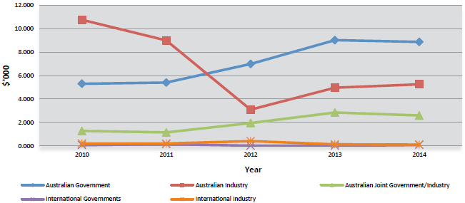

Note 3: Cost of output by Research Programs
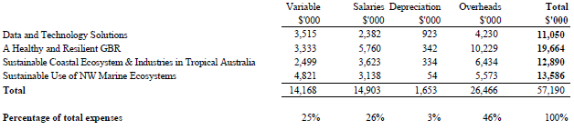

Note 4: Supplier Expenses
Expenses | 2014 | 2013
Consist of: | $'000 | $'000
Appointment expenses | 170 | 200
Auditing | 51 | 49
Catering | 109 | 101
Chemical and laboratory supplies | 374 | 297
Cleaning and ground maintenance | 370 | 338
Collaborations | 2,349 | 985
Communications, telephone and postage | 497 | 410
Consultancies | 120 | -
Contracting and servicing | 2,271 | 1,369
Consumables | 1,450 | 1,089
Electricity | 1,264 | 971
Equipment and software purchases | 218 | 73
Field costs | 512 | 567
Freight | 396 | 422
Fuel, oil and gas | 1,125 | 1,040
Hire of equipment | 1,273 | 877
Insurances | 438 | 435
Lab Services | 32 | -
Legal | 53 | 10
Licences and fees | 350 | 319
Operating lease rentals | 4 | 4
Patents and trademarks | - | 6
Publications, journals and subscriptions | 378 | 388
Rent | 229 | 476
Repairs and maintenance | 2,368 | 2,378
Security | 373 | 364
Stationery | 50 | 46
Tenders and outboards | 15 | 18
Training, seminars and conferences | 266 | 173
Travel and accommodation | 1,353 | 1,621
Vessels management and staffing | 3,399 | 3,279
Victuals | 125 | 139
Water | 168 | 166
Workers compensation | 38 | 58
Total supplier expenses | 22,188 | 18,667

PART FOUR: APPENDICES
Appendix 1. SCIENCE PUBLICATIONS 142
Appendix 2. EXTERNAL COMMITTEES AND NON-GOVERNMENT ORGANISATIONS AND POSITIONS 163
International Forum 163
Appendix 3. LEGISLATIVE FOUNDATION AND MINISTERIAL POWERS 167

Appendix 1. SCIENCE PUBLICATIONS
AIMS scientists published a 260 publications in the 2013 calendar year, comprising:
- 186 journal articles
- 7 other articles
- 7 books and book chapters
- 37 reports
- 4 conference papers
- 20 theses

Journal articles
- Albright R, Mason B (2013) Projected near-future levels of temperature and pCO₂ reduce coral fertilization success. PLoS ONE 8: e56468
- Albright R, Langdon C, Anthony KRN (2013) Dynamics of seawater carbonate chemistry, production, and calcification of a coral reef flat, central Great Barrier Reef. Biogeosciences 10: 6747-6758
- Alongi DM (2013) Icarus revisited: tropical forests, REDD+ and ecosystem dynamics. Carbon Management 4(5): 469-472.
- Alongi DM (2013) Cycling and global fluxes of nitrogen in mangroves. Global Environmental Research 17: 69-78
- Alongi DM, Brinkman RM, Trott LA, da Silva F, Pereira F, Wagey T (2013) Enhanced benthic response to upwelling of the Indonesian Throughflow onto the southern shelf of Timor-Leste, Timor Sea. Journal of Geophysical Research: Biogeosciences 118(1): 158-170
- Alongi DM, da Silva M, Wasson RJ, Wirasantosa S (2013) Sediment discharge and export of fluvial carbon and nutrients into the Arafura and Timor Seas: a regional synthesis. Marine Geology 343: 146-158
- Anthony KRN, Diaz-Pulido G, Verlinden N, Tilbrook B, Andersson AJ (2013) Benthic buffers and boosters of ocean acidification on coral reefs. Biogeosciences Discussions 10: 1831-1865
- Anthony KRN, Diaz-Pulido G, Verlinden N, Tilbrook B, Andersson AJ (2013) Benthic buffers and boosters of ocean acidification on coral reefs. Biogeosciences 10(7): 4897-4909
- Bay LK, Guerecheau a, Andreakis N, Ulstrup KE, Matz MV (2013) Gene expression signatures of energetic acclimatisation in the reef building coral Acropora millepora. PLoS ONE 8(5): e61736
- Bell JD, Ganachaud AS, Gerkhe PC, Griffiths SP, Hobday AJ, Hoegh-Guldberg O, Johnson JE, Le Borgne R, Lehodey P, Lough JM, Matear RJ, Pickering TD, Pratchett MS, Sen Gupta a, Senina I, Waycott M (2013) Mixed responses of tropical Pacific fisheries and aquaculture to climate change. Nature Climate Change 3: 591-599
- Bell JJ, Davy SK, Jones T, Taylor MW, Webster NS (2013) Could some coral reefs become sponge reefs as our climate changes? Global Change Biology 19(9): 2613-2624
- Borsa P, Arlyza IS, Chen W-J, Durand J-D, Meekan MG, Shen K-N (2013) Resurrection of New Caledonian maskray Neotrygon trigonoides (Myliobatoidei: Dasyatidae) from synonymy with N. kuhlii, based on cytochrome-oxidase I gene sequences and spotting patterns. Comptes Rendus Biologies 336(4): 221-232
- Bourne DG, Dennis PG, Uthicke S, Soo R, Tyson GW, Webster NS (2013) Coral reef invertebrate microbiomes correlate with the presence of photosymbionts. The ISME Journal 7(7): 1452-1458
- Bourne DG, van der Zee MJJ, Botte E, Sato Y (2013) Sulfur-oxidizing bacterial populations within cyanobacterial dominated coral disease lesions. Environmental Microbiology Reports 5(4): 518-524
- Bradshaw CJA, Field IC, McMahon CR, Johnson GJ, Meekan MG, Buckworth RC (2013) More analytical bite in estimating targets for shark harvest. Marine Ecology Progress Series 48: 221-232
- Brown T, Bourne D, Rodriguez-Lanetty M (2013) Transcriptional activation of c3 and hsp70 as part of the immune response of Acropora millepora to bacterial challenges. PLoS ONE 8(7): e67246.
- Byrne M, Lamare M, Winter D, Dworjanyn SA, Uthicke S (2013) The stunting effect of a high CO2 ocean on calcification and development in sea urchin larvae, a synthesis from the tropics to the poles. Philosophical Transactions of the Royal Society B: Biological Sciences 368: no 1627 20120439
- Caley MJ, Cripps E, Game ET (2013) Phenotypic covariance at species' borders. BMC Evolutionary Biology 13: 105
- Cappo M, Marriot RJ, Newman SJ (2013) James's rule and causes and consequences of a latitudinal cline in the demography of John's Snapper (Lutjanusjohnii) in coastal waters of Australia. Fishery Bulletin 111(4): 309-324
- Cariglia N, Wilson S, Graham N, Fisher R, Robinson J (2013) Sea cucumbers in the Seychelles: effects of marine protected areas on high-value species. Aquatic Conservation: Marine and Freshwater Ecosystems 23: 418-428
- Castine S, Paul NA, Magnusson M, Bird MI, de Nys R (2013) Algal bioproducts derived from suspended solids in intensive land-based aquaculture. Bioresource Technology 131: 113-120
- Castine SA, McKinnon AD, Paul NA, Trott LA, de Nys R (2013) Wastewater treatment for land-based aquaculture: improvements and value-adding alternatives in model systems from Australia. Aquaculture Environment Interactions 4: 285-300
- Ceccarelli DM, Emslie MJ, Lewis AR (2013) Farming versatility by Pomacentrus wardi. Marine and Freshwater Research 64: 558-561
- Ceccarelli DM, McKinnon AD, Andréfouët S, Allain V, Young J, Gledhill D, Flynn a, Bax N, Beaman R, Borsa P, Brinkman R, Bustamante R, Campbell R, Cappo M, Cravatte S, D'Agata S, Dichmont C, Dunstan PK, Dupouy C, Edgar G, Farman R, Furnas M, Garrigue C, Hutton T, Kulbicki M, Letourneur Y, Lindsay D, Menkes C, Mouillot D, Parravicini V, Payri C, Pelletier B, Richer de Forges B, Ridgway K, Rodier M, Samadi S, Schoeman D, Skewes T, Swearer S, Vigliola L, Wantiez L, Williams a, Williams a, Richardson a (2013) Chapter Four—The Coral Sea: Physical environment, ecosystem status and biodiversity assets. Advances in Marine Biology 66: 213-290
- Ceh J, Killburn MR, Cliff JB, Raina J-B, van Keulen M, Bourne DG (2013) Nutrient cycling in early coral life stages: Pocillopora damicornis larvae provide their algal symbiont (Symbiodinium) with nitrogen acquired from bacterial associates. Ecology and Evolution 3(8): 2393-2490
- Ceh J, van Keulen M, Bourne DG (2013) Intergenerational transfer of specific bacteria in corals and possible implications for offspring fitness. Microbial Ecology 65: 227-231
- Cheal AJ, Emslie MJ, MacNeil MA, Miller IR, Sweatman HPA (2013) Spatial variation in the functional characteristics of herbivorous fish communities and the resilience of coral reefs. Ecological Applications 23: 174-188
- Chin a, Heupel MR, Simpfendorfer CA, Tobin AJ (2013) Ontogenetic movements of juvenile blacktip reef sharks: evidence of dispersal and connectivity between coastal habitats and coral reefs. Aquatic Conservation: Marine and Freshwater Ecosystems 23(3): 468-474
- Chin a, Simpfendorfer CA, Tobin AJ, Heupel MR (2013) Validated age, growth and reproductive biology of Carcharhinus melanopterus, a widely distributed and exploited reef shark. Marine and Freshwater Research 64(10): 965-975
- Chin a, Tobin AJ, Heupel MR, Simpfendorfer CA (2013) Population structure and residency patterns of the blacktip reef shark Carcharhinus melanopterus in turbid coastal environments. Journal of Fish Biology 82(4):1192-1210
- Cinner JE, Graham NAJ, Huchery C, MacNeil MA (2013) Global effects of local human population density and distance to markets on the condition of coral reef fisheries. Conservation Biology 27(3) 453-458
- Clark TD, Farwell CJ, Rodriguez LE, Brandt WT, Block BA (2013) Heart rate responses to temperature in free-swimming Pacific bluefin tuna (Thunnus orientalis). The Journal of Experimental Biology 216: 3208-3214
- Clark TD, Sandblom E, Jutfelt F (2013) Aerobic scope measurements of fishes in an era of climate change: respirometry, relevance and recommendations. The Journal of Experimental Biology 216(15): 2771-2782
- Cohen Y, Pollock FJ, Rosenberg E, Bourne DG (2013) Phage therapy treatment of the coral pathogen Vibrio coralliilyticus. MicrobiologyOpen 2: 64-74
- Collins AL, Hinch SG, Welch DW, Cooke SJ, Clark TD (2013) Intracoelomic acoustic tagging of juvenile sockeye salmon: swimming performance, survival, and postsurgical wound healing in freshwater and during a transition to seawater. Transactions of the American Fisheries Society 142: 515-523
- Collins GM, Clark TD, Rummer JL, Carton AG (2013) Hypoxia tolerance is conserved across genetically distinct sub-populations of an iconic, tropical Australian teleost (Lates calcarifer). Conservation Physiology 1(1): 10.1093/consphys/cot029
- Connell SD, Kroeker KJ, Fabricius KE, Kline DI, Russell BD (2013) The other ocean acidification problem: CO2 as a resource among competitors for ecosystem dominance. Philosophical Transactions of the Royal Society B 368: no. 1627
- Cooke SJ, Donaldson MR, O'Connor CM, Raby GD, Arlinghaus R, Danylchuk AJ, Hanson KC, Hinch SG, Clark TD, Patterson DA, Suski CD (2013) The physiological consequences of catch-and-release angling: perspectives on experimental design, interpretation, extrapolation and relevance to stakeholders. Fisheries Management and Ecology 20(2): 268-287
- Cornall M, Beyer S, Rose a, Streten-Joyce C, McGuinness K, Parry D, Gibb K (2013) HCl-Extractable metal profiles correlate with bacteria population shifts in metal-impacted anoxic coastal sediment from the wet/ dry tropics.. Geomicrobiology Journal 30: 48-60
- Cumbo V, Baird AH, Moore RB, Negri AP, Neilan BA, Salih a, van Oppen MJH, Wang Y, Marquis CP (2013) Chromera velia is endosymbiotic in larvae of the reef corals Acropora digitifera and a. tenuis. Protist 164: 237-244
- Cumbo V, Baird AH, van Oppen MJH (2013) The promiscuous larvae: flexibility in the establishment of symbiosis in corals. Coral Reefs 32: 111-120
- Currey LM, Heupel MR, Simpfendorfer CA, Clark TD (2013) Blood lactate loads of redthroat emperor Lethrinus miniatus associated with angling stress and exhaustive exercise. Journal of Fish Biology 83(5): 1401-1406
- de Bettignies T, Wernberg T, Lavery PS (2013) Size, not morphology, determines hydrodynamic performance of a kelp during peak flow. Marine Biology 160(4): 843-851
- De'ath G, Fabricius K, Lough J (2013) Yes—Coral calcification rates have decreased in the last twenty-five years! Marine Geology 346: 400-402
- Depczynski M, Gagliano M (2013) Natural-born con artists and counterfeiters: Who is being deceived here? Communicative & Integrative Biology 6(4): e24586
- Depczynski M, Gilmour JP, Ridgway T, Barnes H, Heyward AJ, Holmes TH, Moore JAY, Radford B, Thomson DP, Tinkler P, Wilson SK (2013) Bleaching, coral mortality and subsequent survivorship on a West Australian fringing reef. Coral Reefs 32: 233-238
- Duckworth AR, Peterson BJ (2013) Effects of seawater temperature and pH on the boring rates of the sponge Cliona celata in scallop shells. Marine Biology 160: 27-35
- Dunlap WC, Starcevic a, Baranasic D, Diminic J, Zucko J, Gacesa R, van Oppen MJH, Hranueli D, Cullum J, Long PF (2013) KEGG orthology-based annotation of the predicted proteome of Acropora digitifera: ZoophyteBase—an open access and searchable database of a coral genome. BMC Genomics 14: 509
- Eliason EJ, Clark TD, Hinch SG, Farrell AP (2013) Cardiorespiratory collapse at high temperature in swimming adult sockeye salmon. Conservation Physiology 1(1): 10.1093/conphys/cot008
- Eliason EJ, Clark TD, Hinch SG, Farrell AP (2013) Cardiorespiratory performance and blood chemistry during swimming and recovery in three populations of elite swimmers: Adult sockeye salmon. Comparative Biochemistry and Physiology Part a: Molecular & Integrative Physiology 166(2): 385-397
- Erler D, Trott L, Alongi D, Eyre B (2013) Denitrificaion, anammox and nitrate reduction in sediments of the southern Great Barrier Reef lagoon. Marine Ecology Progress Series 478: 57-70
- Erwin PM, Pineda MC, Webster NS, Turon X, Lopez-Legentil S (2013) Small core communities and high variability in bacteria associated with the introduced ascidian Styela plicata. Symbiosis 59(1): 35-46
- Evans-Illidge EA, Logan M, Doyle J, Fromont J, Battershill CN, Ericson G, Wolff CW, Muirhead a, Kearns P, Abdo D, Kininmonth S, Llewellyn L (2013) Phylogeny drives large scale patterns in Australian marine bioactivity and provides a new chemical ecology rationale for future biodiscovery. PLoS ONE 8(9): e73800
- Fabina NS, Putnam HM, Franklin EC, Stat M, Gates RD (2013) Symbiotic specificity, association patterns, and function determine community responses to global changes: Defining critical research areas for coral-Symbiodinium symbioses. Global Change Biology 19(11): 3306-3316
- Fabricius KE, Cseke S, Humphrey CA, De'ath AG (2013) Does trophic status enhance or reduce the thermal tolerance of scleractinian corals? a review, experiment and conceptual framework. PLoS ONE 8: e54399
- Fabricius KE, De'ath G, Humphrey C, Zagorskis I, Schaffelke B (2013) Intra-annual variation in turbidity in response to terrestrial runoff on near-shore coral reefs of the Great Barrier Reef. Estuarine, Coastal and Shelf Science 116: 57-65
- Fan L, Liu M, Simister R, Webster NS, Thomas T (2013) Marine microbial symbiosis heats up: the phylogenetic and functional response of a sponge holobiont to thermal stress. The ISME Journal 7: 911-1002
- Fang JKH, Mello-Athayde MA, Schonberg CHL, Kline DI, Hoegh-Guldberg O, Dove S (2013) Sponge biomass and bioerosion rates increase under ocean warming and acidification. Global Change Biology 19(12): 3581-3591
- Fang JHK, Schonberg CHL, Kline DI, Hoegh-Guldberg O, Dove S (2013) Methods to quantify components of the excavating sponge Cliona orientalis Thiele, 1900. Marine Ecology 34(2): 193-206
- Field IC, Tillett BJ, Charters R, Johnson GJ, Buckworth RC, Meekan MG, Bradsahw CJA (2013) Distribution, relative abundance and risks from fisheries to threatened Glyphis sharks and sawfishes in northern Australia. Endangered Species Research 21(2): 171-180
- Flores F, Collier CJ, Mercurio P, Negri AP (2013) Phytotoxicity of four photosystem II herbicides to tropical seagrasses. PLoS ONE 8(9): e75798
- Fordham DA, Brook BW, Caley MJ, Bradshaw CJA, Mellin C (2013) Conservation management and sustainable harvest quotas are sensitive to choice of climate modelling approach for two marine gastropods. Diversity and Distributions 19(10): 1299-1312
- Fordham DA, Mellin C, Russell BD, Akcakaya RH, Bradshaw CJA, Aiello-Lammens ME, Caley JM, Connell SD, Mayfield S, Shepherd SA, Brook BW (2013) Population dynamics can be more important than physiological limits for determining range shifts under climate change. Global Change Biology 19(10): 3224-3237
- Gagliano M, Depczynski M (2013) Spot the difference: Mimicry in a coral reef fish. PLoS ONE 8(2): e55938.
- Gilmour JP, Smith LD, Heyward AJ, Baird AH, Pratchett MS (2013) Recovery of an isolated coral reef system following severe disturbance. Science 340(6128): 69-71
- Gonzalez-Bernat MJ, Lamare M, Uthicke S, Byrne M (2013) Fertilisation, embryogenesis and larval development in the tropical intertidal sand dollar Arachnoidesplacenta in response to reduced seawater pH. Marine Biology 160(8): 1927-1941
- González-Rivero M, Ereskovsky a, Schönberg CHL, Ferrari R, Fromont J, Mumby PJ (2013) Life-history traits of a common Caribbean coral-excavating sponge, Cliona tenuis (Porifera: Hadromerida). Journal of Natural History 47(45-46): 2815-2834
- Goulden EF, Hall MR, Pereg LL, Baillie BK, Høj L (2013) Probiont niche specialization contributes to additive protection against Vibrio owensii in spiny lobster larvae. Environmental Microbiology Reports 5: 39-48
- Grove CA, Kasper S, Zinke J, Pfeiffer M, Garbe-Schonberg D, Brummer G-JA (2013) Confounding effects of coral growth and high SST variability on skeletal Sr/Ca: Implications for coral paleothermometry. Geochemistry, Geophysics, Geosystems 14(4): 1277-1293
- Grove CA, Zinke J, Peeters F, Park W, Scheufen T, Kasper S, Randriamanantsoa B, McCulloch MT, Brummer G-J a (2013) Madagascar corals reveal a multidecdal signature of rainfall and river runoff since 1708. Climate of the Past 9: 641-656
- Gusmao LFM, McKinnon AD, Richardson AJ (2013) No evidence of predation causing female-biased sex ratios in marine pelagic copepods. Marine Ecology Progress Series 482: 279-298
- Haapkyla J, Melbourne-Thomas J, Flavell M, Willis BL (2014) Disease outbreaks, bleaching and a cyclone drive changes in coral assemblages on an inshore reef of the Great Barrier Reef. Coral Reefs 32(3): 815-824
- Harvey ES, Cappo M, Kendrick GA, McLean DL (2013) Coastal fish assemblages reflect geological and oceanographic gradients within an Australian zootone. PLoS ONE 8(11): e80955
- Hobbs J-PA, Frisch AJ, Ford BM, Thums M, Saenz-Agudelo P, Furby KA, Berumen ML (2013) Taxonomic, spatial and temporal patterns of bleaching in Anemones inhabited by Anemonefishes. PLoS ONE 8(8): e70966
- Hobbs J-PA, van Herwerden L, Jerry DR, Jones GP, Munday PL (2013) High genetic diversity in geographically remote populations of endemic and widespread coral reef Angelfishes (genus: Centropyge). Diversity 5(1): 39-50
- Holt BG, Rioja-Nieto R, MacNeil MA, Lupton J, Rahbek C (2013) Comparing diversity data collected using a protocol designed for volunteers with results from a professional alternative. Methods in Ecology and Evolution 4(4): 383-392
- Howells EJ, Berkelmans R, van Oppen MJH, Willis BL, Bay LK (2013) Historical thermal regimes define limits to coral acclimatization. Ecology 94(5): 1078-1088
- Howells EJ, Willis BL, Bay LK, van Oppen MJH (2013) Spatial and temporal genetic structure of Symbiodinium populations within a common reef-building coral on the Great Barrier Reef. Molecular Ecology 22(14): 3693-3708
- Johansson CL, Bellwood DR, Depczynski M, Hoey AS (2013) The distribution of the sea urchin Echinometra mathaei (de Blainville) and its predators on Ningaloo Reef, Western Australia: The implications for top-down control in an intact reef system. Journal of Experimental Marine Biology and Ecology 442: 39-46
- Johansson CL, van de Leemput IA, Depczynski M, Hoey AS, Bellwood DR (2013) Key herbivores reveal limited functional redundancy on inshore coral reefs. Coral Reefs 32(4): 963-972
- Jones HJ, Butler ECV, Macleod CK (2013) Spatial variability in selenium and mercury interactions in a key recreational fish species: Implications for human health and environmental monitoring. Marine Pollution Bulletin 74(1): 231-236
- Kennedy EV, Perry CT, Halloran PR, Iglesias-Prieto R, Schönberg CHL, Wisshak M, Form AU, Carricart-Ganivet JP, Fine M, Eakin CM, Mumby PJ (2013) Avoiding coral reef functional collapse requires local and global action. Current Biology 23(10): 912-918
- Klueter a, Andreakis N (2013) Assessing genetic diversity in the scleractinian coral Stylophora pistillata (Esper 1797) from the central Great Barrier Reef and the Coral Sea. Systematics and Biodiversity 11: 67-76
- Kockler J, Motti CA, Robertson S, Oelgemoller M, Glass BD (2013) HPLC method for the simultaneous determination of the UV-filters Butyl Methoxy Dibenzoylmethane and Octocrylene in the presence of their photodegradants. Chromatographia 76(23-24): 1721-1727
- Kool JT, Moilanen a, Treml EA (2013) Population connectivity: recent advances and new perspectives. Landscape Ecology 28(2): 165-185
- Lamborg CH, Swarr G, Hughen K, Jones RJ, Birdwhistell S, Furby K, Murty SA, Prouty N, Tseng C-M (2013) Determination of low-level mercury in coralline aragonite by calcination-isotope dilution-inductively coupled plasma-mass spectrometry and its application to Diplora specimens from Castle Harbour, Bermuda. Geochimica et Cosmochimica Acta 109: 27-37
- Leahy SM, Kingsford MJ, Steinberg CR (2013) Do clouds save the Great Barrier Reef? Satellite imagery elucidates the cloud-SST relationship at the local scale. PLoS ONE 8(7): e70400
- Lesser M, Stat M, Gates RD (2013) Endosymbiotic dinoflagellates (Symbiodinium sp.) of corals are parasites and mutualists. Coral Reefs 32(3): 603-611
- Lukoschek V, Cross P, Torda G, Zimmerman R, Willis BL (2013) The importance of coral larval recruitment for the recovery of reefs impacted by Cyclone Yasi in the central Great Barrier Reef. PLoS ONE 8(6): e65363
- Lundgren P, Vera JC, Peplow LM, Manel S, van Oppen MJH (2013) Genotype-environment correlations in corals from the Great Barrier Reef using next generation sequence data. BMC Genetics 14: 9
- McKinnon AD, Duggan S, Bottger-Schnack R, Gusmao LFM, O'Leary R (2013) Depth structuring of pelagic copepod biodiversity in waters adjacent to an Eastern Indian Ocean coral reef. Journal of Natural History 47: 639-665
- McKinnon AD, Logan M, Castine SA, Duggan S (2013) Pelagic metabolism in the waters of the Great Barrier Reef. Limnology and Oceanography 58(4): 1227-1242
- McLeod E, Anthony KRN, Andersson a, Beeden R, Golbuu Y, Kleypas JA, Kroeker K, Manzello P, Salm RV, Schuttenberg HZ, Smith J (2013) Preparing to manage coral reefs for ocean acidification: lessons from coral bleaching. Frontiers in Ecology and the Environment 11: 20-27
- McLeod IM, Rummer JL, Clark TD, Jones GP, McCormick MI, Wenger AS, Munday PL (2013) Climate change and the performance of larval coral reef fishes: the interaction between temperature and food availability. Conservation Physiology 1(1): 10.1093/conphys/cot024
- MacNeil MA, Cinner JE (2013) Hierarchical livelihood outcomes among co-managed fisheries. Global Environmental Change 23(6): 1393-1401
- Magnusson M, Heimann K, Ridd M, Negri AP (2013) Pesticide contamination and phytotoxicity of sediment interstitial water to tropical benthic microalgae. Water Research 47(14): 5211-5221
- Maina JM, de Moel H, Zinke J, Madin JS, McClanahan TR, Vermaat JE (2013) Human deforestation outweighs future climate change impacts of sedimentation on coral reefs. Nature Communications 4: 1986
- Miller I, Cripps E (2013) Three dimensional marine seismic survey has no measurable effect on species richness or abundance of a coral reef associated fish community. Marine Pollution Bulletin 77(1-2): 63-70
- Miller IR, Logan M, Johns KA, Jonker MJ, Osborne K, Sweatman HPA (2013) Determining background levels and defining outbreaks of crustose coralline algae disease on the Great Barrier Reef. Marine and Freshwater Research 64(11): 1022-1028
- Momigliano P, Uthicke S (2013) Symbiosis in a giant protist (Marginopora vertebralis, Soritinae): flexibility in symbiotic partnerships along a natural temperature gradient. Marine Ecology Progress Series 491: 33-46
- Montanari SR, Gardner MG, Hobbs J-PA, Pratchett MS, Bay LK, van Herwerden L (2013) Isolation and characterization of twenty microsatellite markers for the study of hybridization in butterflyfish of the genus Chaetodon. Conservation Genetics Resources 5(3): 783-786
- Morrow KM, Liles MR, Paul VJ, Moss AG, Chadwick NE (2013) Bacterial shifts associated with coral-macroalgal competition in the Caribbean Sea. Marine Ecology Progress Series 488: 103-117
- Mumtaz S, Streten-Joyce C, Parry DL, McGuinness KA, Lu P, Gibb KS (2013) Fungi outcompete bacteria under increased uranium concentration in culture media. Journal of Environmental Radioactivity 120: 39-44
- Neave MJ, Glasby CJ, McGuinness KA, Parry DL, Streten-Joyce C, Gibb KS (2013) The diversity and abundance of polychaetes (Annelida) are altered in sediments impacted by alumina refinery discharge in the Northern Territory, Australia. Marine Environmental Research 92: 253-263
- Nelson TM, Rogers TL, Brown MV (2013) The gut bacterial community of mammals from marine and terrestrial habitats. PLoS ONE 8(12): e83655
- Nelson TM, Rogers TL, Carlini AR, Brown MV (2013) Diet and phylogeny shape the gut microbiota of Antarctic seals: a comparison of wild and captive animals. Environmental Microbiology 15(4): 1132-1145
- Noonan SHC, Fabricius KE, Humphrey C (2013) Symbiodinium community composition in Scleractinian corals is not affected by life-long exposure to elevated carbon dioxide. PLoS ONE 8(5): e63985
- Noreen AME, van Oppen MJH, Harrison PL (2013) Genetic diversity and differentiation among high-latitude broadcast-spawning coral populations disjunct from the core range. Marine Ecology Progress Series 491: 101-109
- Olin JA, Hussey NE, Rush SA, Poulakis GR, Simpfendorfer CA, Heupel MR, Fisk AT (2013) Seasonal variability in stable isotopes of estuarine consumers under different freshwater flow regimes. Marine Ecology Progress Series 487: 55-69
- O'Shea OR, Braccini M, McAuley R, Speed CW, Meekan MG (2013) Growth of tropical dasyatid rays estimated using a multi-analytical approach. PLoS ONE 8(10): e77194
- O'Shea OR, Thums M, van Keulen M, Kempster RM, Meekan MG (2013) Dietary partitioning by five sympatric species of stingray (Dasyatidae) on coral reefs. Journal of Fish Biology 82(6): 1805-1820
- O'Sullivan JE, Watson RJ, Butler ECV (2013) An ICP-MS procedure to determine Cd, Co, Cu, Ni, Pb and Zn in oceanic waters using in-line flow-injection with solid-phase extraction for preconcentration. Talanta 115: 999-1010
- Pollock FJ, Katz SM, Bourne DG, Willis BL (2013) Cymo melanodactylus crabs slow progression of white syndrome lesions on corals. Coral Reefs 32: 43-48
- Prouty NG, Goodkin NF, Jones R, Lamborg CH, Storlazzi CD, Hughen KA (2013) Environmental assessment of metal exposure to corals living in Castle Harbour, Bermuda. Marine Chemistry 154: 55-66
- Puckridge M, Andreakis N, Appleyard SA, Ward RD (2013) Cryptic diversity in flathead fishes (Scorpaeniformes: Platycephalidae) across the Indo-West Pacific uncovered by DNA barcoding. Molecular Ecology Resources 13(1): 32-42
- Puckridge M, Last P, White WT, Andreakis N (2013) Phylogeography of the Indo-West Pacific maskrays (Dasyatidae, Neotrygon): a complex example of chondrichthyan radiation in the Cenozoic. Ecology and Evolution 3: 217-232
- Purcell S, Mercier a, Conand C, Hamel J-F, Toral-Granda MV, Lovatelli a, Uthicke S (2013) Sea cucumber fisheries: global analysis of stocks, management measures and drivers of overfishing. Fish and Fisheries 14: 34-59
- Raby GD, Cooke SJ, Cook KV, McConnachie SH, Donaldson MR, Hinch SG, Whitney CK, Drenner SM, Patterson DA, Clark TD, Farrell AP (2013) Resilience of pink salmon and chum salmon to simulated fisheries capture stress incurred upon arrival at spawning grounds. Transactions of the American Fisheries Society 142: 524-539
- Raina J-B, Tapiolas DM, Forêt S, Lutz AH, Abrego D, Ceh J, Seneca FO, Clode PL, Bourne DG, Willis BL, Motti CA (2013) DMSP biosynthesis by an animal and its role in coral thermal stress response. Nature 502: 677-680
- Reid EL, Weynberg KD, Love J, Isupov MN, Littlechild JA, Wilson WH, Kelly SL, Lamb DC, Allen MJ (2013) Functional and structural characterisation of a viral cytochrome b5. FEBS Letters 587(22): 3633-3639
- Reisser J, Shaw J, Wilcox C, Hardesty BD, Proietti M, Thums M, Pattiaratchi CB (2013) Marine plastic pollution in waters around Australia: Characteristics, concentrations, and pathways. PLoS ONE 8(11): e80466
- Rivera-Posada J, Caballes CF, Pratchett MS (2013) Lethal doses of oxbile, peptones and thiosulfate-citrate-bile-sucrose agar (TCBS) for Acanthaster planci, exploring alternative population control options. Marine Pollution Bulletin 75(1-2): 133-139
- Robinson KA, Hinch SG, Gale MK, Clark TD, Wilson SM, Donaldson MR, Farrell AP, Cooke SJ, Patterson DA (2013) Effects of post-capture ventilation assistance and elevated water temperature on sockeye salmon in a simulated capture-and-release experiment. Conservation Physiology 1(1): 10.1093/conphys/cot015
- Roff G, Clark TR, Reymond CE, Zhao J, Feng Y, McCook LJ, Done TJ, Pandolfi JM (2013) Palaeoecological evidence of a historical collapse of corals at Pelorus Island, inshore Great Barrier Reef, following European settlement. Proceedings of the Royal Society B Biological Sciences 280: 1750
- Rosic NN, Leggat W, Kaniewska P, Dove S, Hoegh-Guldberg O (2013) New-old hemoglobin-like proteins of symbiotic dinoflagellates. Ecology and Evolution 3(4): 822-834
- Ruppert JLW, Travers MJ, Smith LD, Fortin M-J, Meekan MG (2013) Caught in the middle: Combined impacts of shark removal and coral loss on the fish communities of coral reefs. PLoS ONE 8(9): e74648
- Russell BD, Connell SD, Uthicke S, Muehllehner N, Fabricius KE, Hall-Spencer JM (2013) Future seagrass beds: Can increased productivity lead to increased carbon storage? Marine Pollution Bulletin 73(2): 463-469
- Saenger C, Wang Z, Gaetani G, Cohen a, Lough JM (2013) The influence of temperature and vital effects on magnesium isotope variability in Porites and Astrangia corals. Chemical Geology 360-361: 105-117
- Sato Y, Willis BL, Bourne DG (2013) Pyrosequencing-based profiling of archaeal and bacterial 16S rRNA genes identifies a novel archaeon associated with black band disease in corals. Environmental Microbiology 15(11): 2994-3007
- Saunders KM, Harrison JJ, Butler ECV, Hodgson DA, McMinn (a) (2013) Recent environmental change and trace metal pollution in World Heritage Bathurst Harbour, southwest Tasmania, Australia. Journal of Paleolimnology 50(4): 471-485
- Schick RS, New LF, Thomas L, Costa DP, Hindell MA, McMahon CR, Robinson PW, Simmons SE, Thums M, Harwood J, Clark JS (2013) Estimating resource acquisition and at-sea body condition of a marine predator. Journal of Animal Ecology 82(6): 1300-1315
- Schmidt-Roach S, Lundgren P, Miller KJ, Gerlach G, Noreen AME, Andreakis N (2013) Assessing hidden species diversity in the coral Pocillopora damicornis from Eastern Australia. Coral Reefs 32: 161-172
- Schmidt-Roach S, Miller KJ, Andreakis N (2013) Pocillopora aliciae: a new species of scleractinian coral (Scleractinia, Pocilloporidae) from subtropical Eastern Australia. Zootaxa 3626 (4): 576-582
- Schwarz JA, Mitchelmore CL, Jones R, O'Dea a, Seymour S (2013) Exposure to copper induces oxidative and stress responses and DNA damage in the coral Montastraea franksi. Comparative Biochemistry and Physiology Part C: Toxicology & Pharmacology 157(3): 272-279
- Sequeira AMM, Mellin C, Delean S, Meekan MG, Bradshaw CJA (2013) Spatial and temporal predictions of inter-decadal trends in Indian Ocean whale sharks. Marine Ecology Progress Series 478: 185-195
- Sequeira AMM, Mellin C, Meekan MG, Sims DW, Bradshaw CJA (2013) Inferred global connectivity of whale shark populations. Journal of Fish Biology 82:367-389
- Smale DA, Wernberg T (2013) Extreme climatic event drives range contraction of a habitat-forming species. Proceedings of the Royal Society of London B Biological Sciences 280(1754): 20122829
- Speed CW, Babcock RC, Bancroft KP, Beckley LE, Bellchambers LM, Depczynski M, Field SN, Friedman KJ, Gilmour JP, Hobbs J-PA, Kobryn HT, Moore JAY, Nutt CD, Shedrawi G, Thomson DP, Wilson SK (2013) Dynamic stability of coral reefs on the West Australian coast. PLoS ONE 8(7): e69863
- Speed CW, O'Shea OR, Meekan MG (2013) Transmitter attachment and release methods for short-term shark and stingray tracking on coral reefs. Marine Biology 160: 1041-1050
- Spence E, Bryan SJ, Lisfi M, Cullum J, Dunlap WC, Shick JM, Mullineaux CW, Long PF (2013) 2-epi-5-epi-Valiolone synthase activity is essential for maintaining phycobilisome composition in the cyanobacterium Anabaena variabilis ATCC 29413 when grown in the presence of a carbon source. Photosynthesis Research 116(1): 33-43
- Stat M, Pochon X, Franklin EC, Bruno JF, Casey KS, Selig ER, Gates RD (2013) The distribution of the thermally tolerant symbiont lineage (Symbiodinium clade D) in corals from Hawaii: correlations with host and the history of ocean thermal stress. Ecology and Evolution 3(5): 1317-1329
- Steward GF, Culley AI, Mueller JA, Wood-Charlson E, Belcaid M, Poisson G (2013) Are we missing half the viruses in the ocean? The ISME Journal 7: 672-679
- Stieglitz TC (2013) Habitat engineering by decadal-scale bioturbation around shipwrecks on the Great Barrier Reef mid-shelf. Marine Ecology Progress Series 447: 29-40
- Stieglitz TC, Clark JF, Hancock GJ (2013) The mangrove pump: The tidal flushing of animal burrows in a tropical mangrove forest determined from radionuclide budgets. Geochimica et Cosmochimica Acta 102: 12-22
- Streten-Joyce C, Manning J, Gibb K, Neilan BA, Parry D (2013) The chemical composition and bacteria communities in acid and metalliferous drainage from the wet-dry tropics are dependent on season. Science of the Total Environment 443: 76-79
- Sukardjo S, Alongi DM, Kusmana C (2013) Rapid litter production and accumulation in Bornean mangrove forests. Ecosphere 4(7): article 79
- Tapiolas DM, Raina J-B, Lutz AH, Willis BL, Motti CA (2013) Direct measurement of dimethylsulfoniopropionate (DMSP) in reef-building corals using quantitative nuclear magnetic resonance (qNMR) spectroscopy. Journal of Experimental Marine Biology and Ecology 443: 85-89
- Taylor MW, Tsai P, Simister R, Deines P, Botte E, Ericson G, Schmitt, S, Webster NS (2013) 'Sponge-specific' bacteria are widespread (but rare) in diverse marine habitats. The ISME Journal 7: 438-443
- Thums M, Bradshaw CJ, Sumner MD, Horsburgh JM, Hindell MA (2013) Depletion of deep marine food patches forces divers to give up early. Journal of Animal Ecology 82: 72-83
- Thums M, Meekan MG, Stevens J, Wilson SG, Polovina JJ (2013)Evidence for behavioural thermoregulation by the world's largest fish. Journal of the Royal Society Interface 10(78): 20120477
- Thums M, Whiting SD, Reisser JW, Pendoley KL, Pattiaratchi CB, Harcourt RG, McMahon CR, Meekan MG (2013) Tracking sea turtle hatchlings—a pilot study using acoustic telemetry. Journal of Experimental Marine Biology and Ecology 440: 156-163
- Torda G, Lundgren P, Willis BL, van Oppen MJH (2013) Genetic assignment of recruits reveals short- and long-distance larval dispersal in Pocillopora damicornis on the Great Barrier Reef. Molecular Ecology 22(23): 5821-5834
- Torda G, Lundgren P, Willis BL, van Oppen MJH (2013) Revisiting the connectivity puzzle of the common coral Pocillopora damicornis. Molecular Ecology 22(23): 5805-5820
- Torda G, Schmidt-Roach S, Peplow LM, Lundgren P, van Oppen MJH (2013) a rapid genetic assay for the identification of the most common Pocillopora damicornis genetic lineages on the Great Barrier Reef. PLoS ONE 8(3): e58447
- Turchini GM, Hermon K, Cleveland BJ, Emery JA, Rankin T, Francis DS (2013) Seven fish oil substitutes over a rainbow trout grow-out cycle: I) Effects on performance and fatty acid metabolism. Aquaculture Nutrition 19(s1): 82-94
- Turchini GM, Hermon K, Moretti VM, Caprino F, Busetto ML, Bellagamba F, Rankin T, Francis DS (2013) Seven fish oil substitutes over a rainbow trout grow-out cycle: II) Effects on final eating quality and production costs. Aquaculture Nutrition 19(s1): 95-109
- Turchini GM, Moretti VM, Hermon K, Caprino F, Busetto ML, Bellagamba F, Rankin T, Keast RSJ, Francis DS (2013) Monola oil versus canola oil as a fish oil replacer in rainbow trout feeds: Effects on growth, fatty acid metabolism and final eating quality. Food Chemistry 141(2): 1335-1344
- Udyawer V, Chin a, Knip DM, Simpfendorfer CA, Heupel MR (2013) Variable response of coastal sharks to severe tropical storms: Environmental cues and changes in space use. Marine Ecology Progress Series 480: 171-183
- Udyawer V, Read MA, Hamann M, Simpfendorfer CA, Heupel MR (2013) First record of sea snake (Hydrophis elegans, Hydrophiinae) entrapped in marine debris. Marine Pollution Bulletin 73: 336-338
- Underwood JN, Wilson SK, Ludgerus L, Evans RD (2013)Integrating connectivity science and spatial conservation management of coral reefs in north-west Australia. Journal for Nature Conservation 21(3): 163-172
- Uthicke S, Momigliano P, Fabricius KE (2013) High risk of extinction of benthic foraminifera in this century due to ocean acidification. Scientific Reports 3: Article number 1769
- Uthicke S, Pecorino D, Albright R, Negri AP, Cantin N, Liddy M, Dworjanyn S, Kamya P, Byrne M, Lamare M (2013) Impacts of ocean acidification on early life-history stages and settlement of the coral-eating sea star Acanthasterplanci. PLoS ONE 8(12): e82938
- Uthicke S, Soars N, Foo S, Byrne M (2013) Effects of elevated pCO₂ and the effect of parent acclimation on development in the tropical Pacific sea urchin Echinometra mathaei. Marine Biology 160(8): 1913-1926
- van der Meer MH, Horne JB, Gardner MG, Hobbs J-P a, Pratchett M, van Herwerden L (2013) Limited contemporary gene flow and high self-replenishment drives peripheral isolation in an endemic coral reef fish. Ecology and Evolution 3(6): 1653-1666
- Vianna GMS, Meekan MG, Meeuwig JJ, Speed CW (2013) Environmental influences on patterns of vertical movement and site fidelity of grey reef sharks (Carcharhinus amblyrhynchos) at aggregation sites. PLoS ONE 8(4): e60331
- Vianna GMS, Meekan MG, Pannell DJ, Marsh SP, Meeuwig JJ (2013) Valuing individual animals through tourism: Science or speculation?—Reply to Catlin et al. (2013). Biological Conservation 166: 301-302
- Webster NS, Luter HM, Soo RM, Botte ES, Simister RL, Abdo D, Whalan S (2013) Same, same but different: Symbiotic bacterial associations in GBR sponges. Frontiers in Aquatic Microbiology 3:444
- Webster NS, Negri AP, Flores F, Humphrey C, Soo R, Botte ES, Vogel N, Uthicke S (2013) Near-future ocean acidification causes differences in microbial associations within diverse coral reef taxa. Environmental Microbiology Reports 5(2) 243-251
- Webster N, Pantile R, Botte E, Abdo D, Andreakis N, Whalan S (2013) a complex life cycle in a warming planet: Gene expression in thermally stressed sponges. Molecular Ecology 22: 1854-1868
- Webster NS, Uthicke S, Botte ES, Flores F, Negri AP (2013) Ocean acidification reduces induction of coral settlement by crustose coralline algae. Global Change Biology 19: 303-315
- Weeks SJ, Steinberg C, Congdon BC (2013) Oceanography and seabird foraging: Within-season impacts of increasing sea-surface temperature on the Great Barrier Reef. Marine Ecology Progress Series 490: 247-254
- Weston AJ, Chung R, Dunlap WC, Morandini AC, Marques AC, Moura-da-Silva AM, Ward M, Padilla G, da Silva LF, Andreakis N, Long PF (2013) Proteomic characterisation of toxins isolated from nematocysts of the South Atlantic jellyfish Olindias sambaquiensis. Toxicon 71: 11-17
- White J, Heupel M, Simpfendorfer CA, Tobin AJ (2013) Shark-like batoids in Pacific fisheries: prevalence and conservation concerns. Endangered Species Research 19: 277-284
- White JR, McCormick MI, Meekan MG (2013) Syndromes or flexibility: Behavior during a life history transition of a coral reef fish. PLoS ONE 8(12): e84262
- White JR, Meekan MG, McCormick MI, Ferrari MCO (2013) a comparison of measures of boldness and their relationships to survival in young fish. PLoS ONE 8(7): e68900
- White JR, Simpfendorfer CA, Tobin AJ, Heupel M (2013) Application of baited remote underwater video surveys to quantify spatial distribution of elasmobranchs at an ecosystem scale. Journal of Experimental Marine Biology and Ecology 448: 281-288
- Wilkinson C, Nowak M, Miller I, Baker V (2013) Status of Caribbean coral reefs in seven countries in 1986. Marine Pollution Bulletin 7(1-2): 7-9
- Williams AJ, Loeun K, Nicol SJ, Chavance P, Ducrocq M, Harley SJ, Pilling GM, Allain V, Mellin C, Bradshaw CJA (2013) Population biology and vulnerability to fishing of deep-water Eteline snappers. Journal of Applied Ichthyology 29(2): 395-403
- Wilson B, Muirhead a, Bazanella M, Huete-Stauffer C, Vezzulli L, Bourne DG (2013) An improved detection and quantification method for the coral pathogen Vibrio coralliilyticus. PLoS ONE 8(12): e81800
- Wilson SK, Fisher R, Pratchett M (2013) Differential use of shelter holes by sympatric species of blennies (Blennidae). Marine Biology 160(9): 2405-2411
- Winn KM, Bourne DG, Mitchell JG (2013) Vibrio coralliilyticus search patterns across an oxygen gradient. PLoS ONE 8(7): e67975
- Wisshak M, Schonberg CHL, Form a, Freiwald a (2013) Effects of ocean acidification and global warming on reef bioerosion—lessons from a clionaid sponge. Aquatic Biology 19: 111-127
- Wolanski E, Lambrechts J, Thomas C, Deleersnijder E (2013) The net water circulation through Torres Strait. Continental Shelf Research 64: 66-74
- Wooldridge SA (2013) Breakdown of the coral-algae symbiosis: towards formalising a linkage between warm-water bleaching thresholds and the growth rate of the intracellular zooxanthellae. Biogeosciences 10: 1647-1658
- Wooldridge SA (2013) a new conceptual model of coral biomineralisation: hypoxia as the physiological driver of skeletal extension. Biogeosciences 10: 2867-2884
- Xu J, Lowe RJ, Ivey GN, Pattiaratchi C, Jones NL, Brinkman R (2013), Dynamics of the summer shelf circulation and transient upwelling off Ningaloo Reef, Western Australia, Journal of Geophysical Research Oceans 118: 1099-1125

Other articles
- Clark TD, Sandblom E, Jutfelt F (2013) Response to Farrell and to Portner and Giomi. The Journal of Experimental Biology 216: 4495-4497
- Evans-Illidge EA (2013) Sea of miracles: industrial uses for ocean biodiversity. The Conversation. https://theconversation.com/sea-of-miracles-industrial-uses-for-ocean-biodiversity-13172
- Ganachaud a, Bowen M, Brassington G, Cai W, Cravatte S, Davis R, Gourdeau L, Hasegawa T, Hill K, Holbrook N, Kessler W, Maes C, Melet a, Qiu B, Ridgway K, Roemmich D, Schiller a, Send U, Sloyan B, Sprintall J, Steinberg C, Sutton P, Verron J, Widlansky M, Wiles P (2013) Advances from the Southwest Pacific Ocean Circulation and Climate Experiment (SPICE). CLIVAR Newsletter Exchanges 18, no. 61 (March): 16-23
- Gusmao LFM, McKinnon AD, Richardson AJ (2013) Female-biased sex ratios in marine pelagic copepods: Response to Hirst et al. (2013). Marine Ecology Progress Series 489: 299-301. [reply comment]
- Meekan M (2013) Killing sharks is killing coral reefs too. The Conversation. http://theconversation.com/killing-sharks-is-killing-coral-reefs-too-18368
- Messmer V, Pratchett MS, Clark TD (2013) Capacity for regeneration in crown of thorns starfish. Coral Reefs (Reef Sites) 32: 461
- Schonberg CHL, Fromont J (2013) Functional sponge morphologies. In: Edwards L (Ed) CATAMI biota classification. NECTAR/ NERP

Books and book chapters
- Bourne DG, Webster N (2013) Coral reef microbial communities. Chapter 10. pp. 163-187. In: Rosenberg E (Editor-in-chief), DeLong E, Lory S, Stackebrandt E, Thompson F (Eds) The Prokaryotes: Prokaryotic Communities and Ecophysiology (4th Edition). Springer Verlag Berlin Heidelberg. (ISBN: 978-3-642-30122-3)
- Brinkman DL, Bourne DG (2013) Microcystinase. pp. 1726-1731. In: Rawlings ND, Salvesen G (Eds) Handbook of Proteolytic Enzymes (Third Edition). Oxford: Academic Press. (ISBN: 978-0-12-382219-2)
- Fabricius KE (2013) Acanthaster plana. Chapter 13. pp. 132-141. In: Lawrence JM (Ed) Starfish: Biology and Ecology of the Asteroidea. The Johns Hopkins University Press, Baltimore. (ISBN: 978-1-42140787-6)
- Gordon BR, Leggat W, Motti CA (2013) Extraction protocol for nontargeted NMR and LC-MS metabolomics-based analysis of hard coral and their algal symbionts. Chapter 10. pp. 129-147. In: Roessner U, Dias DA (Eds) Metabolomics Tools for Natural Product Discovery. Methods and Protocols. Series: Methods in Molecular Biology, Volume 1055. Humana Press (ISBN: 978-1-62703-576-7)
- Goulden E, Hoj L, Hall M R (2013) Microbial management for bacterial pathogen control in invertebrate aquaculture hatcheries. pp. 246-285. In: Allan G, Burnell G (Eds) Advances in Aquaculture Hatchery Technology. Woodhead Publishing Ltd, Oxford, UK (ISBN: 978-0-85709119-2)
- Hall M R, Kenway M, Salmon M, Francis D, Goulden E, H0j L (2013) Palinurid lobster larval rearing for closed-life cycle hatchery production. pp. 289-328. In: Allan G, Burnell G (Eds) Advances in Aquaculture Hatchery Technology. Woodhead Publishing Ltd, Oxford, UK. (ISBN: 978-0-85709119-2)
- Heupel MR, Webber DM (2013) Trends in fish tracking: where are the fish going and how will we follow them? pp. 219-231. In: McKenzie J, Parsons B, Seitz a, Kopf RK, Mesa M, Phelps Q (Eds) Advances in Fish Tagging and Marking Technology. American Fisheries Society Symposium 76. American Fisheries Society, Bethesda, Maryland. 560 p. (ISBN: 978-1-934874-27-1)

Reports
- Anthony KRN, Dambacher JM, et al. (2013) a framework for understanding cumulative impacts, supporting environmental decision-making, and informing resilience-based management of the Great Barrier Reef World Heritage. Final report to GBRMPA and the Department of the Environment. Townsville/Canberra. www.environment.gov.au/resource/framework-understanding-cumulative-impacts-supporting-environmental-decisions-and-informing
- Bainbridge S (2013) Report on Water Quality Monitoring in Halifax Bay. Report for GBRMPA. Australian Institute of Marine Science, Townsville.
- Brodie J, Waterhouse J, Maynard J, Bennett J, Furnas M, Devlin M, Lewis S, Collier CJ, Schaffelke B, Fabricius K, Petus C, Teixeira da Silva E, Zeh D, Randall L, Brando VE, McKenzie L, O'Brien D, Smith R, Warne M, Brinkman R, Tonin H, Bainbridge Z, Barley R, Negri a, Turner R, Davis AM, Bentley C, Mueller JF, Alvarez-Romero JG, Henry N, Waters D, Yorkston H, Tracey D (2013) Assessment of the relative risk of water quality to ecosystems of the Great Barrier Reef. TropWATER Report 13/28, Townsville Australia. (136 pp.)
- Brodie J, Waterhouse J, Schaffelke B, Furnas M, Maynard J, Collier C, Lewis S, Warne M, Fabricius K, Devlin M, McKenzie L, Yorkston H, Randall L, Bennett J, Brando V (2013). Supporting evidence to Scientific Consensus Statement: Land use impacts on Great Barrier Reef water quality and ecosystem condition. Chapter 3, Relative risks to the Great Barrier Reef from degraded water quality. Reef Water Quality Protection Plan Secretariat, Brisbane.
- Brodie J, Waterhouse J, Schaffelke B, Kroon F, Thorburn P, Rolfe J, Johnson J, Fabricius K, Lewis S, Devlin M, Warne M, McKenzie L (2013) Reef Plan Scientific Consensus Statement: Land use impacts on Great Barrier Reef water quality and ecosystem condition. Reef Water Quality Protection Plan Secretariat, Brisbane.
- Butler ECV, Streten-Joyce C, Tsang JJ, Williams DK, Alongi DM, Furnas MJ, McKinnon AD (2013) a procedure for evaluating the nutrient assimilative capacity of Darwin Harbour. Report for Aquatic Health Unit, NT Department of Land Resource Management. Australian Institute of Marine Science, Darwin. (41 pp.+appendices)
- Butler ECV, Tsang JJ (2013) Investigation of discharge from the Bing Bong dredge settlement ponds. Report for Glencore Xstrata McArthur River Mine. Australian Institute of Marine Science, Darwin. (26 pp. + appendices)
- Furnas M, Brinkman R, Fabricius K, Tonin H, Schaffelke B (2013) Chapter 1: Linkages between river runoff, phytoplankton blooms and primary outbreaks of crown-of-thorns starfish in the Northern GBR. In: Assessment of the relative risk of water quality to ecosystems of the Great Barrier Reef: Supporting Studies. a report to the Department of the Environment and Heritage Protection, Queensland Government, Brisbane. TropWATER Report 13/30, Townsville, Australia.
- Gilmour JP, Case M, Depczynski M, Fisher R, Meekan M, Ninio R, Radford B, Speed CW (2013) Long-term monitoring of shallow water coral and fish communities at Scott Reef 2012. Report for Woodside Energy Ltd. Australian Institute of Marine Science, Perth. (64 pp.)
- Heyward a, Case M, Colquhoun J, Depczynski M, Fisher R, Gilmour J, Meekan M, Radford B, Rogers S, Speed CW, Suosaari G (2013) Seringaptam Reef Baseline Surveys 2012-13. Report for Conoco Phillips (Browse Basin) Pty Ltd. Australian Institute of Marine Science, Perth. (123 pp.)
- Heyward a, Speed C, Meekan M, Cappo M, Case M, Colquhoun J, Fisher R, Meeuwig J, Radford B (2013) Montara: Barracouta East, Goeree and Vulcan Shoals Survey 2013. Report for PTTEP Australasia (Ashmore Cartier) Pty Ltd. Australian Institute of Marine Science, Perth. (87 pp.)
- Johnson J, Maynard J, Devlin M, Wilkinson S, Anthony K, Yorkston H, Heron S, Puotinen M, van Hooidonk R (2013). Supporting evidence to Scientific Consensus Statement: Land use impacts on Great Barrier Reef water quality and ecosystem condition. Chapter 2, Resilience of Great Barrier Reef marine ecosystems and drivers of change. Reef Water Quality Protection Plan Secretariat, Brisbane.
- Llewellyn LE, McIntosh E, Wakeford M (2013) Mapping and synthesis of data and monitoring in Gladstone Harbour. Gladstone Healthy Harbour Partnership. (179 pp.)
- Meekan MG, Thums M, Brooks K (2013) Behaviour, demography and migration patterns of Indian Ocean whale sharks. Report to Apache Corporation. Australian Institute of Marine Science, Perth. (10 pp.)
- Miller IR, Sweatman HPA (2013)The status of crown-of-thorns starfish populations on the Great Barrier Reef from AIMS surveys. Report to the National Environment research Program. Reef and Rainforest Research Centre Limited, Cairns. ( 22 pp.)
- Negri AP, Mercurio P, Flores F, Eaglesham G, Mueller JF (2013) Pesticide dynamics in the Great Barrier Reef catchment and lagoon: grazing, bananas and grain. Project RRRD038: Herbicide persistence in the marine environment. Report to the Reef Rescue Water Quality Research & Development Program. Australian Institute of Marine Science (AIMS) and Reef and Rainforest Research Centre Limited, Cairns. (18 pp.)
- Osborne K, Miller I, Johns K, Jonker M, Sweatman H (2013) Preliminary report on surveys of biodiversity of fishes and corals in Torres Strait. Report to the National Environmental Research Program. and Australian Institute of Marine Science and Reef and Rainforest Research Centre Limited, Cairns (33 pp.)
- Patterson RG, Williams DK (2013) Gove Harbour Alumina Dust Modelling. Report for Gove Operations Pacific Aluminium. Australian Institute of Marine Science, Darwin.
- Patterson RG, Williams DK (2013) Gove Harbour Particulate Accumulation Survey. Report for Gove Operations Pacific Aluminium. Australian Institute of Marine Science, Darwin.
- Patterson RG, Williams DK (2013) Hydrodynamic and wave modelling of a proposed multi-user barge facility at East Arm, Darwin Harbour. Report for Aurecon. Australian Institute of Marine Science, Darwin.
- Patterson RG, Williams DK (2013) Sediment Transport Modelling of Charles Point Patches Dredging Lane Darwin Harbour. Report for Darwin Port Corporation. Australian Institute of Marine Science, Darwin.
- Pratchett MS, Rivera-Posada J, Caballes C, Grand a (2013) Efficacy of oxible for controlling outbreak populations of Acanthasterplana on the Great Barrier Reef. National Environmental Research Program. (12 pp.)
- Radford B, Middleton NJ (2013) Engaging the Community to Understand the World Heritage Values of Ningaloo: MERI Final Report August 2013. Report for Caring for our Country, DSEWPaC/DAFF. Australian Institute of Marine Science, Perth. (37pp)
- Rigby P, Williams DK, Steinberg C (2013) Darwin National Reference Station, Deployment Dates: January 2012 - June 2013, Data and Servicing Report to Darwin Port Corporation. Australian Institute of Marine Science. (21 pp.)
- Rivera-Posada J, (2013) Osmotic shock as alternative method to control Acanthaster plana. National Environmental Research Program. (19 pp.)
- Rivera-Posada J, Caballes C, Pratchett M (2013) Lethal doses of oxbile, peptones and thiosulfate-citrate-bile-sucrose agar (TCBS) for Acanthaster plana; exploring alternative population control options. National Environmental Research Program. ( 21 pp.)
- Rivera-Posada J, Caballes C, Pratchett M (2013) The immune response of the Crown-of-thorns starfish to Oxgall injections and antibiotic treatment. National Environmental Research Program. (17 pp.)
- Rivera-Posada J, Pratchett M, Caballes C (2013) Sublethal predation in different size classes of Acanthaster plana from inside and outside a no-take reserve. National Environmental Research Program. (23 pp.)
- Schaffelke B, Anthony K, Blake J, Brodie J, Collier C, Devlin M, Fabricius K, Martin K, McKenzie L, Negri a, Ronan M, Thompson a, Warne M (2013) Supporting evidence to Scientific Consensus Statement: Land use impacts on Great Barrier Reef water quality and ecosystem condition. Chapter 1, Marine and Coastal ecosystem impacts. Reef Water Quality Protection Plan Secretariat, Brisbane.
- Streten-Joyce C (2013) Analysis of Vibrios in Waters of South West Gulf of Carpentaria. Report to Xstrata Zinc McArthur River Mine. Australian Institute of Marine Science, Darwin. (24 pp.)
- Streten-Joyce C, Harries S (2013) Investigation of low dissolved oxygen in discharge from RMD. Report to Queensland Alumina Limited. Australian Institute of Marine Science, Darwin. (38 pp.)
- Streten-Joyce C, van Dam J, Trenfield M, van Dam R, Harford a, Gibb KS, Parry D (2013-2014) Developing new ecotoxicological methods to protect Australian tropical marine ecosystems 4th - 7th quarterly reports. Series of reports to Rio Tinto Alcan. Australian Institute of Marine Science, Darwin.
- Thompson a, Costello P, Davidson J, Schaffelke B, Uthicke S, Liddy M (2013) Reef Rescue Marine Monitoring Program. Report of AIMS Activities - Inshore coral reef monitoring 2012. Report for Great Barrier Reef Marine Park Authority. Australian Institute of Marine Science, Townsville. (120 pp.)
- Tsang JJ, Butler ECV (2013) Monitoring the concentrations of bioavailable metals and lead isotope ratios in seawater by diffusive gradients in thin-films deployed around Glencore Xstrata McArthur River Mine's Bing Bong loading facility: Review of 2012-13 data. Report for Glencore Xstrata McArthur River Mine. Australian Institute of Marine Science, Darwin. (41 pp. + appendices)
- Tsang JJ, Butler ECV (2013) Monitoring the concentrations of bioavailable metals and lead isotope ratios in seawater by diffusive gradients in thin-films deployed around Glencore Xstrata McArthur River Mine's Bing Bong loading facility: Review of 2012-13 data. Report for Glencore Xstrata McArthur River Mine. Australian Institute of Marine Science, Darwin. (41 pp. + appendices)
- Williams DK, Patterson RG, Tsang JJ (2013) Sediment Transport Modelling of Charles Point Patches Dredging Lane, Darwin Harbour. Phase 2 (2013). Report for Darwin Port Corporation. Australian Institute of Marine Science, Darwin.
- Williams DK, Streten-Joyce C (2013) Rio Tinto Alcan Yarwun expanded diffuser model validation 2013. Report to Rio Tinto Alcan Yarwun. Australian Institute of Marine Science, Darwin. (69 pp.)

Conference Proceedings
- Bell J, Ganachaud a, Gehrke P, Hobday a, Hoegh-Guldberg O, Johnson J, Le Borgne R, Lehodey P, Lough J, Pickering T, Pratchett M, Sikivou M, Waycott M (2013) Vulnerability of fisheries and aquaculture to climate change in Pacific Island countries and territories. pp. 25-109. In: Johnson J, Bell J, De Young C (Eds) Priority adaptations to climate change for Pacific fisheries and aquaculture. Reducing risks and capitalizing on opportunities. FAO/ Secretariat of the Pacific Community, 5-8 June 2012 Noumea New Caledonia. FAO Fisheries and Aquaculture Proceedings 28. (114 pp.)
- O'Shea OR, Meekan MG, van Keulen M (2013) Lethal sampling of stingrays (Dasyatidae) for research. In: Proceedings of the Australian and New Zealand Council for the Care of Animals in Research and Teaching. Annual Conference on Thinking Outside the Cage: a Different Point of View, 24-26 July 2012, Perth Western Australia.
- Steinberg CR, Brinkman R, Rigby P, Tonin H, Herzfeld M, Hughes D (2013) Q-IMOS monitoring and eReefs modeling: a partnership to inform our understanding of the tropical north Queensland coast. Coasts and Ports 2013, 11-13 September 2013, Manly, New South Wales.
- Williams DK, Steinberg C, Rigby P, Brinkman R (2013) Observations in support of port activities: Recent developments and future opportunities. Coasts and Ports 2013, 11-13 September 2013, Manly, New South Wales.

Theses
- Camus, Thomas (2012) The Improvement of Copepods Intensive Culture Protocols as Live Feeds for Aquaculture Hatcheries. Thesis (PhD), James Cook University
- Castine, Sarah (2013) Nitrogen Removal and Reuse in Land-based Aquaculture. Thesis (PhD), James Cook University
- Cetina Heredia, Paulina (2013) Modelling Physical and Biological Drivers of Larval Supply in Reef Systems. Thesis (PhD), James Cook University
- Chin, Andrew (2013) The Biology and Ecology of the Blacktip Reef Shark Carcharhinus melanopterus (Quoy & Gaimard, 1824) and Implications for Management. Thesis (PhD), James Cook University
- Coker, Darren J (2013) The Importance of Live Coral Habitat for Reef Fishes and its Role in Key Ecological Processes. Thesis (PhD), James Cook University
- Fang, James KH (2013) Combined Effects of Ocean Warming and Acidification on the Marine Excavating Sponge Cliona orientalis Thiele, 1900. Thesis (PhD), The University of Queensland
- Johansson, Charlotte (2013) a Functional Analysis of Herbivory on Ningaloo Reef, Australia. Thesis (PhD), James Cook University
- Lutz, Adrian (2013) Coenzyme Q and Plastoquinone Redox States in the Coral-Symbiodinium Symbiosis. Thesis (PhD), James Cook University
- Mumtaz, Saqib (2014) Soil Microbiology of Bushland Subject to Pond Irrigation Water at Ranger Uranium Mine. Thesis(PhD), Charles Darwin University
- Norin, Tommy (2013) Intraspecific Variation in Metabolic Rates of Fishes: Causes, Consequences and Consistency. Thesis (PhD), Aarhus University, Denmark
- O'Shea, Owen (2013) The Ecology and Biology of Stingrays (Dasyatidae) at Ningaloo Reef. Thesis (PhD), Murdoch University.
- Raina, Jean-Baptiste (2013) Production and Fate of Dimethylsulfoniopropionate (DMSP) in Reef-building Corals and its Integral Role in Coral Health. Thesis (PhD), James Cook University
- Ruppert, Jonathan (2013) Top-predators as Structuring Agents of Communities in Dynamic Marine Environments. Thesis (PhD), University of Toronto, Canada
- Schlott, Caterina (2013) Effects of Hyposalinity on the Physiology of Selected Coral Species from the Great Barrier Reef. Diplomarbeit Dresden University of Technology, Germany
- Schmidt-Roach, Sebastian (2013) The Ecological and Evolutionary Significance of Reproductive Traits in Corals. Thesis (PhD), University of Tasmania
- Sequeira, Ana Micaela Martins (2013) The Ecology of Whale Sharks in the Indian Ocean. Thesis (PhD), University of Adelaide
- Simister, Rachel (2013) Microbial Ecology of Marine Sponge-associated Microorganisms. Thesis (PhD), University of Auckland, New Zealand
- Torda, Gergely (2013) Genetic Assessment of Population Structure and the Origin of Recruits in Brooding Corals: Understanding Population Connectivity on the Great Barrier Reef on Various Timescales. Thesis (PhD), James Cook University.
- van Dam, Joost (2013) Combined Effects of Temperature and Herbicides on Symbiont-bearing Calcifying Reef Organisms. Thesis (PhD), The University of Queensland.
- Warner, Patricia (2013) The Reproductive Ecology, Population Genetic Structure, and Adaptation to Heat Stress in the Brooding Coral Seriatopora hystrix on the Great Barrier Reef. Thesis (PhD), James Cook University

Appendix 2. EXTERNAL COMMITTEES AND NON-GOVERNMENT ORGANISATIONS AND POSITIONS

International Forum
Arafura Timor Seas Ecosystem Action (ATSEA) Scientific Steering Committee
Arafura Timor Seas Expert Forum (ATSEF) Steering Committee
Association of Official Analytical Chemists (AOAC) Presidential Task Force on Marine and Freshwater Toxins
Global Environment Fund Coral Disease Working Group
Global Ocean Observing System (GOOS) Steering Committee, Co-Chair
Great Barrier Reef Foundation International Scientific Advisory Committee (ISAC)
Indonesian Research Agency for Marine and Fisheries Blue Carbon Scientific Advisory Committee
International Union for Conservation of Nature (IUCN) Shark Specialist Group, Vice-Chair for Strategy
Intergovernmental Panel on Climate Change (IPCC) Working Group on Coastal Wetlands
Intergovernmental Panel on Climate Change (IPCC) Task Group Greenhouse Gas Inventories
International Congress on Fish Telemetry Committee
International Oceanographic Commission Intergovernmental Panel on Harmful Algal Blooms, Australian representative
IOC/CI/UDP International Blue Carbon Scientific Advisory Committee International Society for Microbial Ecology (ISME) International Board
Ocean Acidification Expert Review Committee to the United Nation's Convention on Biological Diversity Ocean Tracking Network (Canada) Scientific Advisory Committee Save Our Seas Foundation Conservation and Science Advisory Panel Scientific Committee on Oceanic Research (SCOR), Australian delegate
United Nations Oceans & Law of the Sea Global Reporting and Assessment of the State of the Marine Environment (Regular Process) Pool of Experts
Wildlife Trust of India Scientific Advisory Committee
World Porifera Database & World Register of Marine Species, Taxonomic Editor for Bioeroding Sponges
AIMS@JCU Management Committee
AIMS@JCU Scientific Advisory Committee
Antarctic Science Advisory Committee (ASAC)
Antarctic Research Assessment Committee (ARAC) Life Sciences, Chair
ANZLIC Marine Community Profile Metadata Standards Governance Committee
Arafura Timor Research Facility (ATRF) Governance Group
Australian Animal Tagging and Monitoring System Scientific Committee
Australian Centre for Tropical Freshwater Research (ACTFR) Advisory Committee
Australian Forum of Operational Oceanography
Australian Government Science ICT Network Committee
Commonwealth Government Department of Industry Coordination Committee on Innovation (CCI)
Commonwealth Government Department of Environment Threatened Species Scientific Committee
Commonwealth Government Department of Environment BioIndustry Panel
Australian Lions Foundation for Medical Research into Species of Medical Importance to Humans Scientific Advisory Committee
Australian Maritime Safety Authority (AMSA) Marine Pollution Recovery Technical Group
Australian National Sportfishing Association (ANSA) Scientific Research Foundation
Australian Ocean Data Centre Joint Facility
Australian Ocean Data Network Technical Advisory Group
Australian Research Council Centre of Excellence for Coral Reef Studies Advisory Board
Australian Tropical Marine Alliance (ATMA)
CATAMI (Collaborative and Automated Tools for Analysis of Marine Imagery and video project), Adviser on sponge growth forms for benthic surveys
Chevron Australia Pty Ltd (Wheatstone LNG) Dredging Technical Advise Panel
Chevron Australia Pty Ltd, Independent expert on the Gorgon Marine Turtle Expert Panel, Ministerial appointment
Coral Reef Environmental Observatory Network (CREON), Co-Chair
Darwin Harbour Advisory Committee (DHAC)
Darwin Harbour Integrated Monitoring and Research Program Committee
Darwin Marine Supply Base, Taskforce Advisory Group
eReefs Project Board
eReefs User Reference Group
Fisheries Research & Development Corporation (FRDC) National Research Providers Network Fishing and Aquaculture Research, Development and Extension Strategy
Fitzroy Partnership for River Health Science Panel
Gladstone Healthy Harbour Partnership (GHHP) Management Committee
Gladstone Healthy Harbour Partnership (GHHP) Science Panel
Great Barrier Reef Coastal Experts Advisory Committee
Great Barrier Reef Foundation (GBRF) Coral Genomics Consortium, representative on Coral Genomics Advisory Panel to the GBRF International Advisory Panel
Great Barrier Reef Foundation Biophysical Technical Advisory Group
Great Barrier Reef Marine Park Authority (GBRMPA) Reef Water Quality Protection Plan (RWQPP) Project Committee
GBRMPA Ecosystem Reef Advisory Committee (ERAC)
GBRMPA Expert Panel on Effects of Dredging
Healthy Waterways Alliance Mackay Whitsunday Ecosystem Water Quality Think Tank
Integrated Marine Observing System (IMOS) Board
Integrated Marine Observing System (IMOS) Steering Committee
International Advisory Committee for the Coral Triangle Initiative Regional Marine Protected Areas Technical Working Group
IMOS Australian National Moorings Network Facility
IMOS Facility for Automated Intelligent Monitoring of Marine Systems (FAIMMS)
IMOS Advisory Committee for the Australian Animal Tagging and Monitoring System
INPEX Ichthys Project Expert Panel (IPDEP) for the Darwin Harbour LNG development
James Cook University School of Business Industry Advisory Panel
Kakadu Research Advisory Committee
Marine National Facility Future Research Vessel Technical Advisory Group
Marine National Facility Steering Committee (MNFSC)
Marine Observation Australian & New Zealand Arrangement Steering Committee
National Environmental Research Program (NERP) Marine Biodiversity Hub Steering Committee
National Environmental Research Program (NERP) Marine Biodiversity Hub, Theme Leader
National Environmental Research Program (NERP) Tropical Ecosystems Hub, Science Leader
National Environmental Research Program (NERP) Tropical Ecosystems Hub Torres Strait Implementation Group
National Environmental Research Program (NERP) Tropical Ecosystems Hub GBR Biodiversity Implementation Group
National Environmental Research Program (NERP) Tropical Ecosystems Hub Water Quality Implementation Group
Northern Australia Ministerial Forum Expert Advisory Panel
North Australia Marine Research Alliance (NAMRA), Director
North Australia Marine Research Alliance (NAMRA) Steering Committee
National Strategic Rural Research and Development Investment Plan
Oceans Policy Science Advisory Group (OPSAG), Chair
Q-IMOS, Node Leader
Q-IMOS Technical Reference Group
Queensland Government Marine Stinger Advisory Committee Research Working Group
Reef and Rainforest Research Centre Pty Ltd Board of Directors
Reef Water Quality Protection Plan Independent Science Panel
SafeFish, Technical Expert
Torres Strait Scientific Advisory Committee
Twin Cities Fish Stocking Society, Scientific Adviser
Western Australian IMOS (WAIMOS) Scientific Reference Group
Western Australian Marine Science Institution (WAMSI) Board
Western Australian Marine Science Institution (WAMSI), Governor
Western Australian Marine Science Institution (WAMSI) Research & Development Committee
Western Australian Marine Science Institution (WAMSI), Node Leader Science
Western Australian Marine Science Institution (WAMSI) Dredging Science Advisory Committee (DSAC)

Appendix 3. LEGISLATIVE FOUNDATION AND MINISTERIAL POWERS

Enabling legislation
The Australian Institute of Marine Science is a statutory authority established on 9 June 1972 by the Australian Institute of Marine Science Act 1972 (AIMS Act).
Functions of Institute
(1) The functions of the Institute are:
(a) to carry out research and development in relation to:
i) marine science and marine technology; and
ii) the application and use of marine science and marine technology; and
(b) to encourage and facilitate the application and use of the results of research and development of that kind; and
(c) to arrange for carrying out research and development of that kind; and
(d) to cooperate with other institutions and persons in carrying out research and development of that kind; and
(e) to provide any other institution or person with facilities for carrying out research and development of that kind; and
(f) to collect and disseminate information relating to:
i) marine science and marine technology; and
ii) the application and use of marine science and marine technology; and, in particular, to publish reports and other papers; and
(g) to produce, acquire, provide and sell goods, and to provide services, in connection with:
i) marine science and marine technology; and
ii) the application and use of marine science and marine technology; and
(h) to make available to other persons, on a commercial basis, the knowledge, expertise, equipment, facilities, resources and property of the Institute; and
(i) to do anything incidental or conducive to the performance of any of the functions in paragraphs (a) to (h).

Powers of the Institute
Under Section 10 of the AIMS Act the Institute is empowered to do all things necessary or convenient to be done for, or in connection with, the performance of its functions, including power to:
(a) Enter into contracts;
(b) Acquire, hold and dispose of personal property;
(ba) to take on hire, or to accept on loan, equipment (including vessels) or other goods needed for the purposes of the Institute;
(bb) to lend or to hire out equipment (including vessels) or other goods that are the property of the Institute;
(c) Purchase or take on lease land or buildings, and to erect buildings, necessary for the purposes of the Institute;
(d) Dispose of, or grant leases of, land or buildings vested in the Institute;
(e) Occupy, use and control any land or building owned or held under lease by the Commonwealth and made available for the purposes of the Institute;
(f) Participate in partnerships, trusts, unincorporated joint ventures and other arrangements for sharing profits;
(g) Subscribe for and to purchase shares in, and debentures and other securities of, companies;
(h) Form, and to participate in the formation of, companies; and
(i) Appoint agents and attorneys, and to act as agents for other persons;
(j) Accept anything given or transmitted to the Institute whether on trust or otherwise, and to act as trustee of money or other property vested in the Institute on trust;
(k) Arrange for displaying material and giving lectures, to the public or otherwise, in respect of matters relating to marine science and marine science technology; and the application and use of marine science and marine technology.

Ministerial powers of direction
Under Section 10 (1) of the AIMS Act, the Minister has power to direct the Institute in matters of a general or specific nature. These powers pertain particularly to the following:
- Granting leave of absence to Council members (Section 13, 16(b));
- Appointing (and terminating such appointment) a person to act as Chairperson (Section 17(1) and (3));
- Appointing (and terminating such appointment) a person to act as a member of Council (Section 17(2) and (3));
- Convening a meeting of Council (Section 20(2));
- The Finance Minister may give directions at any time as to amount and moneys to be paid to the Institute (Section 36(2));
- Out of money appropriated by the Parliament for the purpose, the Finance Minister has power to lend money to the Institute (Section 42A);
- The Finance Minister has the power to provide written approval for the Institute to borrow money from persons other than the Commonwealth (Section 42B);
- The Finance Minister has the power to guarantee borrowings of the Institute (Section 42C); and
- Appointing a Committee to assist Council and approving the terms and conditions of members (Section 45).
- Delegation of powers by Finance Minister
(1) The Finance Minister may, by written instrument, delegate to an official (within the meaning of the Financial Management and Accountability Act 1997 ) the power:
(a) to approve the provision of guarantees as mentioned in paragraph 10(2)(hb); or
(b) to approve the borrowing of money on terms and conditions specified in, or consistent with, the approval as mentioned in subsection 42B(1); or
(c) to enter into contracts as mentioned in subsection 42C(1); or
(d) to make determinations as mentioned in subsection 42C(2).
(2) In exercising power under a delegation, the official must comply with any directions of the Finance Minister.

PART FIVE: INDEXES
ABBREVIATION LIST 171
INDEX OF ANNUAL REPORT REQUIREMENTS 174

ABBREVIATION LIST
Abbreviation | Description
ABARE | Australian Bureau of Agricultural and Resource Economics
ACTFR | Australian Centre for Tropical Freshwater Research
AFP | Australian Federal Police
AICD | Australian Institute of Company Directors
AIMS | Australian Institute of Marine Science
AIMS Act | Australian Institute of Marine Science Act 1972
AMSA | Australian Maritime Safety Authority
ANAO | Australian National Audit Office
ANSA | Australian National Sportfishing Association
ANU | Australian National University
AOAC | Association of Official Analytical Chemists
AODN | Australian Ocean Data Network
ARAC | Antarctic Research Assessment Committee
ARC | Australian Research Council
ASIC | Australian Securities Commission
ATRF | Arafura Timor Research Facility
ATSEA | Arafura Timor Seas Ecosystem Action
ATSEF | Arafura Timor Seas Expert Forum
ATSIMS | Aboriginals and Torres Strait Islanders in Marine Science
CAC Act | Commonwealth Authorities and Companies Act 1997
CDU | Charles Darwin University
CO₂ | carbon dioxide
Coral CoE | ARC Centre of Excellence for Coral Reef Studies
CREON | Coral Reef Environmental Observatory Network
CSIRO | Commonwealth Scientific and Industrial Research Organisation
DMSP | dimethylsulphoniopropionate
DSTO | Defence Science and Technology Organisation
EAP | Employee Assistance Program
EEO | Equal Employment Opportunity
EIS | Environmental impact statement
EPBC Act | Environment Protection and Biodiversity Conservation Act 1999
FAIMMS | Facility for Automated Intelligent Monitoring of Marine Systems
FAICD | Fellow of the Australian Institute of Company Directors
FAIM | Fellow of the Australian Institute of Management
FOI Act | Freedom of Information Act 1982
FRDC | Fisheries Research & Development Corporation
FTSE | Fellow of the Australian Academy of Technological Sciences and Engineering
GBR | Great Barrier Reef
GBRF | Great Barrier Reef Foundation
GBRMPA | Great Barrier Reef Marine Park Authority
GBRWHA | Great Barrier Reef World Heritage Area
GHHP | Gladstone Healthy Harbour Partnership
GMO | Genetically modified organism
GOOS | Global Ocean Observing System
HSEMS | Health, Safety and Environmental Management System
IMOS | Integrated Marine Observing System
IOMRC | Indian Ocean Marine Research Centre
IPCC | Intergovernmental Panel on Climate Change
IPS | Information Publication Scheme
ISI | Institute for Scientific Information
ISME | International Society for Microbial Ecology
IUCN | International Union for Conservation of Nature
JCU | James Cook University
KAUST | King Abdullah University of Science and Technology
LNG | Liquefied natural gas
LTMP | Long-term Monitoring Program
MMP | Marine Monitoring Program
NAMRA | North Australia Marine Research Alliance
NCRIS | National Collaborative Research Infrastructure Strategy
NERP | National Environmental Research Program
NLRD | Notifiable Low Risk Dealing
NMR | Nuclear magnetic resonance imaging
NRM | Natural resource management
OH&S | Occupational Health and Safety
OPSAG | Oceans Policy Science Advisory Group
OSMP | Operational and Scientific Monitoring Program
PBS | Portfolio Budget Statement
QMS | Quantitative marine science
RDA | Research Data Australia
RRRC | Reef and Rainforest Research Centre Limited
RV | Research vessel
RWQPP | Reef Water Quality Protection Plan
SCOR | Scientific Committee on Oceanic Research
SPICE | Southwest Pacific Ocean Circulation and Climate Experiment
SSBA | Surface supply breathing apparatus
UNESCO | United Nations Educational, Scientific and Cultural Organisation
UNSW | University of New South Wales
UQ | University of Queensland
UWA | University of Western Australia
WAMSI | Western Australian Marine Science Institution

INDEX OF ANNUAL REPORT REQUIREMENTS
The index below shows compliance with information requirements contained in the Commonwealth Authorities and Companies Act 1997 (CAC Act), in particular Part 2 of the Finance Minister's Commonwealth Authorities (Annual Reporting) Orders 2011 and the Australian Institute of Marine Science Act 1972 (AIMS Act).
As the Public Governance, Performance and Accountability Act 2013 (PGPA Act) came into effect on 1 July 2014, reporting requirements under the PGPA Act do not apply to the reporting period covered by this annual report (i.e. 1 July 2013 - 30 June 2014).
This annual report complies with Parliamentary standards of presentation and printing, and uses plain English and clear design.
CAC Act requirements | Source | Page
The annual report includes a report of operations prepared by the directors in accordance with the Finance Minister's Orders. | Schedule 1 Clause 1(a) | 3-91
The annual report includes financial statements prepared by the directors under clause 2 of Schedule 1. | Schedule 1 Clause 1(b) | 92-140
The annual report includes the Auditor-General's report on the financial statements. | Schedule 1 Clause 1(c) | 93-94

Finance Minister's Commonwealth Authorities (Annual Reporting) Orders 2011 | Source | Page
The annual report of Operations is approved by a resolution of directors, is signed by a director, and includes details of how and when approval was given. | Clause 6 | v
The annual report states that directors are responsible for the preparation and contents of the Annual Report of Operations (as required in section 9 of the CAC Act and in accordance with the Finance Minister's Orders). | Clause 6 | v
The annual report complies with Parliamentary standards of presentation and printing. | Clause 8 | 174
The annual report uses Plain English and clear design. | Clause 9 | 174
Enabling legislation is specified, including a summary of its objectives and functions, as specified in its legislation. | Clause 10 | p 174
The responsible Minister is specified. | Clause 11 | 66
The annual report provides details of any Ministerial directions, etc issued and requirements of other relevant legislation, including the: | Clause 12 | 67
- Environment Protection and Biodiversity Conservation Act 1999 | Clause 12 | 82
- Freedom of Information Act 1982 | Clause 12 | 76
- Equal Employment Opportunity (Commonwealth Authorities) Act 1987 | Clause 12 | 88
- Work Health and Safety Act 2011 | Clause 12 | 77
- Privacy Act 1988 | Clause 12 | 76
Information about directors is provided, including names, qualifications, experience, attendance at Board meetings, and whether the director is an executive or non-executive member. | Clause 13 | 69-73
The annual report provides an outline of: | Clause 14 | –
(a) the organisational structure (including subsidiaries) | Clause 14 | 87
(b) the location of major activities and facilities, and provides a statement on governance practices, including details on: | Clause 14 | 58-61
i) board committees and their responsibilities | Clause 14 | 68,72-77
ii) education and performance review processes for directors | Clause 14 | 72
iii) ethics and risk management policies | Clause 14 | 72, 77
The annual report discloses the decision-making process undertaken by the Board in relation to transactions with other entities. | Clause 15 | n/a
The annual report details any key activities and changes that affected the operations or structure, which may include: | Clause 16 | –
a) significant events such as forming or participating in the formation of a company, partnership etc. | Clause 16 | n/a
b) operational and financial results | Clause 16 | 4-9
c) key changes to its status of affairs or principal activities | Clause 16 | n/a
d) amendments to enabling legislation or any other legislation directly relevant to its operation. | Clause 16 | 174
The annual report includes details of third party reviews including: | Clause 17 | –
a) Judicial decisions and reviews by outside bodies | Clause 17 | 75
b) By the Auditor General, a Parliamentary Committee, Commonwealth Ombudsman or Australian Information Officer | Clause 17 | 75
The annual report includes an explanation if information is missing from a subsidiary that is required to be included in the annual report. | Clause 18 | n/a
The annual report includes details of any indemnity given to an officer against a liability, including premiums paid, or agreed to be paid, for insurance against the officer's liability for legal costs. | Clause 19 | 75
The annual report satisfies disclosure requirements for Government Business Enterprises. | Clause 20 | n/a
The annual report provides an index of annual report requirements identifying where relevant information can be found in the annual report. | Clause 21 | 174-176

Australian Institute of Marine Science Act 1972 requirements | Source | Page
The Commonwealth Authorities and Companies Act 1997 applies to the Institute. That Act deals with matters relating to Commonwealth authorities, including reporting and accountability, banking and investment, and conduct of officers. | Act No 55, Clause 7.1  (d) Note | See CAC Act reporting requirements

Other reporting requirements | Source | Page
Fraud control | – | 74

AIMS Index of Marine Industry (June 2014)
http://www.environment.gov.au/resource/integrated-monitoring-framework-great-barrier-ieef-world-heritage-area
Anthony, K., Beeden, R., Dambacher, J. and Walsh, T.A. A framework for understanding cumulative impacts on values in the Great Barrier Reef World Heritage Region. http://www.environment.gov.au/system/files/resources/2910cf7e-30fc-466f-a6c1-0e27aa618d05/files/framework-resilience-based-management_0.pdf
http://www.environment.gov.au/resource/great-barrier-reef-region-strategic-assessment-independent-review-report
The majority of AIMS publication information (including collaboration data) is based on information collected across the calendar, rather than financial, year.
In contrast to the majority of AIMS publications data, the high impact articles listed in this section relate to publications across the 2013-14 financial year.
www.reefplan.qld.gov.au/about.aspx
http://www.reefplan.qld.gov.au/measuring-success/report-cards.aspx
This figure includes five organisational units within CSIRO, namely, CSIRO Land and Water; CSIRO Information and Communication Technologies; and CSIRO Marine in Hobart, Perth, and Brisbane.

